Ultra-Low Background Operation of Near-Infrared Detectors
Using Reference Pixels for NGST

Bernard J. Rauscherª, Donald F. Figer^{a,b}, Michael W. Reganª, Louis E. Bergeronª,
Jesus Ballezaª, Robert Barkhouser^{b}, Gretchen Greeneª, Sungsoo Kimª, Stephan McCandliss^{b},
Ernie Morseª, Russ Pelton^{b}, Tom Reeves^{b}, Utkarsh Sharmaª, P. Stemniskiª,
H. S. Stockmanª, and M. Telewiczª

ªSpace Telescope Science Institute, 3700 San Martin Drive, Baltimore, MD 21218
^{b}Johns Hopkins University, Dept. of Physics & Astronomy,
3400 N. Charles Street, Baltimore, MD 21218

Abstract

The Next Generation Space Telescope (NGST) Project is developing a new generation of near-infrared (NIR; λ=0.6-5 μm) array detectors optimized for ultra-low space-based backgrounds. NASA has selected the Independent Detector Testing Laboratory (IDTL) at the Space Telescope Science Institute (STScI) and the Johns Hopkins University to assist in testing and characterizing NGST’s near-infrared detectors. In the IDTL, we have begun to explore how reference pixels might be used to calibrate infrared array data. Here we report some early results from these studies. Results to date are very encouraging, particularly with regard to techniques using temporal or spatial averaging to compute low-noise reference levels before making row-by-row reference pixel corrections. We explored the effectiveness of four potential calibration strategies using a shorting resistor installed where the detector would normally mount and are currently validating the techniques presented here using candidate NGST detectors.

NGST, reference pixels, infrared detectors, calibration

1. Introduction

We report early results from a study of how reference pixels can be used to calibrate near-infrared (NIR) array detectors. The underlying aim of reference pixels is to provide a stable signal that can be sampled frequently during detector readout. In this manner, one can remove low frequency noise by making differential measurements relative to the reference level. Most infrared astronomers are familiar with the bias and pedestal drifts that are seen in e.g. NICMOS and other astronomical NIR cameras. These noise components can produce frame-by-frame shifts in the overall bias level as well as banding and shading within exposures. Using reference pixels, it will soon be possible to robustly calibrate out many of these artifacts.
Apart from being insensitive to light, reference pixels are designed to electrically mimic a regular pixel Although the details differ according to implementation, there are some common themes. For example, all aim to provide reference pixels that can be sampled frequently while reading out the array. In this paper, we focus on using a reference column (or adjacent reference columns) to reject low frequency noise. Multiple reference columns could be implemented either in hardware, by engineering the multiplexer to incorporate them, or in software by dwelling on a reference pixel and digitizing it multiple times before clocking to the next pixel. The software approach differs from Fowler sampling, in which the entire array is digitized between samples, in that one would dwell on the reference pixel and sample multiple times before clocking to the next pixel. One could also use the traditional Fowler sampling approach, and we expect to explore this in the lab as well.
The concept of reference pixels is not new. Naturally occurring reference pixels have been used by Finger (2000), who used a Raytheon InSb detector, and independently by Hall (2000), who used a Rockwell HgCdTe detector. Using naturally occurring reference pixels, these authors were able to measure dark currents as low as <0.02 e-/s/pixel. Naturally occurring reference pixels are regular pixels that for various reasons, such as open indium bonds, do not respond to light but that are empirically found to be stable over long time periods. These encouraging results led Raytheon and Rockwell to develop specially engineered reference pixels. The engineered reference pixels appear in the data stream along with the regular pixels. As such, they can be computationally operated on like any other pixel.
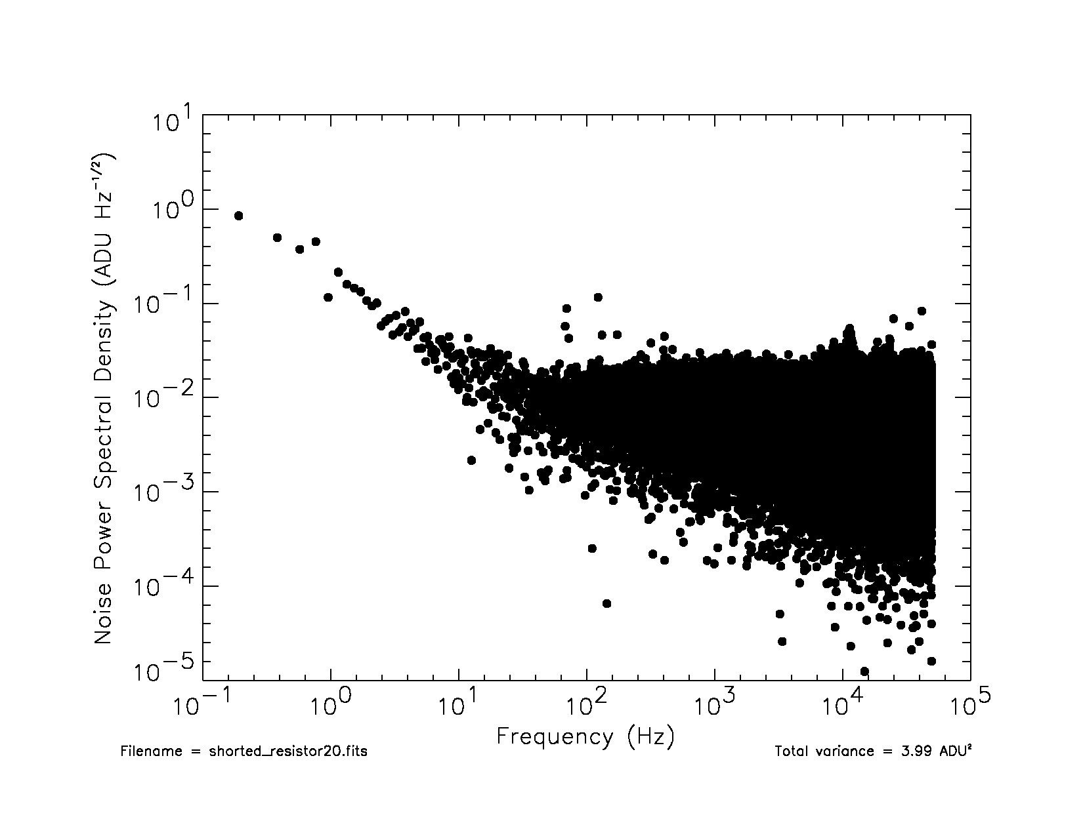 | 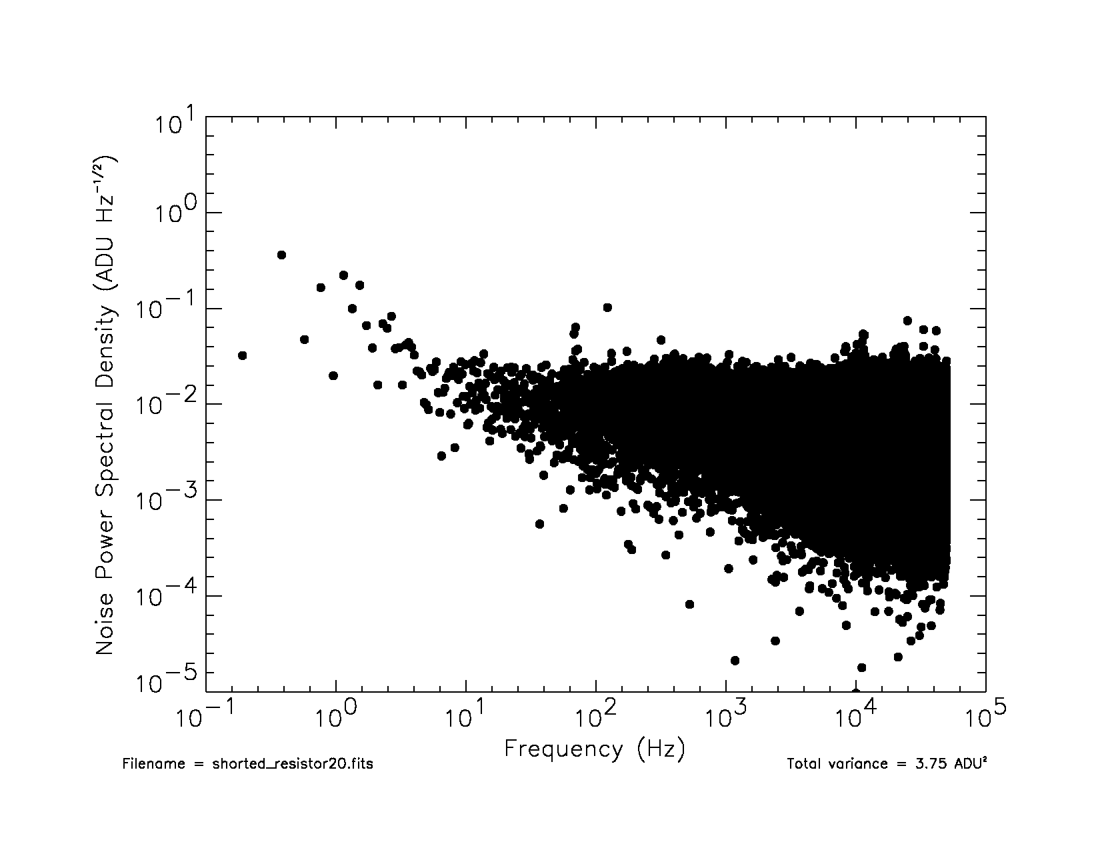
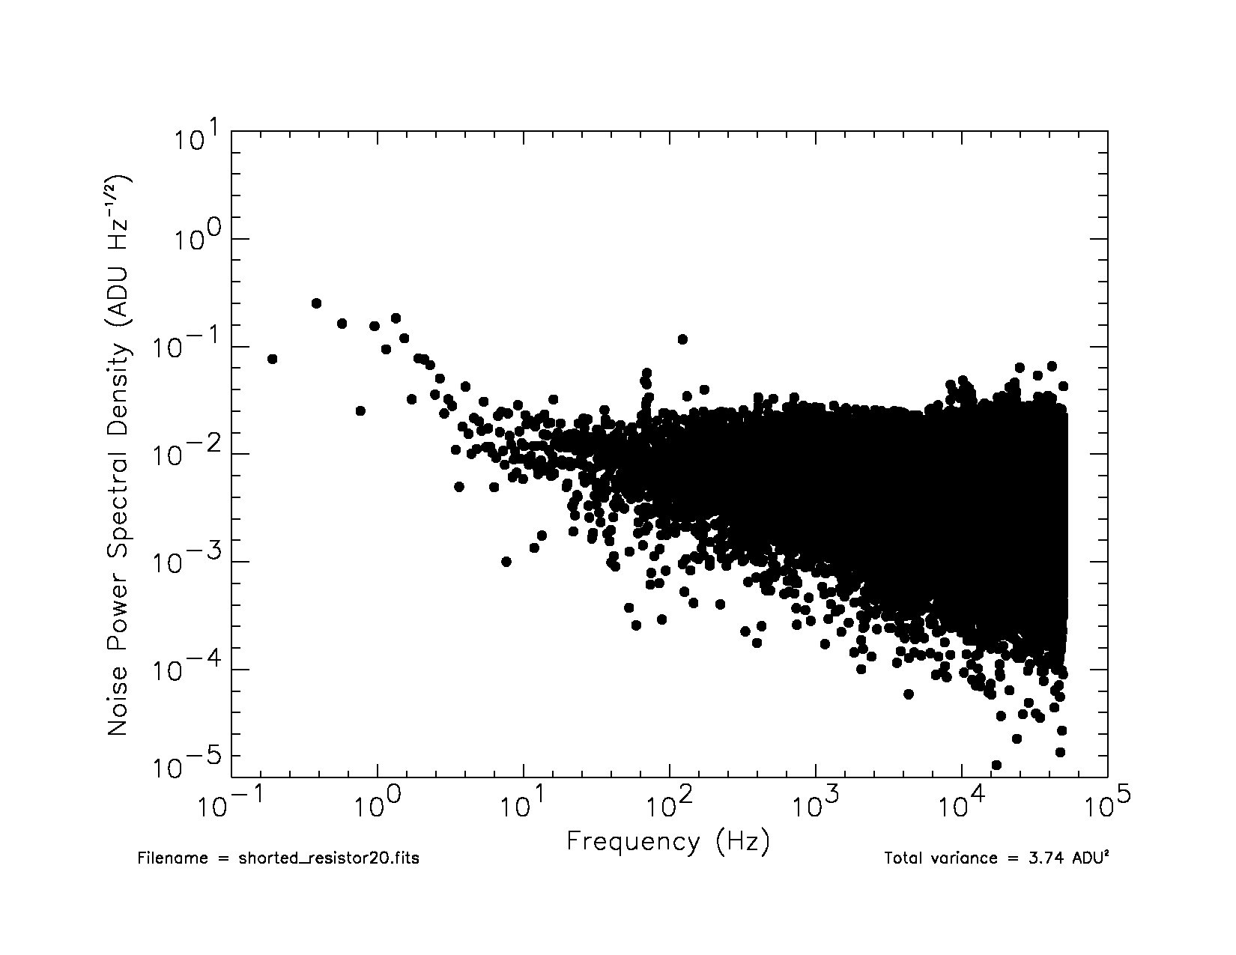 | 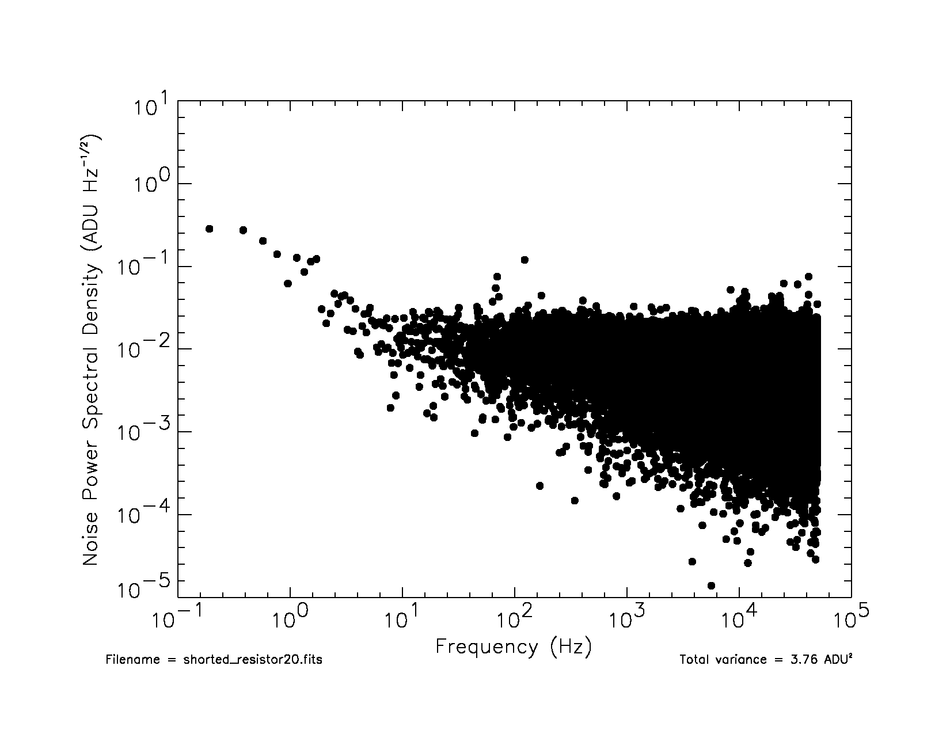
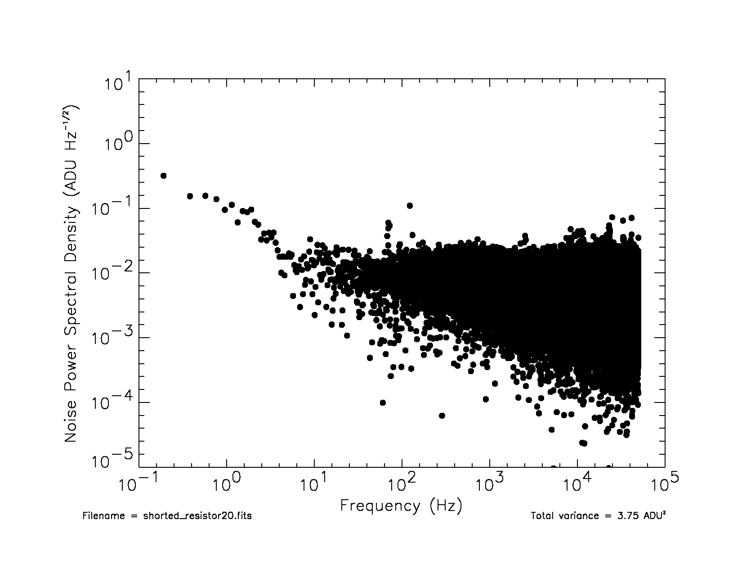 | 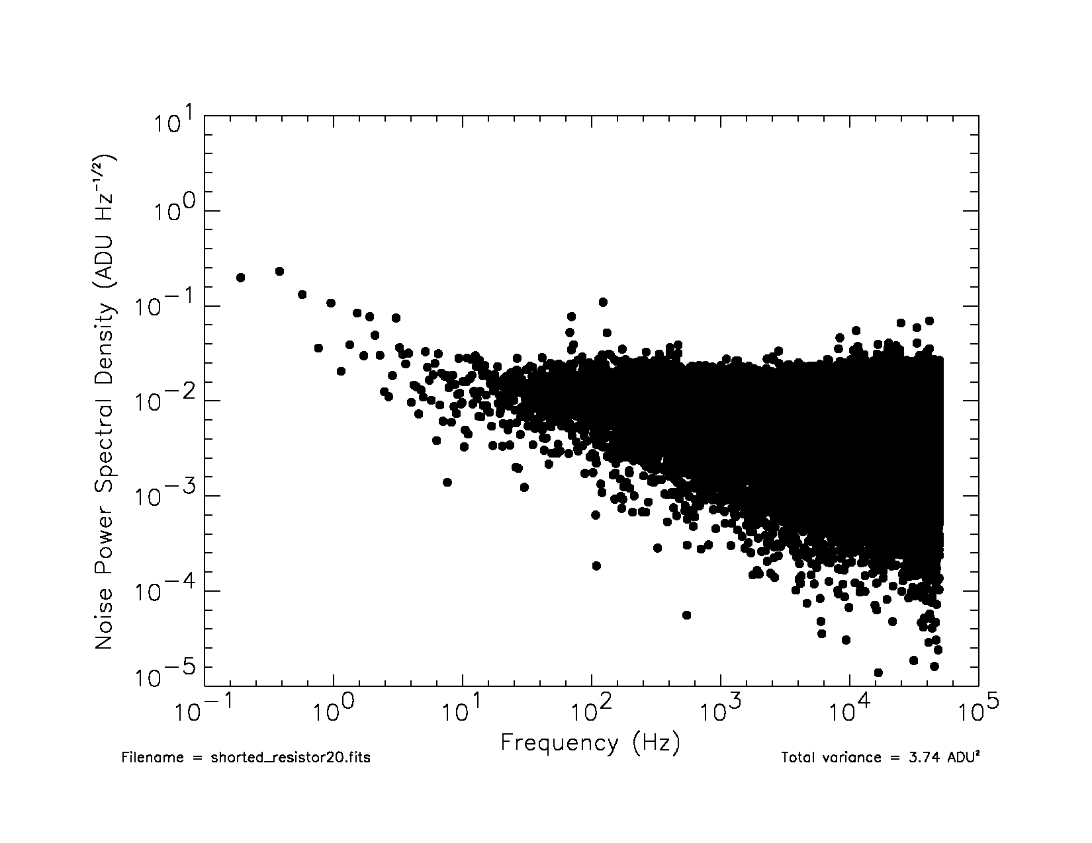
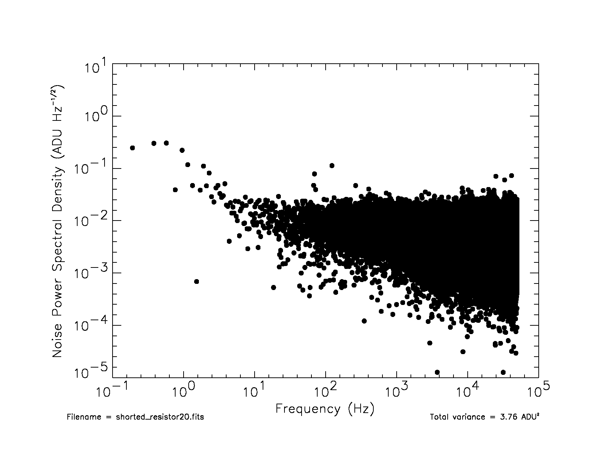 | 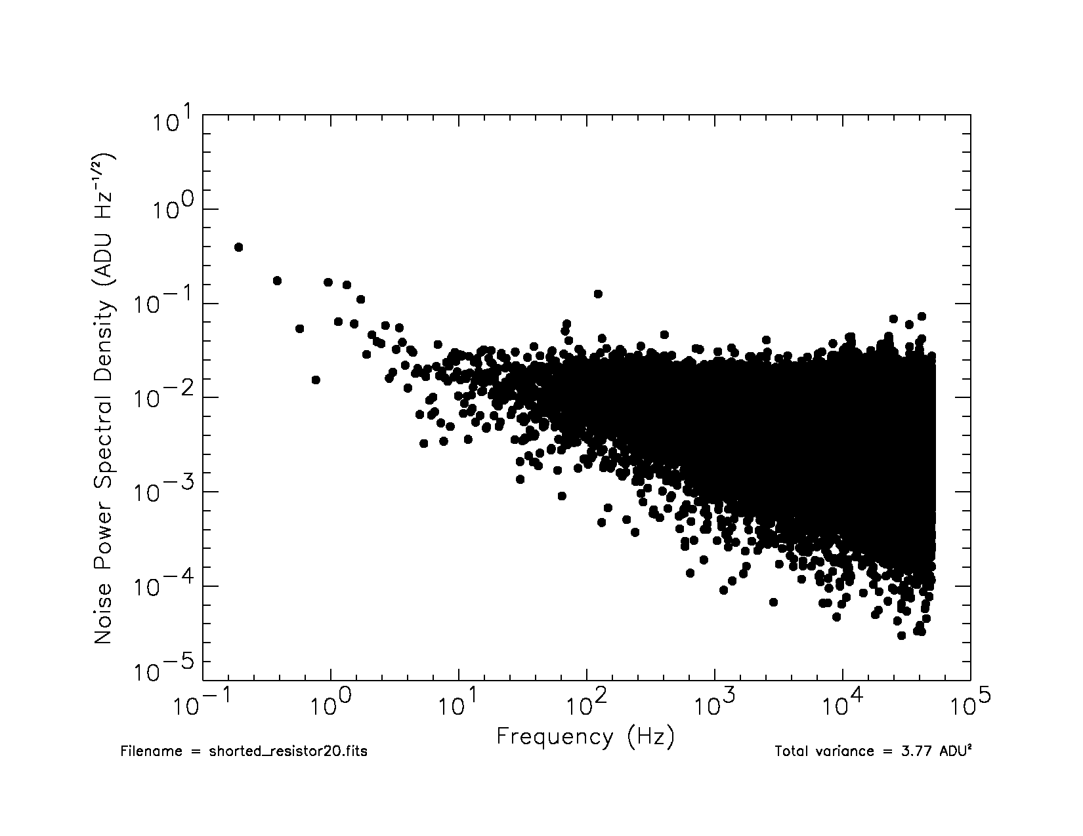
Figure 1. The Fourier Power Spectrum of the detector readout system is dominated by 1/f noise at low frequencies, and by white noise at high frequencies. This figure shows the Fourier Power Spectrum of each read in a Fowler-4 exposure. From top-to-bottom on the left are reads 1-4, taken at the start of the exposure. From top-to-bottom on the right are reads 5-8 taken at the end of the exposure. The normalization is such that the integral over all frequencies is equal to the variance in the read. Each point on the plot represents the noise power spectral density in a frequency interval dν=0.19 Hz wide.

As a first step toward understanding how to best use reference pixels, we undertook the study described in this paper. It includes a Fourier analysis of the noise of our detector readout system and explores how columns of reference pixels can potentially be used to calibrate out the different noise components that were identified. To ensure that the focus would remain practical and widely applicable, we focused on four approaches using standard astronomical data analysis tools. These approaches were as follows.

- Simple Subtraction – Subtract a reference level determined by averaging from one to a few reference pixels in a row from each pixel in that row. We do not recommend this strategy as it adds noise. We include it so that readers can see how it compares to other approaches.

- Maximal Spatial Averaging – Average all of the reference pixels on the detector together. This approach is computationally simple, introduces no obvious artifacts, and is highly effective at removing spatially constant exposure-to-exposure offsets such as e.g. pedestal drifts.

- Spatial Averaging – Fit a continuous 1-dimensional function to a smoothed region of reference pixels and subtract this reference column from each column in the data. In practice, this is the approach that we have been using most often in the lab up to now. It is computationally simple, requires no special detector readout software, is able to reject some 1/ƒ noise components within exposures, and appears to introduce negligible artifacts. We recommend this approach to readers who seek a simple, but effective reference pixel calibration strategy.

- Temporal Averaging – Dwell on reference pixels for much longer than a regular pixel and use multiple non-destructive samples to reduce the uncertainty in the average reference level for each row. For our system, this promises to be the most effective technique. Fourier analysis suggests that it will enable us to remove essentially all of the 1/ƒ noise in individual exposures. We plan to evaluate the effectiveness of this approach using a candidate NGST detector by the end of the year.

To ensure that our results would be general, for this study we focused on testing the detector readout system using a shorting resistor installed where the sensor chip assembly (SCA) would normally be installed. As a cross check, we have used the same setup to characterize a λ_{c} = 5 μm HgCdTe Rockwell HAWAII-1R SCA. In these tests, we were able to reproduce the University of Hawaii’s read noise and dark current measurements to within about 10% for the same device. Although the HAWAII-1R is not a candidate NGST SCA, these tests did allow us to verify our setup down to the low background levels required for NGST.
The remainder of this paper is structured as follows. In Section 2, we discuss the IDTL’s detector readout system. The aim of this section is to provide enough technical detail so that readers can view the noise measurements in context. In section 3, we elaborate on the operational scenarios for using reference pixels called out above. In Section 4 we present our recommendations.

2. The IDTL Detector Readout System

Our aim in this section is to provide a description of the detector readout system in sufficient detail to permit the reader to place the noise measurements in context. Readers who would like to know more should see the companion paper in this volume, Figer et al. (2002). In particular, Figer et al. (2002) provides more information on the design approach and contact details for suppliers of some specialized components.
The IDTL detector readout system is based on a Bob Leach designed Astronomical Research Cameras (ARC), Inc. controller. The Leach controller is connected to a cable harness, which is in turn connected to a Detector Customization Circuit (DCC). The DCC maps pins from the Leach controller onto a single connecter that is specified by the vendor.
When these measurements were made, the IDTL’s Leach controller contained two clock driver boards (ARC Doc Number CLKDRVIR R3B), two co-adding video processor boards (ARC Doc Number VIDPROCA_R3B.SCH), and a fiber optics timing board (ARC Doc Number Gen II TIMING BOARD FIBER OPTIC REV.4B). All of these cards are built into a completely enclosed box that incorporates cooling fans . Some colleagues have reported seeing excess noise associated with the cooling fans. Our experience so far has been that the fans do not inject significant noise when the Leach electronics are properly grounded. In practice, for the IDTL this meant attaching a dedicated ground wire from the
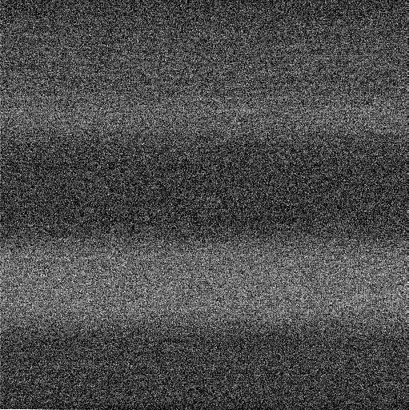

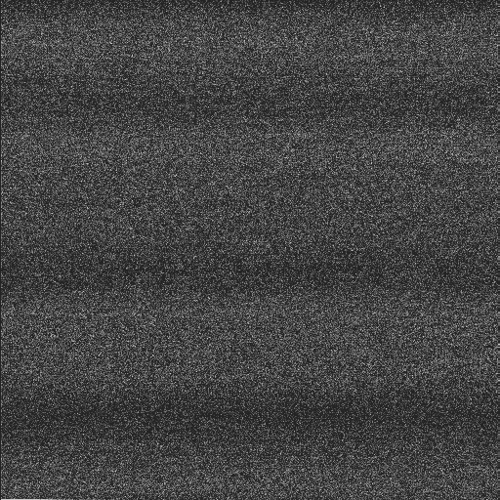

Subtract Reference Pixel,
σ = 8.5 e-
Maximal Spatial Averaging,
σ = 7 e-
Spatial Averaging,
σ = 6.7 e-
Temporal Averaging,
σ = 5.3 e-
Starting image,
σ = 7 e-
Figure 2. Effect of using each of the four calibration strategies consided in this paper on one 512×512 pixels sample from the IDTL detector readout system. So that the results would be general, a 1 kΩ shorting resistor was installed where the detector mounts. The raw image (left) has standard deviation =7 e- with conversion gain (number of e-/ADU) appropriate to an NGST detector. Fourier analysis shows that about 6 e- of this is white noise and about 4 e- is in a 1/ƒ tail that appears as horizontal banding. Total noise per correlated double sample is about 10 e-.

lab’s main ground point to a ground post adjacent to the analog to digital converters (ADCs) on one co-adding video board. This ground post serves as the main on-controller star for all grounding in the digital and analog electronics. The leach controller’s enclosure and power supply enclosure are on different ground stars and there is no conducting path between these boxes and the digital and analog grounds.
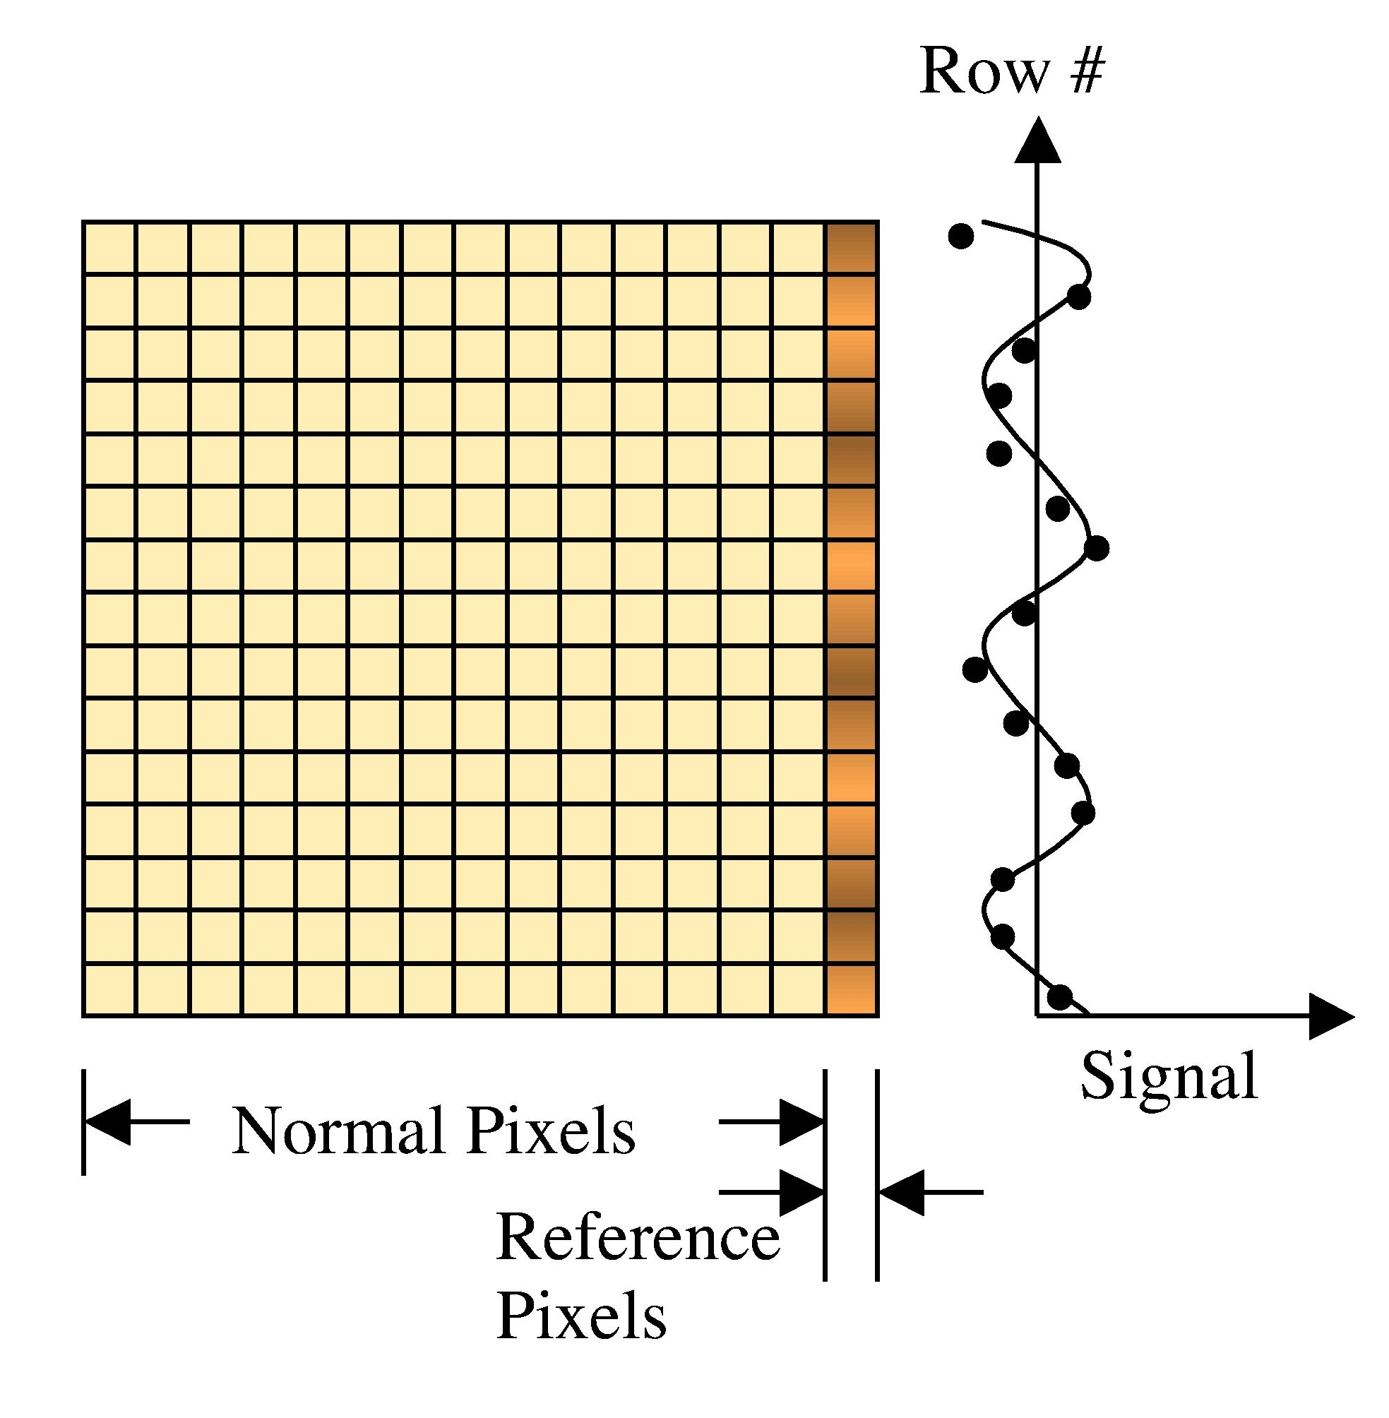 | 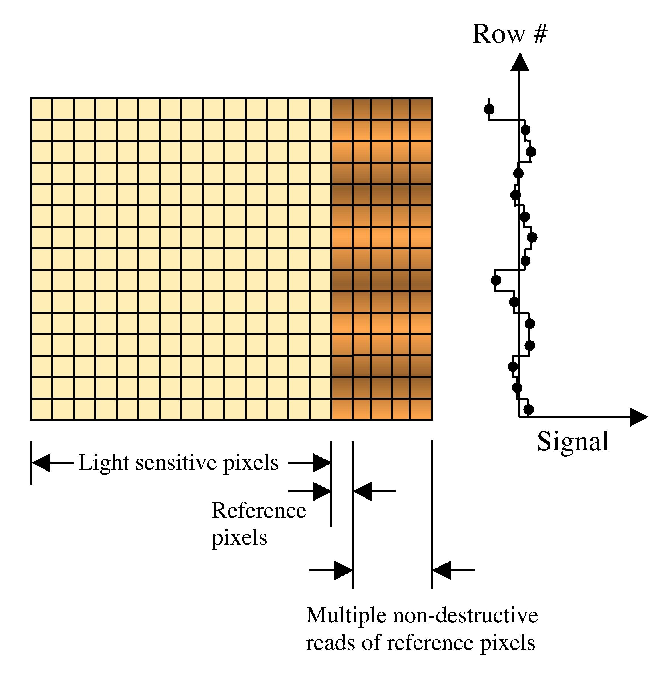
Figures 3a-b. In Spatial Averaging (left), a continuous one dimensional function is fitted to smoothed reference pixels. This can be accomplished using e.g. the IRAF task COLBIAS or software incorporating the IDL SAVGOL procedure for smoothing. In Temporal Averaging (right), multiple non-destructive samples are used to reduce the uncertainty in the averaged reference pixel level for each row.

The co-adding video boards were configured to provide a video input referenced gain =14.3× at the ADC inputs. This results in a conversion gain =10.67 μV/ADU. The bandwidth is an important parameter effecting rms noise. When these measurements were made, the –3dB point was set by an RC filter located at the video inputs to =80 kHz.
The cable harness comprises a “warm” harness that is used outside the cryostat and a cryogenic harness that operates inside the cryostat. Sensitive signals, such as analog biases and video outputs, are carried in a “quiet” harness that is physically separated from the “loud” harness that carries clocks and other non-sensitive signals. Biases and clocks are carried on shielded 24 gauge 4-conductor cables. Video outputs and a reference output are carried by shielded 24 gauge twisted pairs, and a few very sensitive signals (such as the detector substrate) are carried by RG-174 coaxial cable. The warm harness terminates in a 55-pin circular connector (quiet signals) and a 41-pin circular connector (loud signals). All conductors in all cables are copper.
The cryogenic harness consists of laminated ribbon cables (with copper flash for shielding on both sides) that were fabricated to our specification by Tayco Engineering, Inc. Electrically, the cryogenic harness mirrors the warm harness. “Loud” and “quiet” harnesses are kept physically separate, video outputs and references are carried on 30 gauge copper twisted pair, biases are on single conductor 30 gauge copper wire with a grounded shield wire interleaved every 4 conductors, and a few very sensitive signals are on Lakeshore’s copper micro-coaxial cable. The cryogenic harness terminates in four micro-D connectors that mirror the 4 D-subminiature connectors used in the Leach controller. Taken altogether, the total length of the warm plus cryogenic harness is about 1/2 meter, DC resistance from input to output is less than one ohm, and the total capacitance to ground on any one conductor is less than 45 pF. To eliminate the possibility of ground loops, all cable shields terminate before entering the DCC. From the DCC to the detector, all shielding is done using digital ground planes.
The DCC is essentially a personality card for testing a particular detector. It differs from the traditional fanout card in that it incorporates a flexible “neck” to simplify interfacing to the rest of the IDTL system. Circuit design for the DCC was done in the IDTL and PCB layout was done by the Flex Circuit Design Company of San Jose, California. The DCCs were fabricated and tested by Pioneer Circuits of Santa Ana, California.

System Noise Testing
In preparation for our study of using reference pixels to reject low frequency noise, we undertook detailed noise testing of the readout system using a 1 kΩ shorting resistor installed where the SCA would normally mount. In this configuration, one side of the Leach controller’s video input (the reference) was looking at a programmed bias. The other side, which was designed to mimic an SCA, consisted of the 1 kΩ shorting resistor connected between the SCA video output contact and the detector substrate contact.
The experiment consisted of taking a sequence of identical Fowler-n sampled exposures, where n was a variable number of Fowler samples, n ∈ {1, 2, 4, 8, 16, 32, ...}. In Fowler sampling (see e.g. Fowler & Gatley 1990), multiple non-destructive reads are used to average over noise. For example, to take a Fowler-8 exposure, the full detector must be non-destructively read out sixteen times in total. For this example, there would be eight closely spaced samples at the beginning of the exposure and eight closely spaced samples at the end. In doing this, one normally cycles through all pixels before reading any one pixel again.
Fowler sampled data are usually calibrated by averaging together all of the samples at the beginning of the exposure and subtracting them from the average of all samples taken at the end. This process effectively averages over many noise components at both low and high frequencies. However, it would be even better if some of this noise could be removed prior to forming the averages. To investigate this, it is essential to understand the noise characteristics within each Fowler sample.
Figure 1 shows the time-ordered Fourier Power Spectrum of each sample in a Fowler-4 exposure looking at a 1 kΩ shorting resistor. Although this example is for a Fowler-4 exposure, in practice we have found that the power spectrum of any sample in any Fowler sampled exposure is essentially the same. For our Leach II controller, flat-spectrum white noise is dominant at frequencies higher than about 100 Hz. This corresponds to a period of about 2 rows on an NGST detector having 1024² pixels per video output at a 100 kHz pixel rate per output. At frequencies lower than 100 Hz, 1/ƒ noise becomes increasingly dominant. Fourier analysis shows that in a typical sample having total standard deviation σ = 1.9 ADU, about 1 ADU of the noise is contributed by the 1/f tail. For the IDTL system, the total noise budget per Fowler sample breaks down as shown in Table 1. An important point to notice is that if the 1/ƒ noise can be removed on a sample-by-sample basis, the noise floor of the entire IDTL readout system is largely determined by the ADC, which in our system is a DATEL ADS-937. With shorted inputs, the DATEL ADS-937 has a per-sample noise of about 1.5 ADU according to DATEL’s specifications sheet for the part.

- Noise Rejection
as a Function of Reference Pixel Correction Method

The Fourier noise power spectrum (Figure 1) provides one key to understanding how to best use reference pixels to maximize system sensitivity. If at least one reference pixel is available per 512 pixels in the fast scan (“row”) direction, then noise components having a period longer than 1024 pixels will be fully sampled in accordance with the Sampling Theorem. For an NGST-like readout rate of ~10 μs/pixel, noise components at frequencies less than ƒ_{c}=98 Hz are fully sampled and can be rejected if the reference pixel sample noise is low enough. For NGST, the important point is that in order for reference pixels that appear with regular pixels in the data stream to be most effective, the electronics must not generate substantial 1/ƒ noise at frequencies less than ν < 100 Hz.
Because low frequencies are fully sampled by reference pixels in the IDTL system, this raises the interesting question of how one should use the reference pixels to remove this noise. One might assume that a few reference pixels can be averaged together in each row, and that this average can be subtracted from every pixel in that row. This approach would work well, for example, if there were about the same number of reference pixels in each row as there are normal pixels. If, however, only from one to a few reference pixels are averaged, the uncertainty in the reference level will be larger than the effect that one is trying to correct. To see this most clearly, consider the case of one reference pixel per row. In this case, the uncertainty in the derived reference level is equal to the rms noise per pixel. For our system, this adds noise to the image and injects a horizontal striping artifact (see Figure 2).
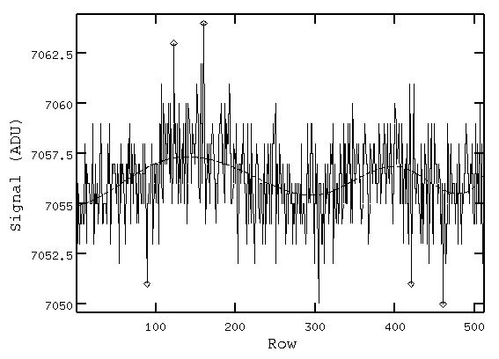
Figure 4. Example using the IRAF task COLBIAS to fit a smooth and continuous function to the rows in the region [1024,*] of an image to create a reference column. For this example, we have fitted the data using COLBIAS’s SPLINE3 function with ORDER=5. The reference pixel correction successfully calibrated out a sinusoidal drift with period ~220 rows.
These considerations led us to consider other methods of using the reference pixels. Clearly, one can straightforwardly average all of the reference pixels in an exposure together to subtract off any drifts that are correlated across the full image. A good example of the kind of drift that could be corrected in this manner is NICMOS’s pedestal effect. In this paper, we refer to this as Maximal Spatial Averaging. This technique is highly effective at removing exposure-to-exposure offsets and other noise sources that are independent of position within an individual exposure. An example of this kind of noise is NICMOS’s Pedestal Effect. In NICMOS, each exposure has a variable bias offset that is of the same order as the rms noise in an image. Although these bias drifts are easy to remove when reducing data by hand, they are a real problem in an automated pipeline such as that that is used for NICMOS and that will be built for NGST.
Although it is useful to remove pedestal drifts to enable pipelined processing, it would be more desirable if reference pixels could also be used to remove the 1/ƒ noise within an exposure or within an individual Fowler sample. In this case, the reference pixels would both simplify the calibration process and yield real sensitivity gains by reducing the total noise per exposure.
In the IDTL, we have begun to experiment with various of approaches toward this goal. These include using standard astronomical tools such as the IRAF task COLBIAS as well as our own application specific IDL procedures. We refer to these approaches as Spatial Averaging (see Figures 3a & 4) and Temporal Averaging (Figure 3b) respectively. In spatial averaging, standard astronomical tools such as COLBIAS, or IDL procedures using a Savitzky-Golay algorithm (SAVGOL procedure) to smooth the data, are used to create a reference column by fitting a continuous function to smoothed reference pixel values. This reference column can then be subtracted from each column in the image
Although spatial averaging is more effective at removing 1/ƒ noise than Maximal Spatial Averaging, it is not very good at filtering out intermediate frequencies from about 10 Hz to 100 Hz. For the time being, the most promising approach appears to be Temporal Averaging. To begin to understand how temporal averaging might work, we wrote an IDL procedure to average together large numbers of reference pixel samples within each row to produce a reference column that is based on unsmoothed data. We then subtracted this reference column from every column in the image to make a row-by-row reference pixel correction. Shorting resistor tests demonstrate that this technique is highly effective at removing 1/ƒ noise, and that it introduces minimal artifacts. The next step in the lab is to confirm these results using a real SCA. In the following paragraphs we briefly elaborate on the shorting resistor tests using Temporal Averaging.
For the tests, the experimental setup was exactly as described in section 1. However, instead of treating every pixel as if it were a regular light sensitive pixel, we assumed that a large number of columns along the right-hand edge were reference pixels. One might do this either in hardware, by building an array that incorporates many reference pixels, or in software by dwelling on the reference pixel and sampling it many times before clocking to the next pixel. If one were to dwell on the reference pixels for long periods, it would have the effect of lowering the 1/ƒ noise frequency that is critically sampled. For example, if there is one reference pixel per 512 pixel long row at a 100 kHz pixel rate, the Nyquist frequency is =98 Hz. If, however, one were to dwell for 100 pixel times on that one reference pixel, then the Nyquist frequency would drop to =82 Hz. The optimal number of samples is therefore a function of the noise characteristics of the detector and detector readout system. For the IDTL’s Leach controller, which shows very little 1/ƒ noise at 82 Hz (see Figure 1), using multiple non-destructive reads to average ~100 reference pixels per row is a reasonable compromise.

- Recommendations

Although it is still too early to say definitively how reference pixels should be used for NGST, our studies have highlighted a few productive avenues for research while testing NGST SCAs. These include the following.

- Temporal Averaging: Using multiple non-destructive reads, it is possible to sample a reference pixel many times before clocking to the next pixel. In this way, one can reduce the error in the reference level for that row to something much smaller than the pixel-to-pixel rms noise. Although this approach appears to be the most promising for removing low frequency noise, it imposes somewhat greater demands on the data system. These include more capable SCA readout software to multiply sample reference pixels before moving on to the next regular pixel and increased data storage capacity. An example of this approach using a 1024×1024 SCA would be to use multiple non-destructive reads to sample pixels in the reference column [1024,*] ~128 times before moving on to the next row. The raw data for the 1024×1024 pixels SCA would appear as a 1152×1024 image with “overscan” in the region [1025:1152,*]. By averaging all of the reference pixels in each row together, we have found that we can remove essentially all of the 1/ƒ noise from our images. A slight variant of this procedure would be to use co-adders to average the multiply-sampled reference pixels before returning a 1024×1024 pixels image to the data system.

- Spatial Averaging: This approach enjoys the advantage of simplicity in that it does not require any special SCA readout software and it does not impose any hardware requirements beyond those needed to read out the SCA normally. Moreover, subtracting a smoothed reference column from each column in an image eliminates pedestal drifts and can remove some low frequency noise. The end result is somewhat lower noise in the final calibrated image than could be obtained by Maximal Spatial Averaging. An example of this approach using a 1024×1024 pixels SCA would be to use the IRAF task COLBIAS to subtract a smoothed reference column made by fitting an e.g. SPLINE3 function to pixels in the region [1024,*].

- Maximal Spatial Averaging: The simplest approach is to average all of the reference pixels within the SCA together. Although this approach does not remove any low frequency noise within an image, it does eliminate pedestal drifts and other correlated bias drifts (e.g. pedestal drifts) from readout to readout that can plague automated calibration pipelines.

Acknowledgements

The IDTL has been funded by the DDRF and by JHU via cost sharing on the NGST Detector Characterization Project. The material in this paper is based upon work supported, in part by NASA, under award No. NAG5-10430.

References

- D. Figer et al., “The Independent Detector Testing Laboratory and the NGST Detector Characterization Project”, this volume
- G. Finger, H. Mehrgan, M. Meyer, A. Moorwood, G. Nicolini, and J. Stegmeier, “Performance of large-format HgCdTE and InSb arrays for low-background applications”, Proc. SPIE Vol. 4008, pp. 1280-1297, 2000.
- A. Fowler and I. Gatley, “Demonstration of an algorithm for read-noise reduction in infrared arrays”, ApJL, pp.L33-L34, 1990.
- D. Hall, K. Hodapp, D. Goldsmith, C. Cabelli, A. Haas, L. Kozlowski, K. Vural, “Characterization of λ_{c}=5 μm Hg:Cd:Te arrays for low-background astronomy”, Proc. SPIE Vol. 4008, pp. 1268-1279, 2000.

