Independent Detector Testing Laboratory

Don Figer, Mike Regan, Bernard Rauscher

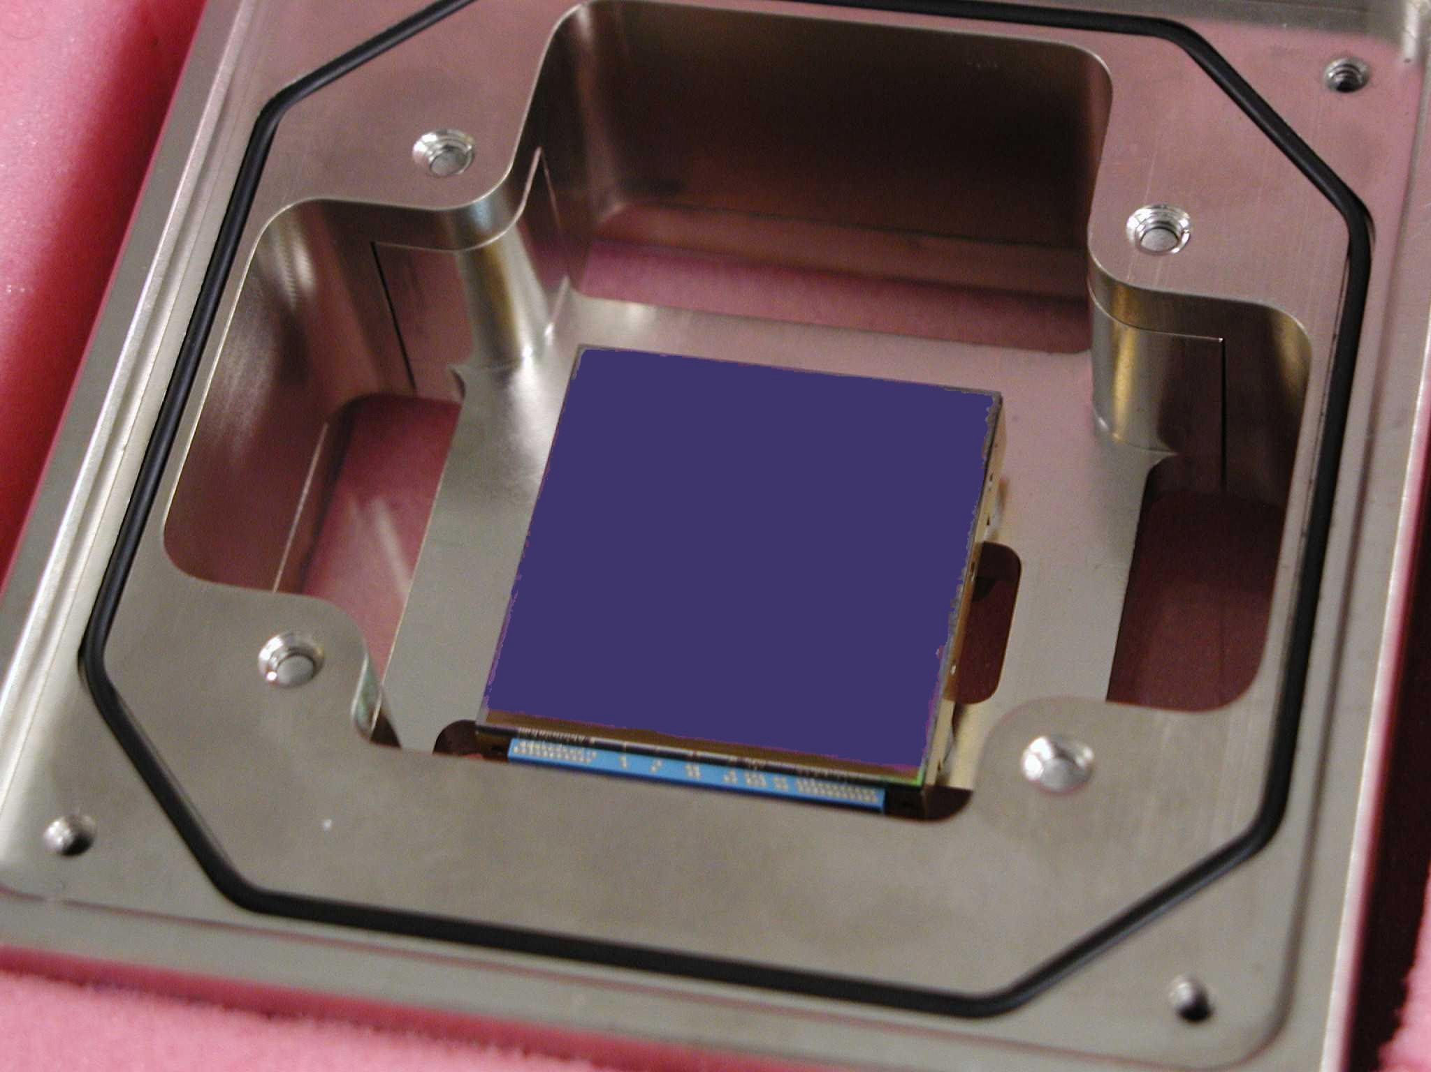
In 2003, the Independent Detector Testing Laboratory (IDTL) completed a critical task for NASA, the characterization of candidate near-infrared detector technologies for the James Webb Space Telescope. On the basis of IDTL results, two Webb scientific instruments selected HgCdTe detectors made by Rockwell Scientific Company.
Figure 1. A prototype Webb detector, the Rockwell H2RG.

The Institute and the Johns Hopkins University (JHU) established the IDTL in 1999 to provide world-class testing and development facilities for astronomical detectors and associated technology. The IDTL serves the astronomical community with its facilities, expertise, technical information, and training in detector technology for graduate students.

The IDTL tests of near-infrared detectors for Webb involved measuring first-order detector properties (read noise, dark current, persistence, quantum efficiency, etc.) as functions of environmental parameters (radiation exposure, thermal conditions, operating modes) for two candidate detector types, using the same procedures, setups, dewars, light sources, targets, electronics, acquisition software, analysis software, and staff. The completed Webb detector characterization project obtained two terabytes of data over two years from a half dozen prototype detectors during 25 cool-downs.

The measured performance of the Rockwell detector is impressive, with dark current as low as 1.3 e⁻/1000 seconds/pixel, the lowest ever measured for an array having a long wavelength sensitivity cutoff at 5 μm. The read noise was low, < 10 e⁻ per frame averaged over eight non-destructive reads. All imaging devices trap charge that can appear later while imaging another object. Rockwell devices showed a very low ‘persistence’ of ~ 0.03% total integrated charge over 2000 seconds after a saturating exposure to light.

The IDTL provided critical data used by University of Arizona in their selection of the Rockwell detectors for the Near Infrared Camera (NIRCam) and by Goddard Space Flight Center and the European Space Agency in their selection of the same detectors for the Near Infrared Spectrograph (NIRSpec).

