 | Master’s Thesis/Ph.D. Research  Opportunity for Veterans
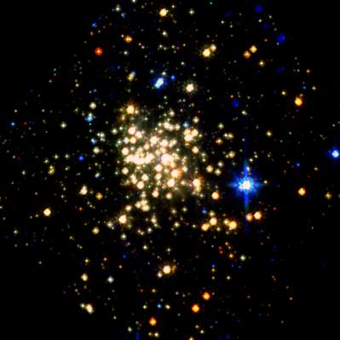  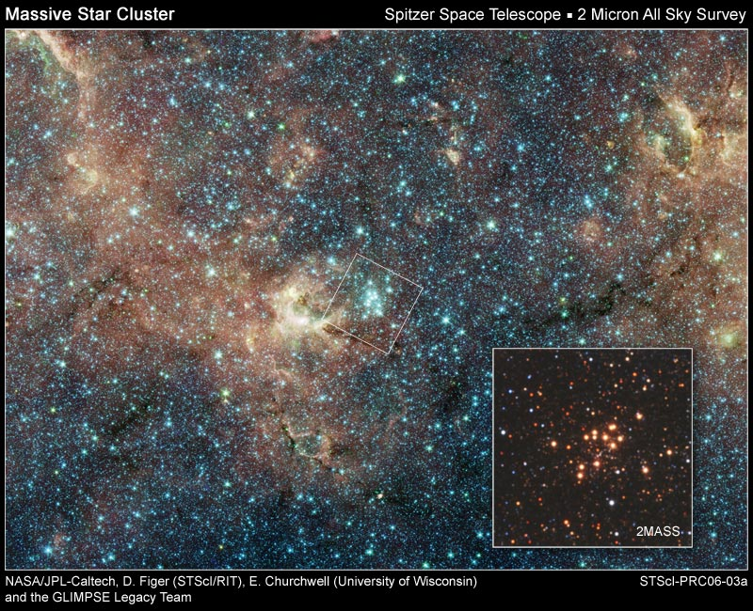    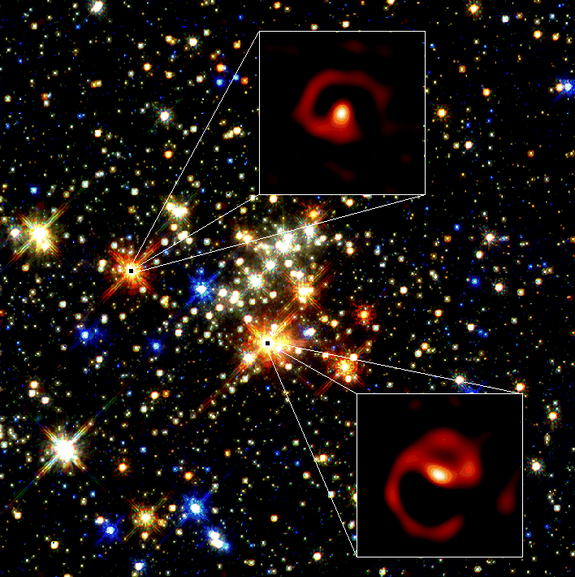  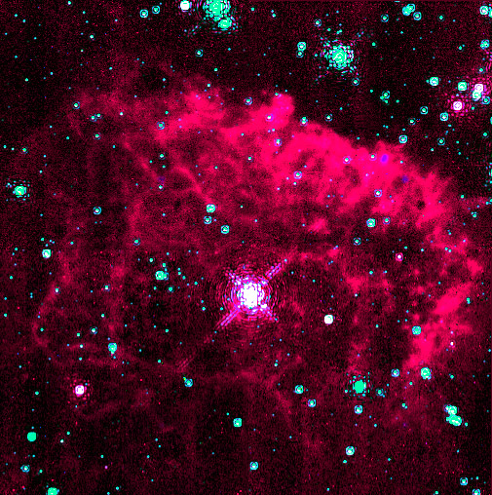 | The Center for Detectors at RIT welcomes interest in a fully funded Master’s or PhD research program for U.S. military veterans. The research can be in any field that benefits from high performance imaging detectors, for example: astrophysics, physics, electrical engineering, biophotonics, remote sensing, materials science, etc.  Inquires about this position may be directed to Dr. Donald F. Figer (figer@cfd.rit.edu); you should include a cover letter and a resume. Applicants should also provide names and contact information on three professional references. We also welcome inquires from graduates who have skills and training in microelectronics manufacturing and advanced computer programming.
 |  | 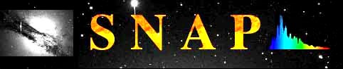 |  |  | 
http://ridl.cfd.rit.edu

