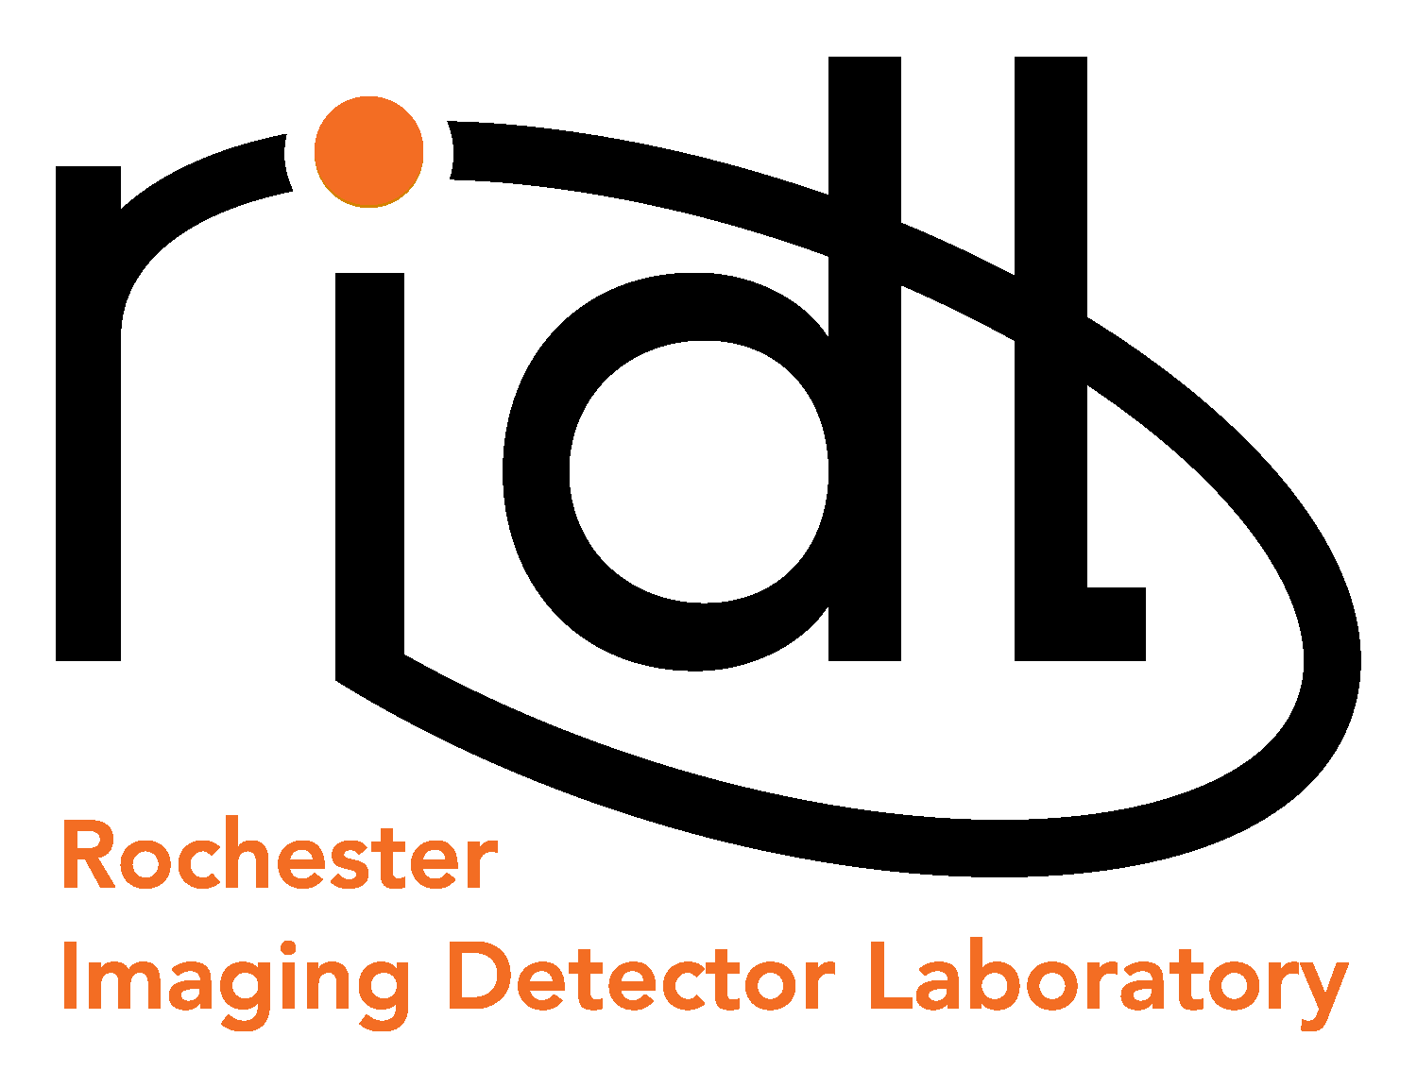 |     54 Lomb Memorial Drive, Rochester, NY 14623-5603
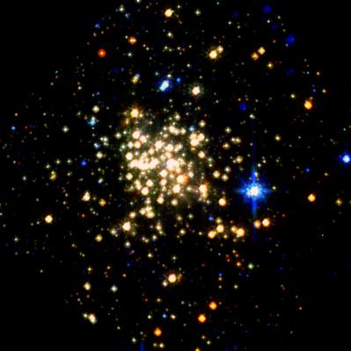  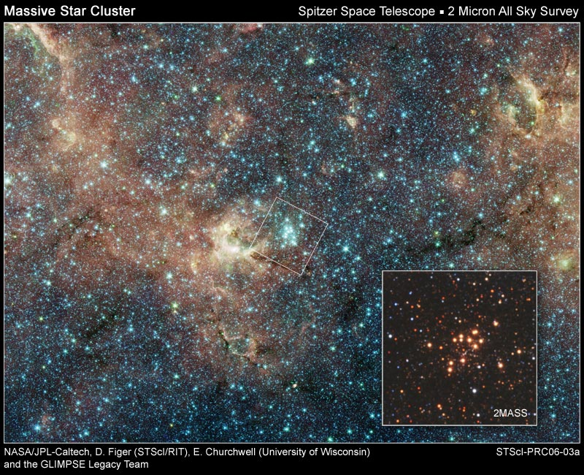  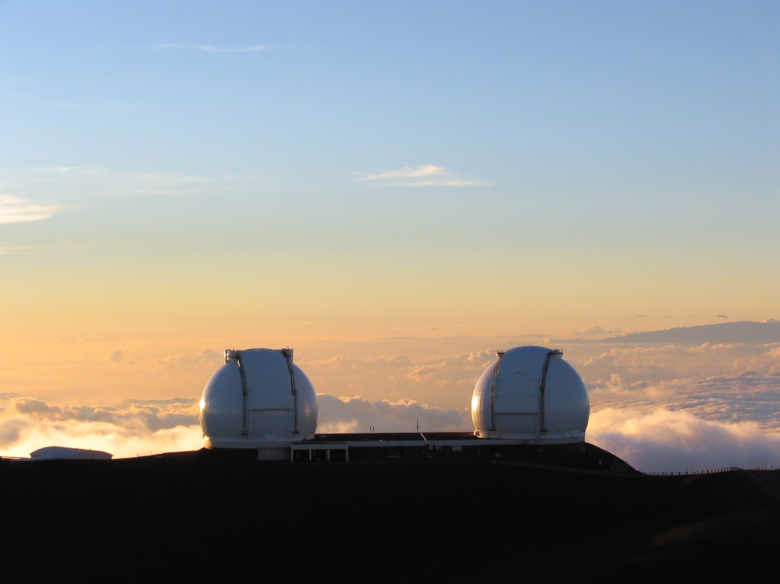  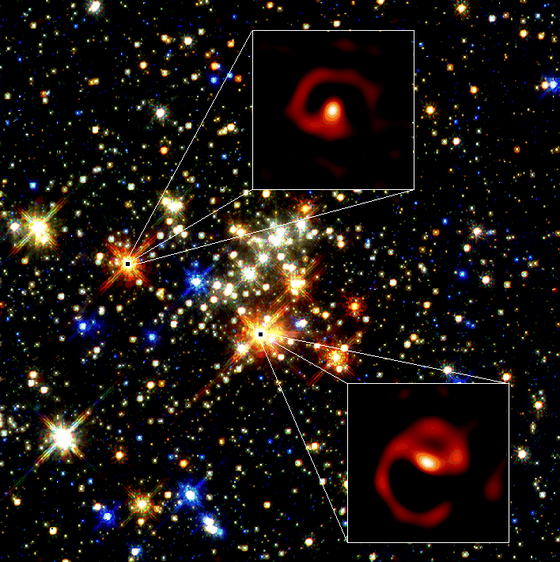  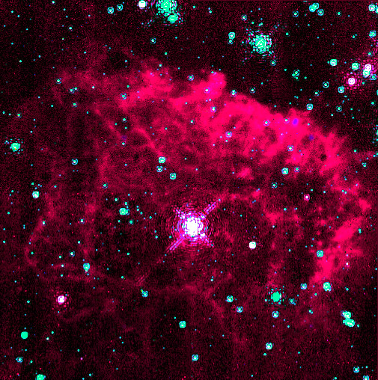 | Master’s Thesis/Ph.D. Research in Advanced Imaging Detector Design and Fabrication  Imagine the following on your resume: “Member of the team that designed and fabricated a zero-noise detector for imaging applications.” This is only one of many cutting-edge projects that the Rochester Imaging Detector Laboratory (RIDL) is working on.  The RIDL is an independent detector testing facility within the Center for Imaging Science. The RIDL was established to develop and advance new innovative detector technologies for astronomy and other fields. The lab pursues these goals by developing new cutting-edge detectors that utilize advanced CMOS readout circuitry (an activity sponsored by NASA).  If you are pursuing a Master’s degree in Computer, Software, Microelectronics, or Electrical Engineering, or a Master’s or Ph.D. in Imaging Science, the RIDL may be the Laboratory for your thesis and dissertation research. Stipends and possible tuition assistance are available as you assist in the design and fabrication of a novel imaging detector in a project carried out by engineers and scientists in the RIDL.  Inquires about this position may be directed to Dr. Donald F. Figer (figer@cis.rit.edu, Bldg.76-2246); you should include a cover letter and a resume. Applicants should also provide names and contact information on three professional references. We also welcome inquires from graduates who have skills and training in microelectronics manufacturing and advanced computer programming.
 |  | 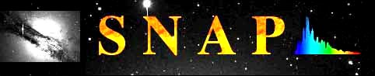 |  |  | 
http://ridl.cis.rit.edu

