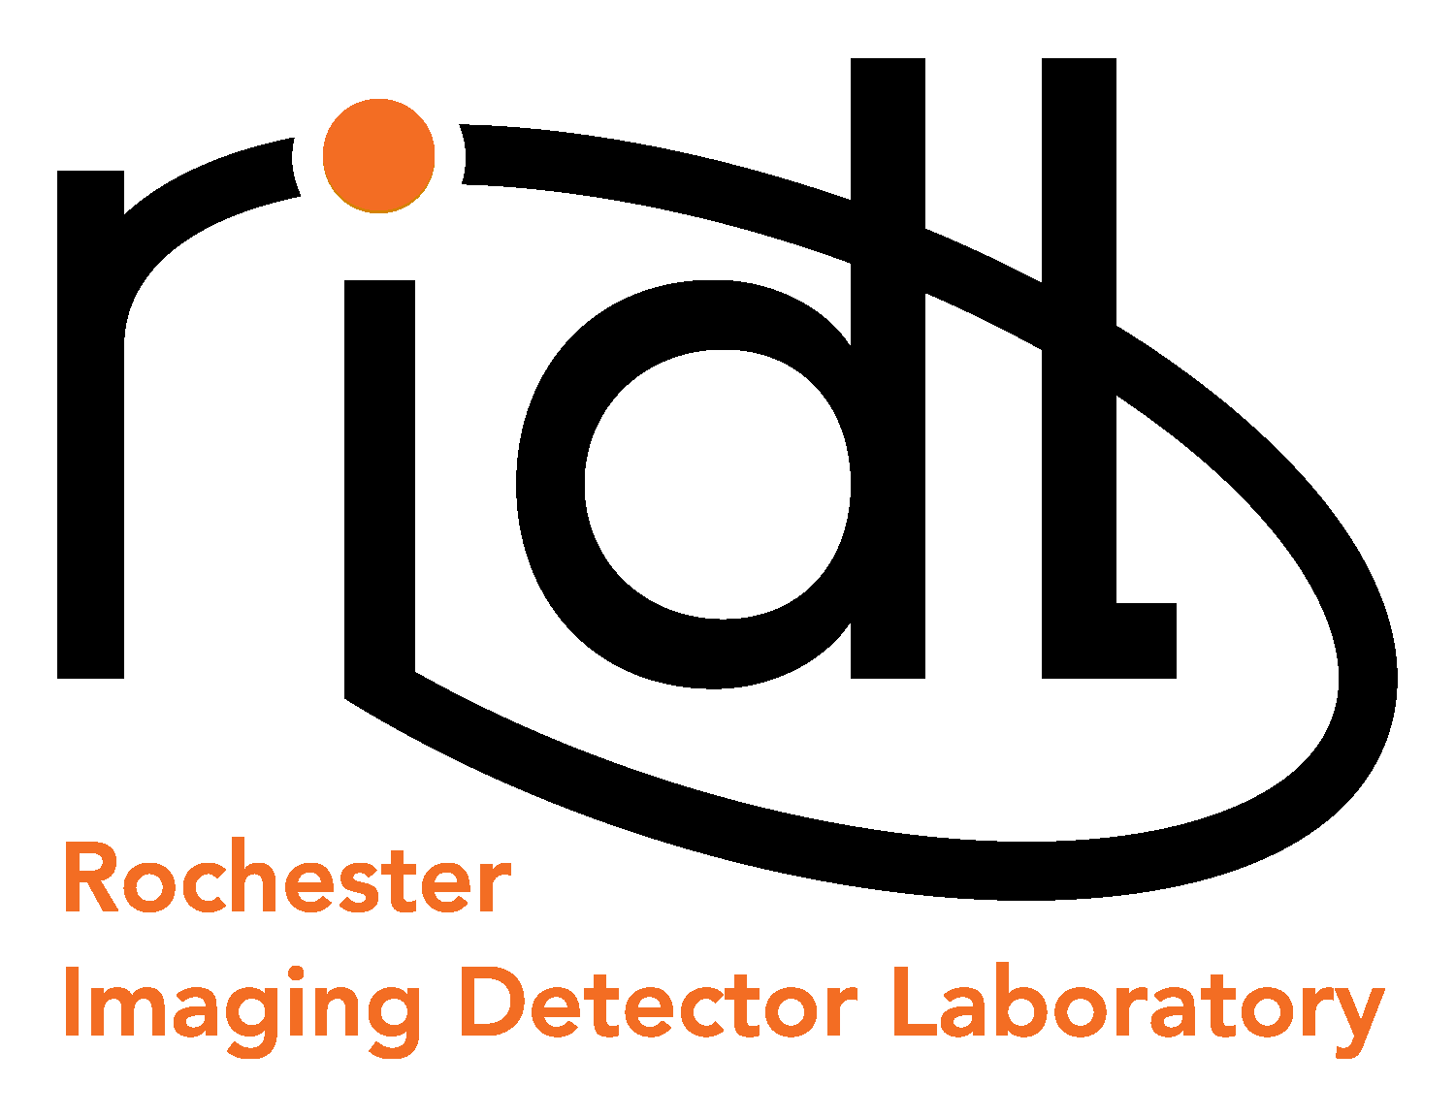 | 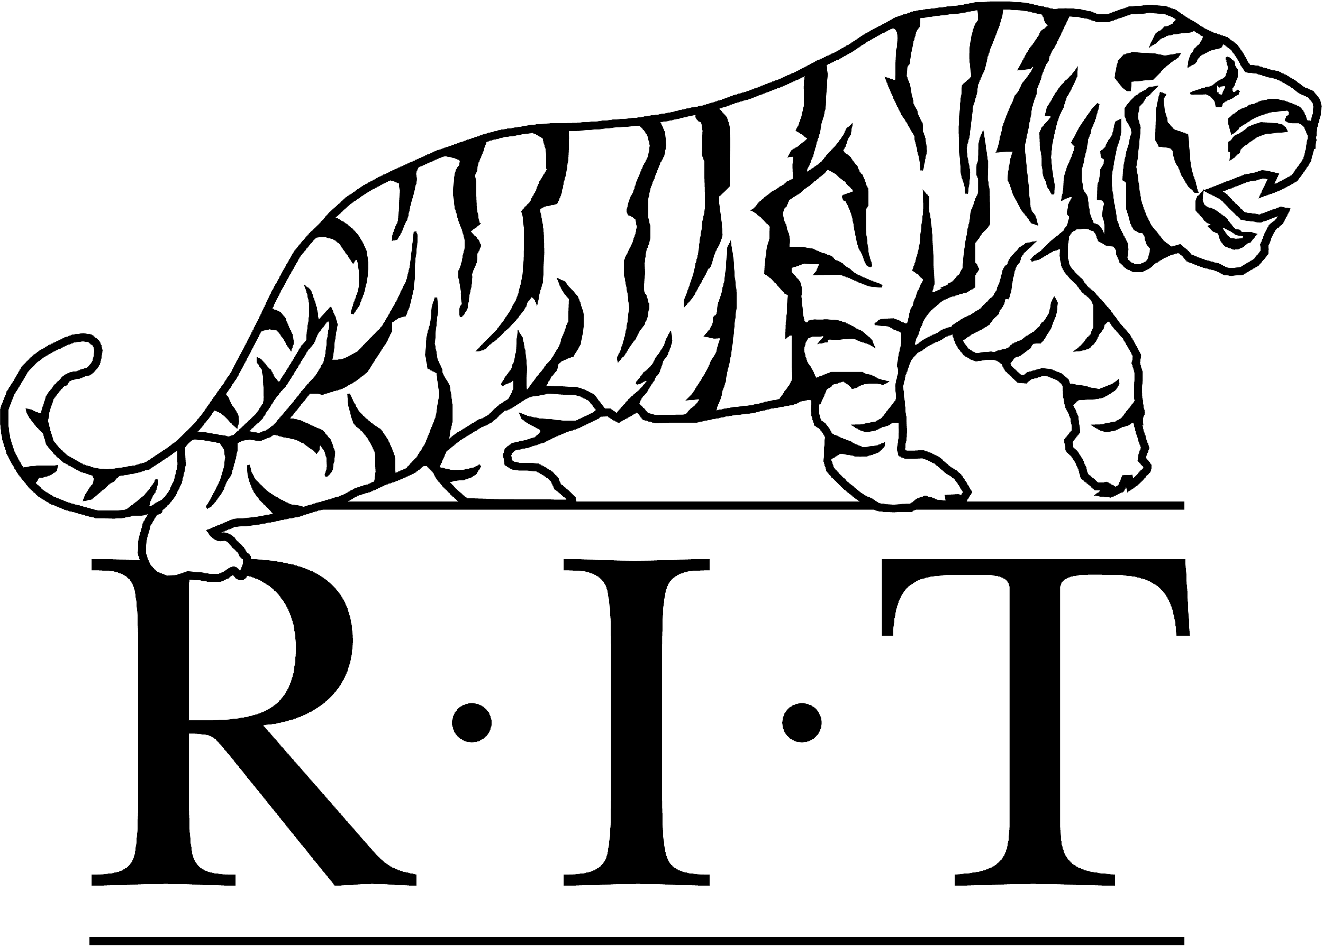    54 Lomb Memorial Drive, Rochester, NY 14623-5603
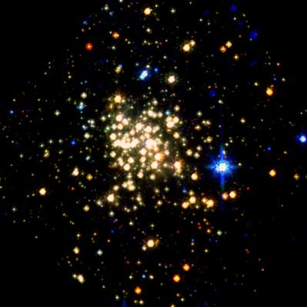  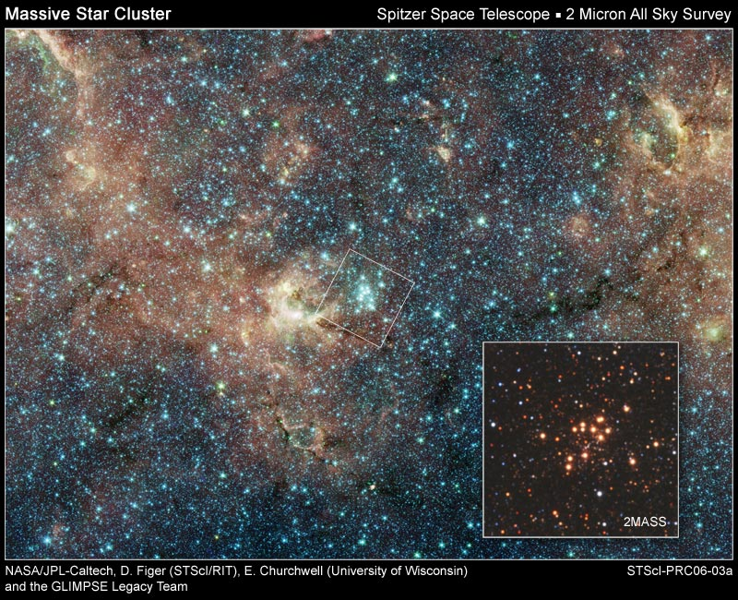  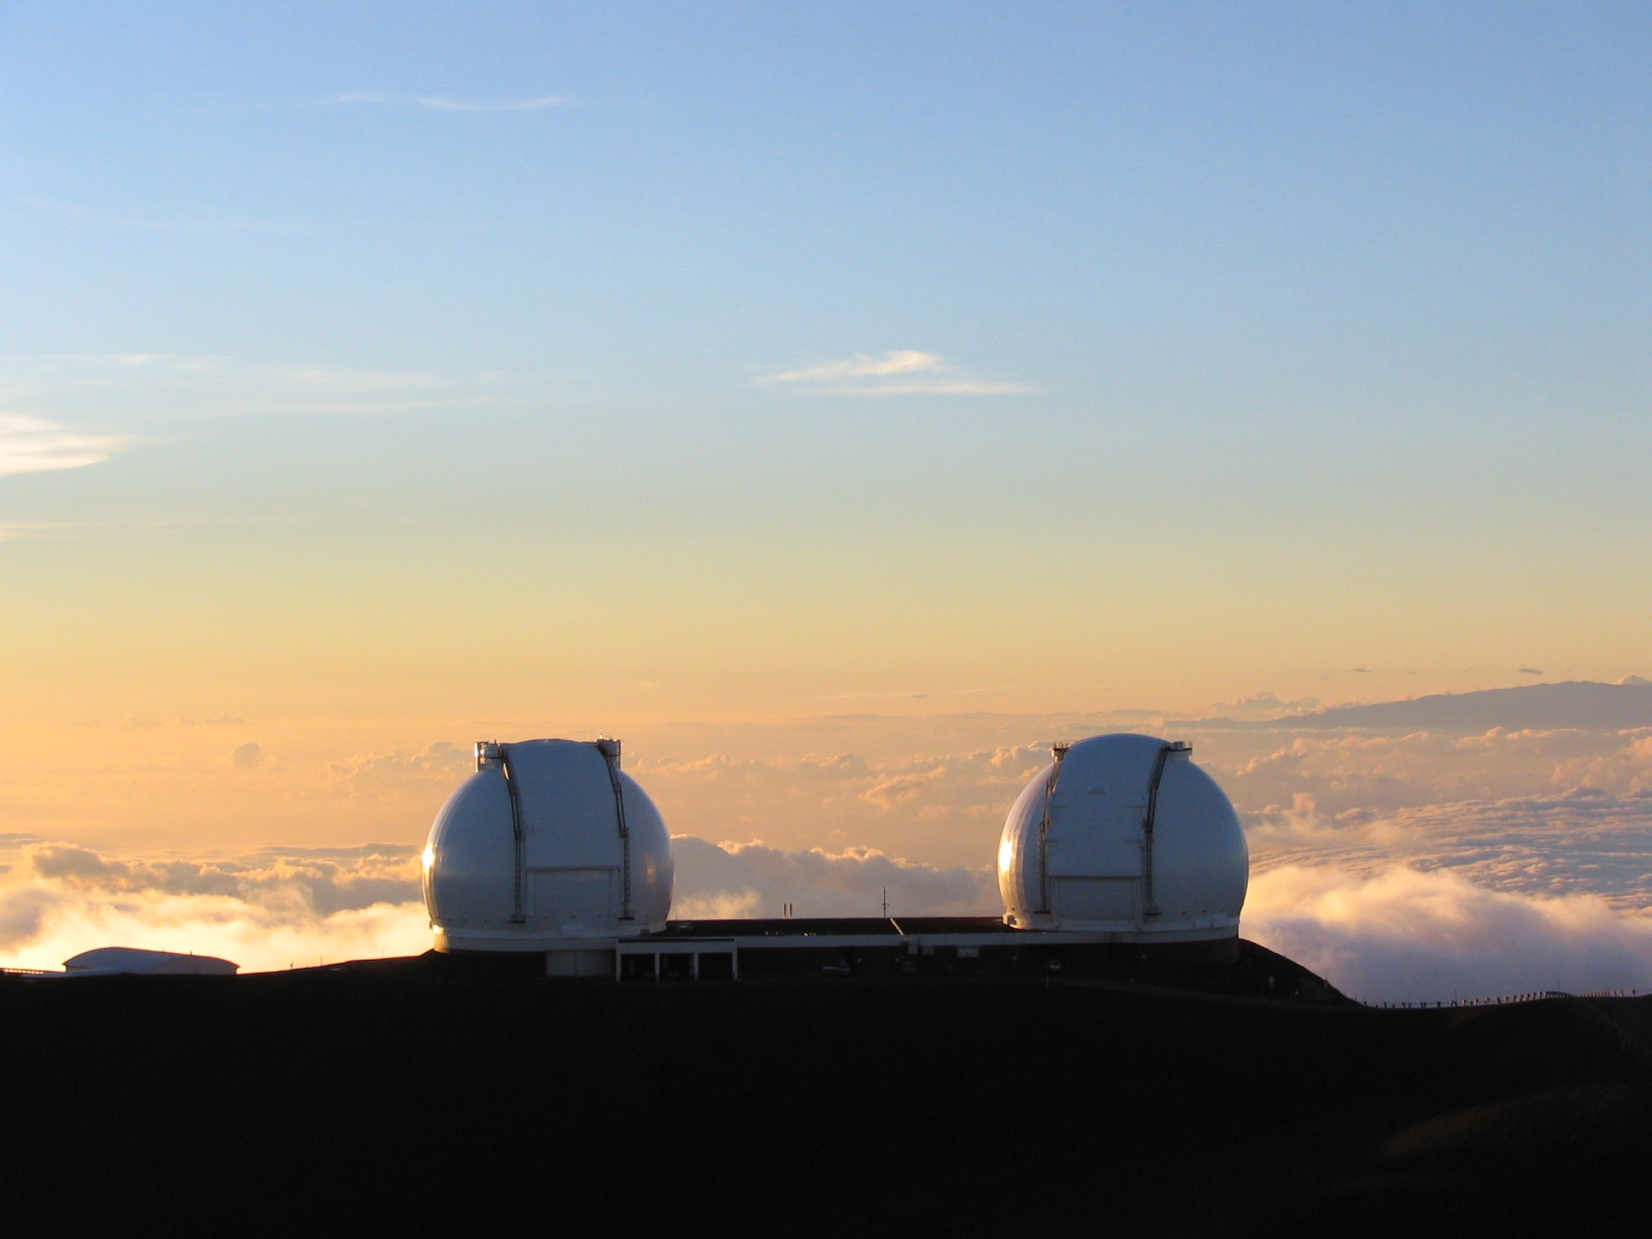  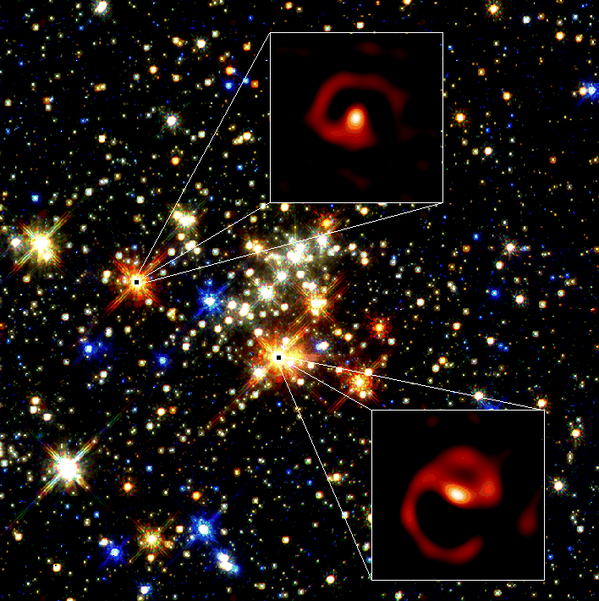  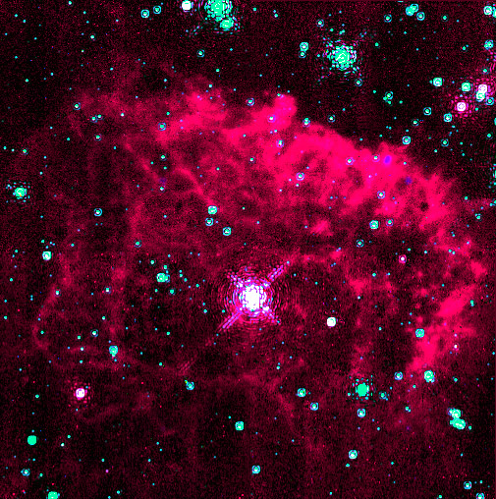 | Co-op/Internship or Part-Time Student work on firmware and camera interfacing at RIDL  The RIDL is an independent detector testing facility within the Center for Imaging Science. The RIDL was established to develop and advance new innovative detector technologies for astronomy and other fields. The lab pursues these goals by developing new cutting-edge detectors that utilize advanced CMOS readout circuitry (an activity sponsored by NASA).  The Co-op/Intern will support a graduate researcher in the development of camera interfacing firmware. The student will be expected to produce and modify/optimize VHDL code, set up a simple hardware interface from an infrared camera to an FPGA, interface the FPGA with a computer over parallel LVDS, and manipulate the image data for proper display.  Applicants must currently be pursuing a BS or MS degree. The successful candidate will have hands-on experience with FPGA programming, basic hardware interfacing and high-level software programming.  Inquires about this position may be directed to Dr. Donald F. Figer (figer@cis.rit.edu, Bldg.76-2246); you should include a cover letter and a resume.
 |  | 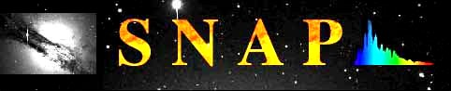 |  |  | 
http://ridl.cis.rit.edu

