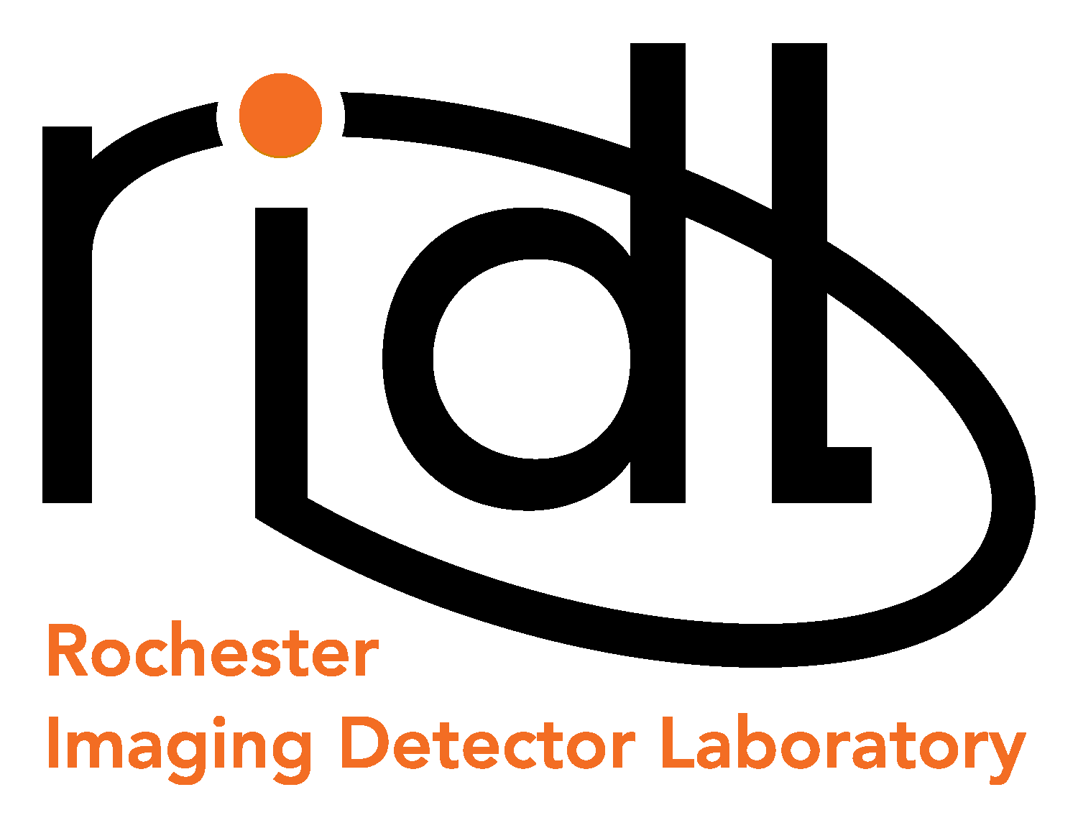 |     54 Lomb Memorial Drive, Rochester, NY 14623-5603
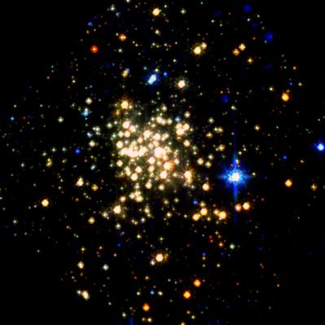  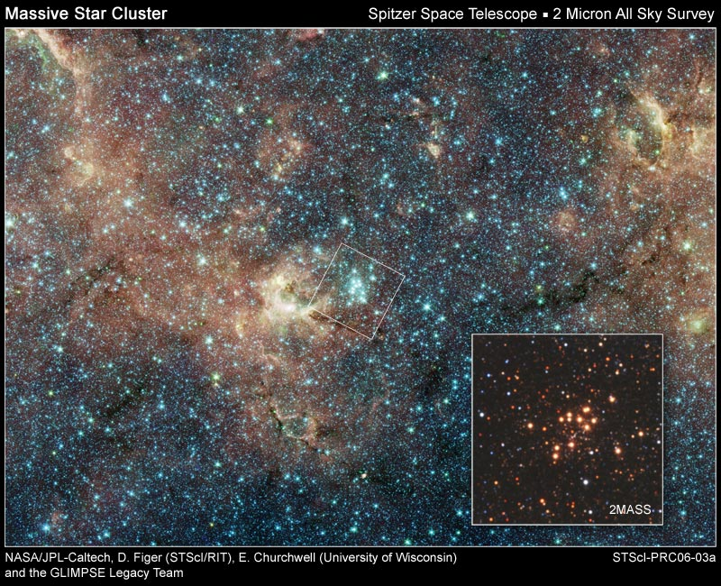    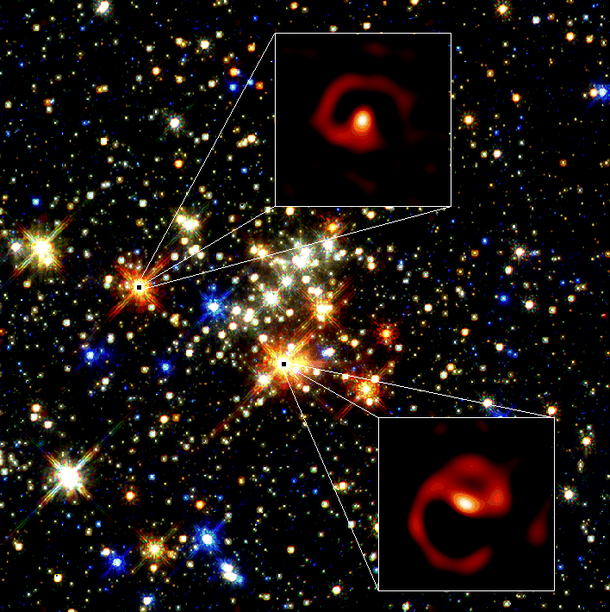  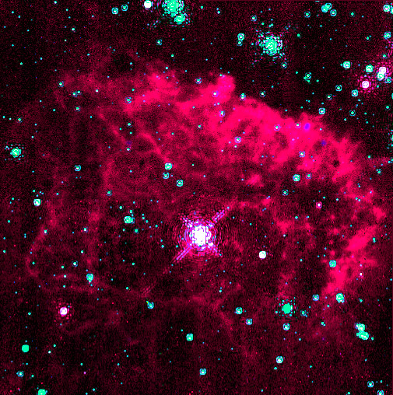 | Co-op/Internship in Advanced Imaging Detector Design and Fabrication  Imagine the following on your resume: “Member of the team that designed and fabricated a zero-noise detector for imaging applications.” This is only one of many cutting-edge projects that the Rochester Imaging Detector Laboratory (RIDL) is working on.  The RIDL is an independent detector testing facility within the Center for Imaging Science. The RIDL was established to develop and advance new innovative detector technologies for astronomy and other fields. The lab pursues these goals by developing new cutting-edge detectors that utilize advanced CMOS readout circuitry (an activity sponsored by NASA).  The Co-op/Intern will support a Post-doc in the design and fabrication of a novel imaging detector in a project carried out by engineers and scientists in the RIDL. The initial appointment will be for one quarter with possible renewals for a second term. Applicants must currently be pursuing a BS or MS degree. The successful candidate will have hands-on experience in clean room process flow and be skilled in utilizing SILVACO for process simulation and device modeling. Additional course work in mathematics, statistics, and computer programming, while not necessary, are also desirable.  Inquires about this position may be directed to Dr. Donald F. Figer (figer@cis.rit.edu, Bldg.76-2246); you should include a cover letter and a resume. Applicants should also provide names and contact information on three professional references. We also welcome inquires from Ph.D. candidates who are seeking dissertation research (stipend and tuition assistance is possible).
 |  | 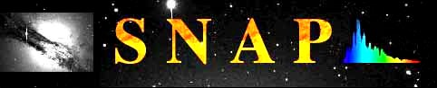 |  |  | 
http://ridl.cis.rit.edu

