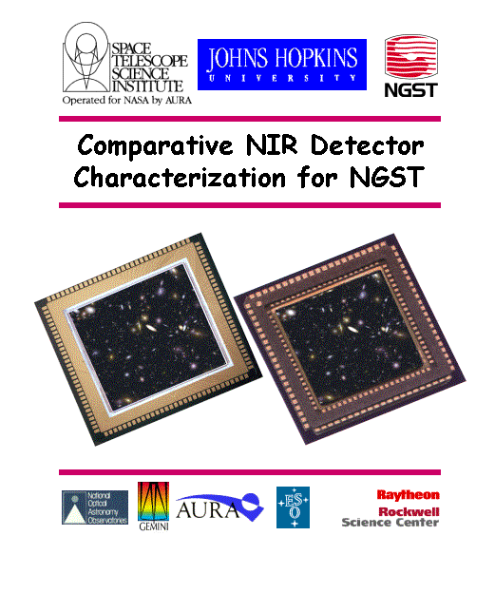
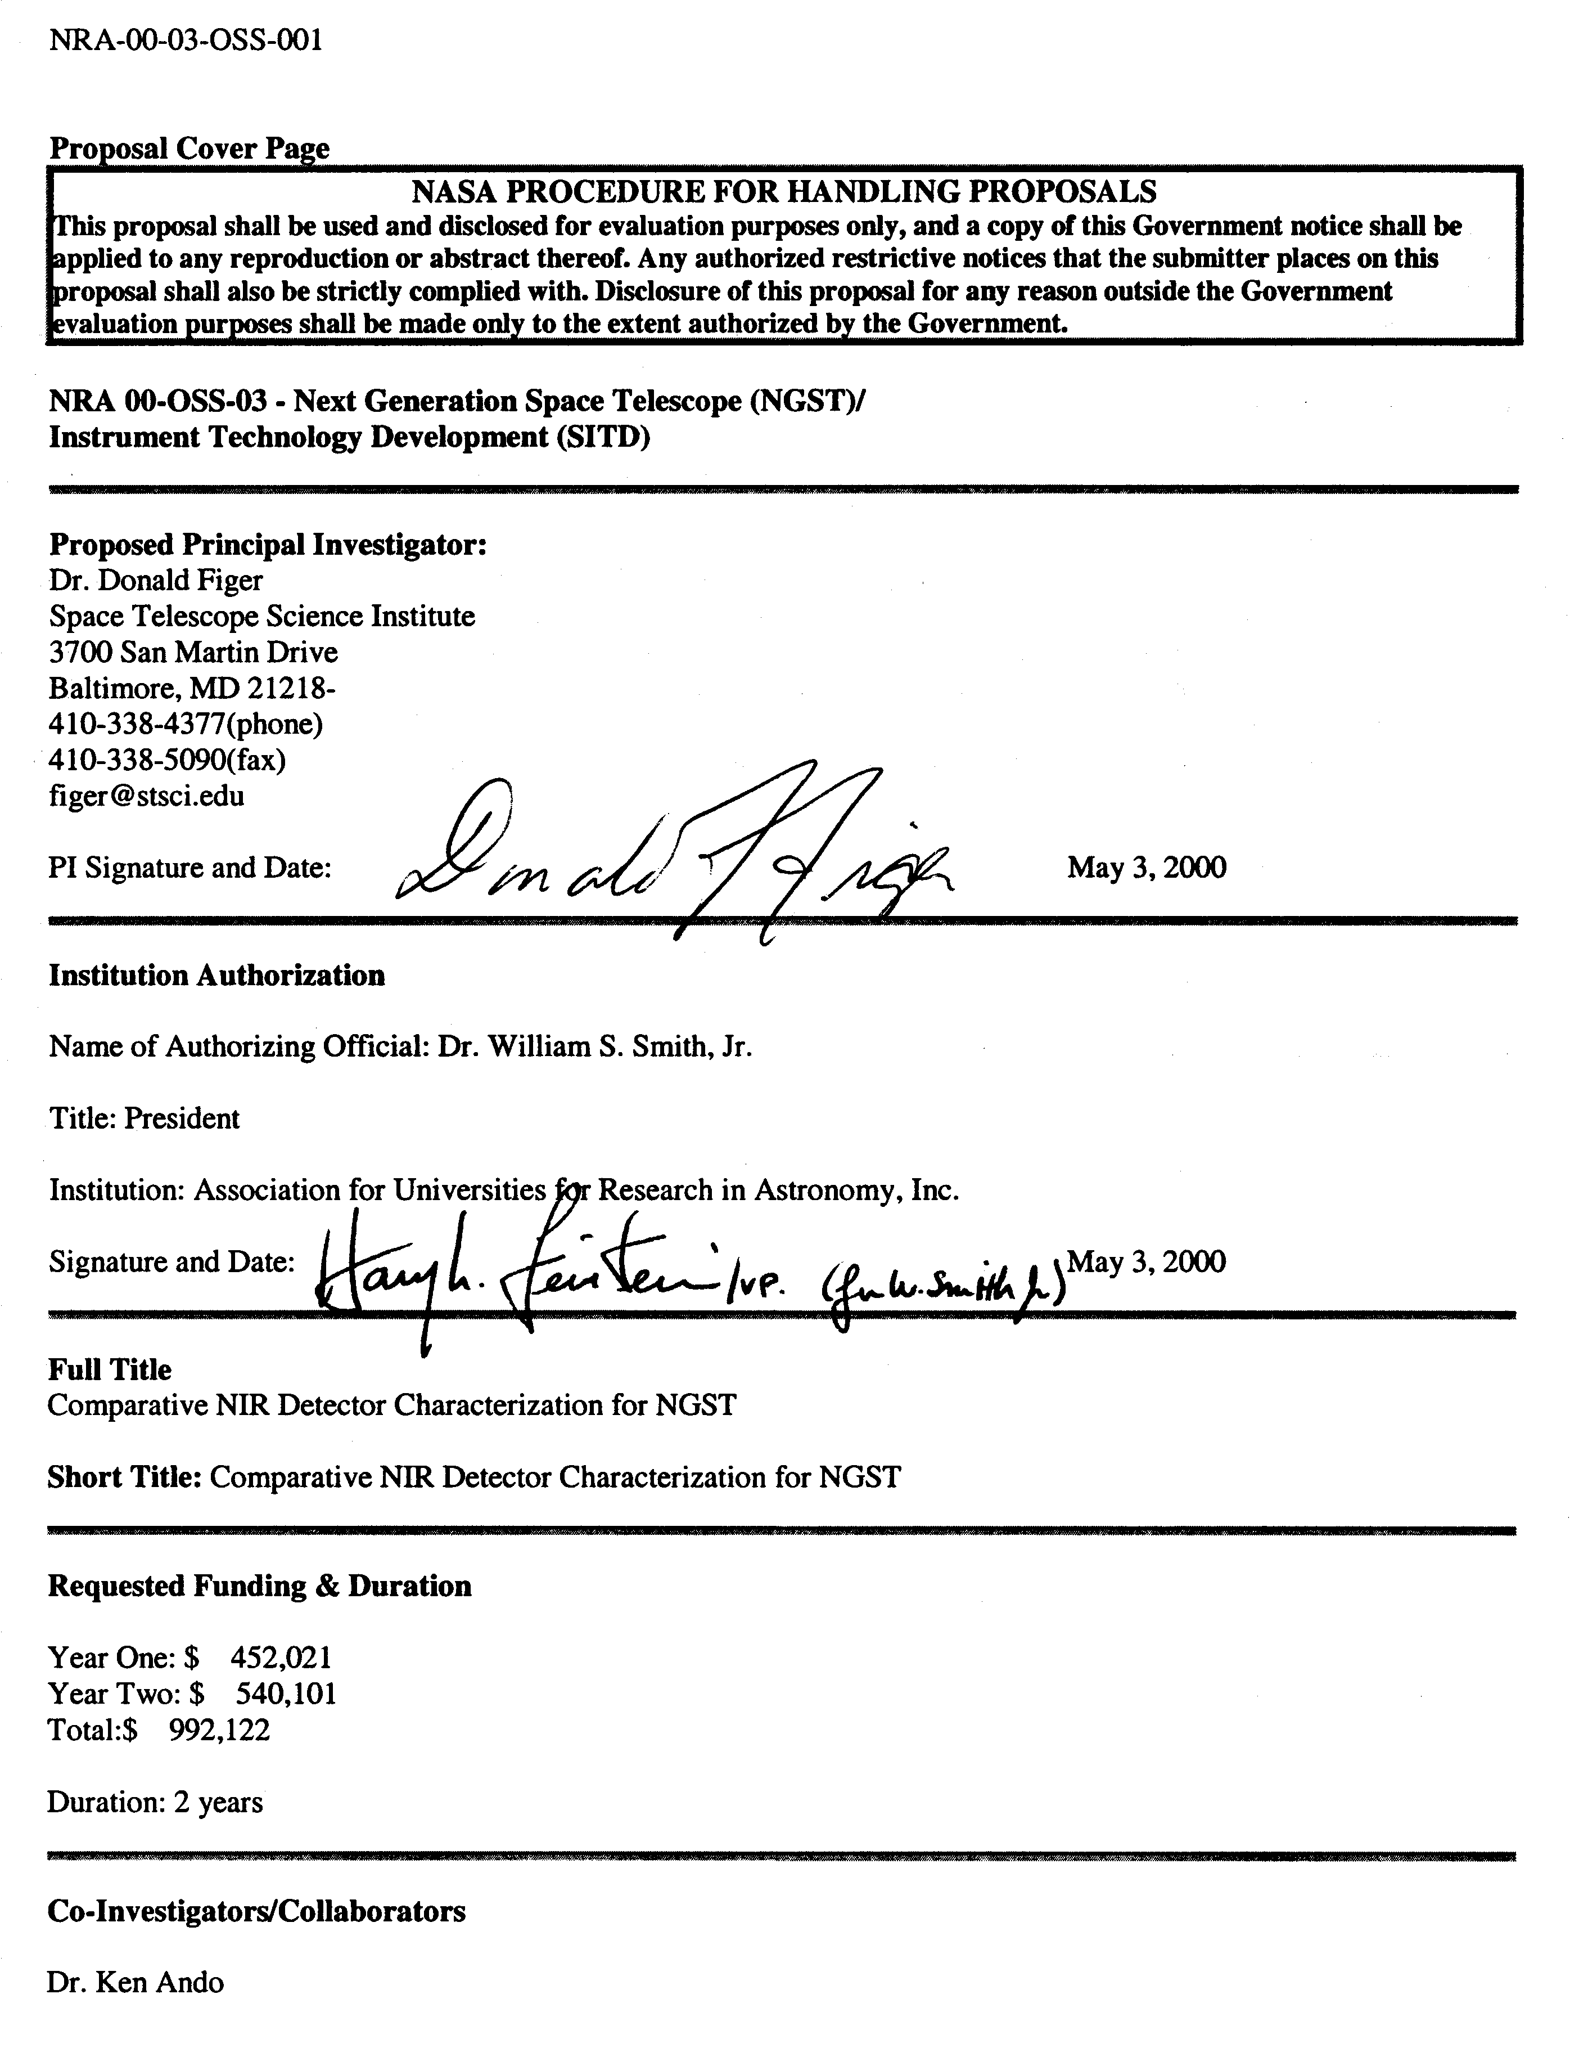
Co-Investigators/Collaborators

Dr. Ken Ando
-- Raytheon Systems Company
-- Collaborator
-- Email: kjando@west.raytheon.com
Dr. Kadri Vural
-- Rockwell International Corporation
-- Collaborator
-- Email: kvural@scimail.remnet.rockwell.com
Dr. Douglas A. Simons
-- Gemini Telescope Project
-- Collaborator
-- Email: dsimons@gemini.edu
Mr. Albert M. Fowler
-- National Optical Astronomy Observatories
-- Co-Investigator
-- Email: fowler@noao.edu
Dr. Gert Finger
-- European Southern Observatory
-- Co-Investigator
-- Email: gfinger@eso.org
Dr. Michael Regan
-- Space Telescope Science Institute
-- Co-Investigator
-- Email: mregan@stsci.edu
Dr. Knox S. Long
-- Space Telescope Science Institute
-- Co-Investigator
-- Email: long@stsci.edu
Dr. Hervey S. Stockman
-- Space Telescope Science Institute
-- Co-Investigator
-- Email: stockman@stsci.edu
Dr. Bernard Rauscher
-- Space Telescope Science Institute
-- Co-Investigator
-- Email: rauscher@stsci.edu
Dr. Stephan R. McCandliss
-- The Johns Hopkins University
-- Co-Investigator
-- Email: stephan@pha.jhu.edu
Dr. Karl Glazebrook
-- Johns Hopkins University
-- Co-Investigator
-- Email: kgb@pha.jhu.edu
Dr. Holland C. Ford
-- The Johns Hopkins University
-- Co-Investigator
-- Email: ford@pha.jhu.edu
Dr Jeffrey E. Van Cleve
-- Cornell University
-- Collaborator
-- Email: vancleve@astrosun.tn.cornell.edu

NASA Grant or Contract Number of any current NASA award that the PI holds that is a logical predecessor of the newly proposed work
Type of Proposing Institution: Nonprofit, nonacademic

Scope of Proposal: Characterization/operation of detectors

Education Component Included? No
Requested Education Funding:
Year One: $ 0
Year Two: $ 0
Total Education Funding: $ 0

Proposal Summary (Abstract)
This is a proposal to assist the NGST Project in selecting the best near-infrared (NIR) detectors for the NGST. We will characterize competing HgCdTe and InSb technologies in NGST-like operating environments, obtaining test data relevant to the success of the NGST science program. We will measure first-order detector properties (read noise, dark current, persistence, quantum efficiency, etc.) as functions of environmental parameters (radiation exposure, thermal conditions, operating modes) for both detector types, using the same procedures, setups, dewars, light sources, targets, electronics, acquisition software, analysis software, and staff. We will publish these data and use them in an "optimal use" study to determine the best way to operate either technology, given the cost and system requirements for NGST. Our results will enable critical assessment of detector performance in a simulated NGST environment, advancing a crucial technology through the NGST development program. All aspects of this work will be public, including test procedures, intermediate and final data, and will be made available to the NGST Project, other detector testing groups, instrument designers, and future NASA missions related to the Origins theme program. Our team has extensive experience in characterizing and operating NIR detectors, designing near-infrared space missions, operating observatories, building ground-based near-infrared instruments, and includes recognized pioneers in detector research and development. Several team members will go on to be part of the NGST operations team, thus ensuring that the lessons learned during detector testing will be transferred to successful mission operations. The effort extends over 2 years, and the requested funding is $992K. The proposal offers considerable cost sharing ($347K), and does not request substantial funds for hardware. Given the expected NIR detector flight procurement budget of >$40M, this proposal requests a prudent investment to help ensure a successful NGST.
Certification of Compliance with Applicable Executive Orders and U.S. Code
By signing and submitting the proposal identified in this Cover Sheet/Proposal Summary, the Authorizing Official of the proposing institution, as identified above (or the individual proposer if there is no proposing institution):
1. certifies that the statements made in this proposal are true and complete to the best of his/her knowledge;
2. agrees to accept the obligations to comply with NASA award terms and conditions if an award is made as a result of this proposal;
3. provides certification to the following that are reproduced in their entirety in this NRA: (i) Certification Regarding Debarment, Suspension, and Other Responsibility Matters; (ii) Certification Regarding Lobbying, and (iii) Certification of Compliance with the NASA Regulations Pursuant to Nondiscrimination in Federally Assisted Programs.

Confidentiality Statement

Data contained in the attached proposal constitutes information that is technical, confidential, and privileged. It is furnished to NASA in confidence with the understanding that it will not, without permission of AURA/ST ScI, be used or disclosed for other than evaluation purposes; provided, however, that if a grant, cooperative agreement, or contract is awarded by NASA as a result of or in connection with the submission of this proposal, NASA shall have the right to use or disclose this data only to the extent provided in the resultant grant, cooperative agreement, or contract. This restriction does not limit NASA's right to use or disclose any data obtained from another source without restriction.

Table of Contents
1.0 Abstract 1
2.0 A Detector Testing Program to Deliver the Promise of NGST 1
2.1 NIR Detectors Are Key to A Successful NGST Mission 1
2.2 The IDTL Serves NGST 3
2.3 The IDTL Provides Independent Detector Testing for NGST 5
2.4 Comparative Detector Testing is Needed for NGST 5
2.4.1 Experiments 6
2.4.2 Dark Current 6
2.4.3 Read Noise, Gain, and Linearity 7
2.4.4 Latent Charge 8
2.4.5 Absolute Quantum Efficiency 10
2.4.6 MTF and Intra-pixel Sensitivity 10
2.4.7 Environmental Effects Will Dominate Science Performance 11
2.4.8 Optimal Use Study - How Would Either Detector Be Operated for NGST? 13
2.5 The IDTL Effort Enables Future NASA Origins Missions 14
2.6 The IDTL Delivers Public Products 14
2.7 Work Plan and Management Approach 14
3.0 References 16
4.0 Facilities and Equipment 18
5.0 CV 20
5.1 Donald F. Figer, STScI/JHU 20
5.2 Hervey S. Stockman, STScI 23
5.3 Bernard J. Rauscher, STScI 24
5.4 Michael W. Regan, STScI 25
5.5 Knox S. Long, STScI/JHU 26
5.6 Holland Ford, JHU/STScI 27
5.7 Karl Glazebrook, JHU 28
5.8 Stephan R. McCandliss, JHU 29
5.9 Albert M. Fowler, NOAO 30
5.10 Gert Finger, ESO 31
5.11 Jeffrey Van Cleve, Cornell University 32
6.0 Current and Pending Support 33
7.0 Statements of Commitment from Co-I's and/or Collaborators 36
8.0 Research Budget Summary and Details 50

Summary of Personnel, Commitments, and Costs

Name | Commitment  to Project | Year 1  Time | Year 1  Unburdened Salary | Year 2  Time | Year 2  Unburdened Salary
Donald F. Figer, STScI/JHU | PI - Overall responsibility | 0.60ª |  | 0.60ª
Hervey S. Stockman, STScI | Co-I - Optimal use study lead | 0.10 | NC^{b} | 0.10 | NC
Knox S. Long, STScI/JHU | Co-I - Project Manager | 0.10 | NC | 0.10 | NC
Bernard J. Rauscher, STScI | Co-I - Project Scientist | 0.10 |  | 0.10
Michael W. Regan, STScI | Co-I - Test Scientist, data acquisition software | 0.30 |  | 0.30
Holland Ford, JHU/STScI | Co-I - Radiation test lead, JHU oversight | 0.10^{c} |  | 0.10^{c}
Karl Glazebrook. JHU | Co-I - Science advisor | 0.10^{c} |  | 0.10^{c}
Stephen R. McCandliss, JHU | Co-I - Calibration Scientist | 0.20^{c} |  | 0.20^{c}
Gert Finger, ESO | Co-I - HgCdTe verification testing, test protocols | 0.10 | NC | 0.10 | NC
Albert Fowler, NOAO | Co-I - InSb test protocols & electronics | 0.10 |  | 0.10
Doug Simmons, Gemini | Collaborator - InSb verification testing, test protocols | < 0.01 | NC | < 0.01 | NC
Jeffrey van Cleve, Cornell | Collaborator - Radiation testing advisor | < 0.01 | NC | < 0.01 | NC
Kadri Vural, Rockwell | Collaborator - HgCdTe dectectors & expertise | < 0.01 | NC | < 0.01 | NC
Ken Ando, Raytheon | Collaborator - InSb detectors & expertise | < 0.01 | NC | < 0.01 | NC
OTHER:
Technician | Data acquisition software, electronics | 0.50^{c} |  | 0.50^{c} | $13K
Post-doc | Data analysis software | 0.50 |  | 0.50
Data Analyst | Date analysis | 0.50 |  | 1.00
Graduate Student | Test setups | 1.00 |  | 1.00
Graduate Student | Data analysis | 1.00 |  | 1.00
Instrument Test Scientist | Radiation test scientist | 0.10 |  | 0.30
ªPI Figer is charging 40% to proposal, however commitment to project is 60%.
^{b}No charge to proposal.
^{c}These commitments are charged to the proposal at 50% of shown level (remaining 50% is cost sharing).
Comparative NIR Detector Characterization for NGST

1.0 Abstract
This is a proposal to assist the NGST Project in selecting the best near-infrared (NIR) detectors for the NGST. We will characterize competing HgCdTe and InSb technologies in NGST-like operating environments, obtaining test data relevant to the success of the NGST science program. We will measure first-order detector properties (read noise, dark current, persistence, quantum efficiency, etc.) as functions of environmental parameters (radiation exposure, thermal conditions, operating modes) for both detector types, using the same procedures, setups, dewars, light sources, targets, electronics, acquisition software, analysis software, and staff. We will publish these data and use them in an “optimal use” study to determine the best way to operate either technology, given the cost and system requirements for NGST. Our results will enable critical assessment of detector performance in a simulated NGST environment, advancing a crucial technology through the NGST development program. All aspects of this work will be public, including test procedures, intermediate and final data, and will be made available to the NGST Project, other detector testing groups, instrument designers, and future NASA missions related to the Origins theme program. Our team has extensive experience in characterizing and operating NIR detectors, designing near-infrared space missions, operating observatories, building ground-based near-infrared instruments, and includes recognized pioneers in detector research and development. Several team members will go on to be part of the NGST operations team, thus ensuring that the lessons learned during detector testing will be transferred to successful mission operations. The effort extends over 2 years, and the requested funding is $992K. The proposal offers considerable cost sharing ($347K), and does not request substantial funds for hardware. Given the expected NIR detector flight procurement budget of >$40M, this proposal requests a prudent investment to help ensure a successful NGST.

2.0 A Detector Testing Program to Deliver the Promise of NGST

2.1 NIR Detectors Are Key to A Successful NGST Mission
The Next Generation Space Telescope (NGST) is the centerpiece of the NASA Office of Space Science (OSS) theme: the Astronomical Search for Origins. The core NGST program to study the origins and evolution of galaxies was recommended by the “HST & Beyond” committee in 1996. The NGST will need to have the sensitivity to see the first light in the Universe to determine how galaxies formed in the web of dark matter that existed when the Universe was in its infancy (z ~10-20). To achieve this, the NGST is being designed as a cold (<40 K) 8-m class telescope located near L2 and optimized for the 1-5 μm waveband. Its goal is to detect sources as faint as magnitude 33 (<one photon per second at the detector), to fully exploit its potential.
The NGST Ad-hoc Science Working Group has encapsulated the scientific goals of NGST into a set of 27 programs requiring ~1/2 of NGST’s design lifetime of 5 years to execute. Approximately 60% of the time, and five of the seven highest priority programs, in the DRM utilize NIR detectors. The reason for the dominance of the NIR for studying the origins of galaxies and stars is straightforward to explain since their light is redshifted to the IR by cosmological expansion. A natural limitation to such observations is presented by sunlight scattered by and thermal emission from interplanetary (zodiacal) dust in the Solar System (See Figure 1). Fortunately, the surface brightness of the foreground emission of that dust is least in the 1–4 μm range, a range in which the apparent spectral energy distributions of high-z (z~1–10) galaxies are maximum. Both imaging and spectroscopic observations are required in the NIR, and as a result, two of the three instruments recommended by the ASWG for the NGST are a wide-field NIR imager (4×4, R=5) and a NIR multiobject spectrograph (3×3, R=100–1000). In addition, NIR detectors will be the primary sensors for guiding and establishing/maintaining the wave front performance of the telescope. For all these reasons, although there are a number of critical technologies required for NGST, none is more crucial than the successful development of very sensitive NIR detectors.
There are two basic challenges associated with the NGST detectors. First, to achieve NGST’s planned sensitivity limit, detector manufacturers must produce detectors that are more sensitive than those flown on previous missions. As illustrated in Figure 1 (left), the total noise resulting from dark current and read noise must be extremely low to assure that NGST imaging is zodiacal light limited. Indeed, the detector will be the dominant noise source for spectroscopy of faint sources, even if we assume optimistic goals for read noise (3 e⁻) and dark current (0.02 e⁻/s). By comparison, the NICMOS HgCdTe detectors on the Hubble Space Telescope have minimum read noise of 18 e⁻ (25 samples, up-the-ramp) and dark current ~0.05 e⁻/s, while SIRTF InSb detectors are expected to exhibit a minimum read noise of 10 e⁻ (64 samples, Fowler sampling) and dark current <1 e⁻/s. The achieved detector performance will translate directly into the time required to complete the DRM. For example as shown in Figure 1 (right), the time required to execute the imaging and spectroscopic portions of the DRM (and any General Observer Science) is directly related to basic detector properties like dark current and read noise. Second, to provide appropriate spatial sampling for the NIR camera and spectrograph, detector manufacturers must produce many more detectors than have ever been produced before. Indeed, the current reference instrument complement on NGST requires ~80 Megapixels, in comparison to 0.2 Megapixels and 0.13 Megapixels in the NICMOS and SIRTF NIR detectors, respectively.
Figure 1. NGST needs low noise detectors. (Left) Background rates as a function of wavelength from zodiacal light, and thermal emission and scattered light from the primary and secondary mirrors. (Right) Time required to complete NIR portion of NGST DRM Science versus read noise.
NASA has recognized these challenges and is conducting an aggressive technology development program with the two primary NIR detector manufacturers, Raytheon and Rockwell, and their respective university partners, the University of Rochester/NOAO (InSb) and the University of Hawaii (HgCdTe). Both technologies show promise for NGST. For instance, InSb detectors have benefited as the choice for many ground-based instruments and SIRTF. Consequently, they have demonstrated some of the requirements for the NGST, specifically moderately high quantum efficiency (QE) over the 1-5 μm band, read noise < 10 e⁻ for multiple samples and dark current <0.1 e⁻/s. Most of the existing experience for HgCdTe is based on devices with a long wavelength cutoff of 2.5 μm. Recently, Rockwell and the University of Hawaii have demonstrated devices with cutoffs of 4.7 μm, as large as 4 Megapixels, and with dark currents <0.01 e⁻/s, although no single device exhibits all these properties over the required fraction of an array. The development of these two detector technologies is expected to continue with the goal of “prototype demonstration in a relevant environment” (Technology Readiness Level of 6) in advance of the detector down-selection and the NGST Non-Advocate Review (~2003 according to this NRA); note that to achieve TRL6, the detectors must be shown to achieve the required performance, given an L2 radiation environment over the life of the mission. Based on the results of this development, NASA expects to procure the NGST flight detectors.
Achieving these goals with current detectors, or detectors being designed is not assured, as can be seen in the “Status” column of Table 1. Indeed the status numbers only pertain to some unspecified fraction of pixels on any given array, and several of the numbers have only been demonstrated for a single array. In addition, the data were not obtained in comparative test setups. Finally, some of the detector properties are simply not known well. Clearly, a new generation of detectors will be required that meet the NGST requirements, and new independent testing is needed to measure their performance in a systematic, comparative way.
While noise and QE are the key characteristics of the NIR detectors, it will be necessary to procure detectors that minimize other undesirable characteristics to achieve the NGST’s ambitious goals in a cost-constrained mission. Sensitivity to cosmic rays, persistence of bright images and cosmic rays, and temperature sensitivity of bias and noise are examples of such undesirable characteristics. Figure 2 shows these and other examples that have been critical for the HST/NICMOS (Bergeron et al. 1999; Böker et al. 1999; Böker et al. 2000). These effects both reduce data quality and increase the effort required to calibrate and to use the detector. As demonstrated by experience at STScI in operating the NICMOS-3 detectors on-orbit, a vigorous ground-testing program could have identified important deficiencies before launch. This would have translated into greater scientific productivity and reduced operations costs.
The purpose of this proposal is to provide the comparative detector characterization needed to allow the NGST Project and the instrument developers to select the best NIR detector technology for the NGST. The right choice is critically important, not only because it will determine the ultimate scientific performance of NGST, but also because it will greatly enhance the probability that NGST can meet its goals within the overall cost cap of the mission. We have assembled an expert team from around the world to perform the work described in this proposal, including scientists and engineers from STScI, JHU, ESO, NOAO, Gemini, Rockwell, and Raytheon. This team has over 100 years of combined expertise in designing, characterizing, and using NIR array detectors, for a variety of ground-based and space-based platforms, including the NGST. An important objective for the proposed effort is to bring together this expertise in service of the NGST mission so that the most competent, sophisticated, and revealing comparative testing is done and reported to everyone in the NGST community.
Table 1: NIR Detector Requirementsª
Parameter | Requirement | Goal | Status^{b}
Parameter | Requirement | Goal | InSb | HgCdTe
System Noise per image^{c} | 10 e⁻ RMS | 3 e⁻ RMS | 10.8 e⁻ RMS | 6.7 e⁻ RMS
Read Noise^{d} (n_{Fowler}≤16) | ~7 e⁻ RMS | ~2.1 e⁻ RMS | 10.6 e⁻ RMS | 4.6 e⁻ RMS
Dark Current^{e} | ~0.05 e⁻/s | ~0.005 e⁻/s | 0.004 e⁻/s | 0.02 e⁻/s
QE | >80% | 95% | >80% | ~74%^{f}
Latent Image | ∼0.1% | 0 | <0.5% | <0.5 %
Fill Factor | >95% | 100% | >98 | >98%
Radiation Immunity | minimal effect | no effect | minimal | unknown
Frame Time | <12 s | <12 s | <12s | <12 s
MTF | TBD | TBD | Ill-defined | Ill-defined
ªAdapted from NGST Detector Requirements Panel report (McCreight et al. 1999).
^{b}Also from “Recommendations of the NGST Detector Requirements Panel.” Red indicates value does not satisfy requirement, black indicates value is between requirement and goal, green indicates value meets goal. Note that the status values have not been achieved by the required number of pixels on any single array at the full wavelength range for NGST.
^{c}Quadrature sum of contributions from read noise, shot noise from dark current, shot noise from glow, 1/f, timing fluctuations, temperature drifts, and temperature gradients across the array, etc., for a 1000 second exposure.
^{d}Assumes that read noise contributes ½ of the system noise and Fowler sampling with 16 samples. Note this number of Fowler samples leads to a 19% overhead just from the reading, thus consuming 2/3 of the total allowable overhead for all of NGST.
^{e}Assumes that the dark current contributes ½ of the system noise.
^{f}Measured over the wavelength range of 1.3 – 4.7 μm.

2.2 The IDTL Serves NGST
Our objectives are to characterize the two competing near-infrared detector types in the parameters indicated in Table 1 as a function of relevant operating conditions using the same procedures, setups, dewars, light sources, targets, electronics, acquisition software, analysis software, and staff. This effort is necessary because high quality devices are required to take advantage of the very low background levels of the NGST. By operating the detectors in low-background conditions that resemble those at L2, we will measure the required data at a time when one must make critical design tradeoffs to minimize mission cost. In studying the performance of the detectors using various readout approaches, i.e Fowler sampling, up-the-ramp sampling, differential sampling, off-chip cryogenic amplification, etc., we will identify the approach that yields the best system performance. In addition, we will determine the operational problems that attend the various read modes, including sensitivity to environmental effects, such as a harsh radiation environment and temperature variations induced by the readout approach.
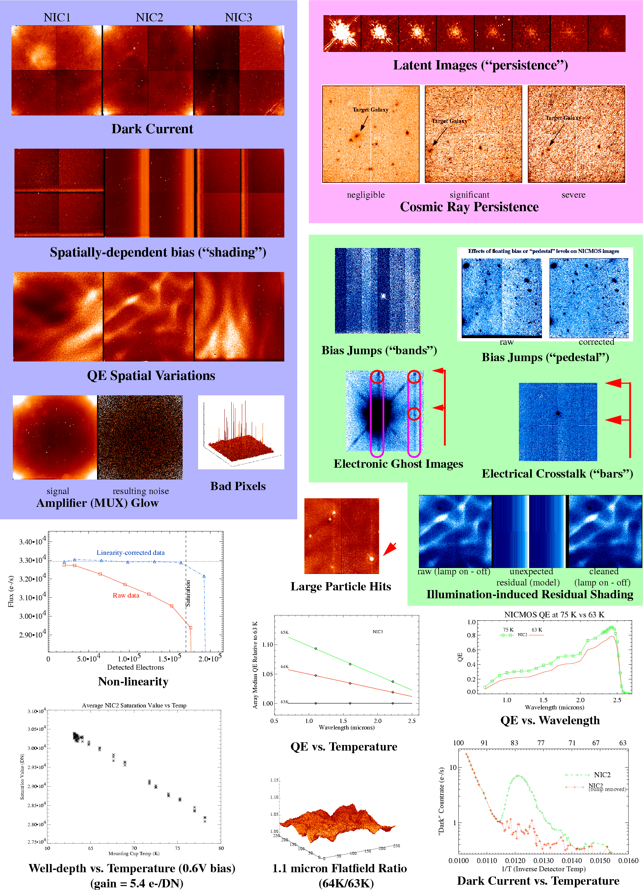
Figure 2. STScI experience with NICMOS shows that many detector noise sources could limit DRM science.
A “public” test facility, without strong ties to, but with the cooperation and involvement of the two major vendors, is important to ensure that test results are unbiased and accepted by the NGST community because only one basic NIR detector technology will be incorporated into the NGST. In recognition of the need for such a facility, STScI/JHU will establish the Independent Detector Testing Laboratory (IDTL), with strong encouragement by both Raytheon and Rockwell (see attached letters). The manufacturers will provide engineering grade NGST detectors to the IDTL, with anticipated delivery before the onset of any funding resulting from this NRA. In addition, they will work with us as collaborators on the proposed effort, ensuring that the protocols and operational procedures provide optimal comparisons between the two systems. In operating the IDTL, we will develop and publish a set of standardized characterization protocols and make available detailed descriptions of the test setups. Our effort will help lay the groundwork for the high volume testing to be done during the manufacturing stages of the NGST Project.

2.3 The IDTL Provides Independent Detector Testing for NGST
The proposed testing complements technology-focussed work being done elsewhere by the University of Hawaii and Rockwell to develop HgCdTe detectors, and the University of Rochester and Raytheon to develop InSb arrays. Several other groups have participated in detector testing without a formal association with the NGST Project. Among these, Co-I Fowler is a recognized leader for his role in designing and characterizing the InSb ALADDIN array (Fowler et al. 1996). Likewise, Co-I Finger has led the ESO group in comparative characterization of both potential NGST NIR detectors (Finger et al. 1999, 2000). As a result, both InSb and HgCdTe detectors have made great strides in recent years (see e.g. Table 1; Hall et al. 2000; Ando et al. 2000; Finger et al. 2000).
The NICMOS on HST has provided a wealth of practical experience in operating NIR arrays in space. As a result, the STScI team is best prepared to assess how array parameters measured in the lab will effect NGST’s performance at L2. This NICMOS experience has allowed us to measure the major detector characteristics as functions of operational parameters and quantify some properties, such as pedestal drift, that were much more important in low-background on-orbit conditions than in comparatively high-background ground-based applications. Our work will extend that done by the Hawaii and Rochester groups and by our Co-investigator organizations by independently assessing both detector types in similar setups, with public results (data, test setups, procedures). In addition, this testing will be specifically geared toward determining the optimal use of either detector type in an NGST environment (low background, low signal, high cosmic ray flux). We will particularly assess the impact of the NGST radiation environment on operating the candidate detectors. The data we produce will be accessible via the web and DVD up until launch, so that instrument developers, the NEXUS Project, and the NGST Project will have measured data to use in the detector down-select process and in simulations. Full test descriptions will accompany the data, thus enhancing their usability. The “optimal use” study could be used to assist the electronics and systems designers to choose designs that maximize the performance of the chosen detector technology. The test procedures and protocols developed will assist the project in performing the high volume array testing program. In addition, our effort will assist the Project in implementing the system to obtain, calibrate, and archive data from the NGST, an effort to be led by the STScI. Having STScI involved in this type of testing, at an early enough time before launch, is a major benefit of our proposal. In addition to these benefits for the NGST, our open approach will benefit ground-based astronomy (see attached letters from Gemini Telescope Project and ESO) in selecting and operating the latest array technologies and detector systems for the low-background operations made feasible by diffraction-limited adaptive optics imaging systems and high resolution spectrometers.

2.4 Comparative Detector Testing is Needed for NGST
InSb and HgCdTe detectors will be tested in an NGST-like low-background environment, using similar test procedures, to measure dark current, read noise, persistence, absolute QE, MTF, and short- and long-term radiation effects. Both detectors will be characterized in similar ways, although the controller voltage levels, clock patterns, and operating temperatures will be individually optimized, as guided by our own findings and those of our collaborators at Rockwell Science Center and Raytheon Systems Company. Aside from these operational differences, the setups will be identical, i.e the same dewars, light sources, targets, electronics, acquisition software, and analysis software. The setups will initially be customized for the HAWAII-1R and ALADDIN III multiplexers, although future designs will be accommodated. Engineering grade devices will be delivered directly to our laboratory from the manufacturers. These devices will be used to verify our electronics, software, dewars, and test procedures. Science grade devices will be delivered to us by the NGST project around July, 2001. The tests will be carried out in laboratory space at JHU that is being instrumented for IR detector characterization by JHU and the STScI. We are acquiring an IR array controller, test dewars and vacuum/cryogenic equipment using funds that are already available to us. We will use a Leach II controller (IR Labs/Astronomical Research Cameras, Inc.), electronics which several of us have used in the past. The ability of this controller to operate both HgCdTe and InSb arrays will be verified before delivery by the manufacturer (see attached letter from Astronomical Research Cameras, Inc.). We are procuring two dewars, based on the IRATEC design (see Figure 3), which are well suited to the calibration of NGST. JHU will be supplying much of the necessary infrastructure, including clean benches, vacuum equipment, and optical tables, for the proposed activity. Detailed descriptions for the individual tests are given below. We envision that each experiment would be repeated three times during the initial phase to verify the performance of our lab. For the final phase (see section on Work Plan and Management), the tests will be repeated twice for each of the two detector types; these tests will be repeated by our Co-Is at ESO (HgCdTe) and NOAO/Gemini (InSb).

2.4.1 Experiments
Figure 3. IRATEC dewar.
A general setup will serve the proposed experiments with little modification between experiments. Blackbody and monochromator sources are placed outside the dewar upstream from the warm focal plane targets. The pinhole target is controlled by a 3-axis motorized stage. There is a cold mechanism (employing a cold motor) just in front of the detector that contains a lens for the MTF experiments, filters, and a cold blank for the dark current and latent charge tests. The detector head will be outfitted to accommodate a cover plate, if necessary, for the dark current tests. There is also an open position used for the absolute QE experiment.

2.4.2 Dark Current
Dark current is the signal that accumulates linearly in the absence of any light source. In an ideal detector diode, the most important contributors to dark current include charge diffusion, thermal generation-recombination of charges within the semiconductor, and small leakage currents (McLean 1997). Diffusion should be negligible for the operating temperature of NGST. Instead, most of the dark current will arise from thermal generation-recombination which decreases exponentially with decreasing temperature.
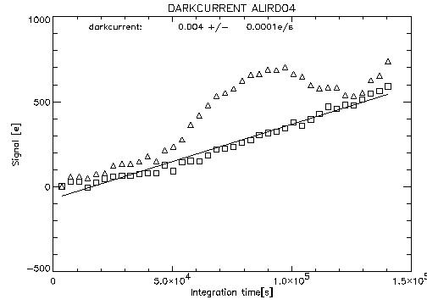
With a nominal exposure time of up to 1000 seconds for moderate resolution spectroscopy (R > 100), shot noise in the dark current is potentially NGST’s most important noise source for near-IR spectroscopy. For example, the near-IR detector requirements, as outlined by the NGST Detector Requirements Panel Report (see Table 1), are total noise of 10 e⁻ and dark current <0.05 e⁻/s. Under these conditions, essentially all of the noise in an R > 100 exposure would arise from detector noise, half of which will be from shot noise on the dark current. Given its importance in determining NGST’s near-IR spectroscopic sensitivity, dark current is clearly an important parameter, but can be difficult to measure accurately, due to a wide variety of systematic effects, including light leaks in the dewar, bias drifts, and multiplexer glow. Fortunately, many of these difficulties, while challenging, can be overcome by proper experiment design.
Figure 4. Reference pixels are crucial for removing the effects of drift and measuring ultra-low dark currents.
Δ - without reference pixels
- with reference pixels
To measure the NGST dark current goal to 10% accuracy, we require that light leaks (including amplifier glow) contribute no more than 0.001 e⁻/s/pixel. This goal can be met by enclosing the detector inside two shields, and by allowing for a metal blank-off to be placed over the detector. When used with an off-chip amplifier and on-chip “reference pixels,” we have used a setup to measure dark currents as low as 0.004 e⁻/s for an 1K² InSb ALADDIN array (see Figure 4) and 0.014 e⁻/s for a 1K² HAWAII array using HgCdTe detectors on an Al₂O₃ substrate (PACE1). In the case of the Aladdin array, the “reference pixels” were naturally occurring unbonded pixels that were empirically found to be stable on long timescales. One can use these pixels, which are scattered about the array, to make a “bias map” allowing one to correct for bias drifts across the array.
We envision obtaining long, up-the-ramp sampled exposures, similar to the method used to measure the data shown in Figure 4 (with reference pixels). Similarly, using 16 samples spread over 2 hour long ramps, Don Hall has measured total noises meeting the NGST requirements in 4.7 μm cutoff HgCdTe arrays, although the operability for this particular device was too low for NGST requirements (Hall & Hodapp 2000). Our experiment will separate the intrinsic dark current from on-chip amplifier glow using a series of ramp exposures alternately using on-chip amplifiers and off-chip amplifiers. We will decompose shift-register glow from the intrinsic dark current by varying the number of samples taken in going up the ramp.
For both Raytheon and Rockwell arrays, efforts are now underway to engineer stable reference pixels into the arrays, i.e. in the HAWAII-1R multiplexer which includes a band of 5 reference pixels on all 4 sides of the 1K² array. Because the multiplexer reads from the outside in, it is envisioned that one would use these pixels like pre-scan data to remove drifts. The reference pixels are not all the same. The outermost pixels will be connected to external capacitors, with capacitances chosen to mimic the capacitance of a real pixel. The inner 4 reference pixels will have fixed capacitance, allowing one to average these pixels to reduce the read noise before making a bias correction. Output amplifier and shift register glow can be important. This is especially true for Rockwell’s HAWAII class HgCdTe detectors (although steps have been taken to minimize shift register glow in the HAWAII-1R multiplexer); these detectors are limited by shift register glow when off-chip amplifiers are used (see Finger et al. 2000). However, there is some hope that shift register glow might be greatly reduced, or even eliminated, by operating the shift registers at very low voltages. In any case, contributions from glow will be modeled and understood by varying the number of samples per ramp, and by selectively bypassing the output amplifiers for some tests.

2.4.3 Read Noise, Gain, and Linearity
Read noise (σ_{read}) expresses the uncertainty in measuring the charge in a pixel. Often, it is determined by measuring the RMS variation in pixel values in a small patch of the array for a short exposure, or by studying the RMS variation of all pixel values in a sequence of short exposures. Alternatively, one can measure read noise and system gain (g; the number of electrons per ADU) using the photon transfer method (Janesick et al. 1987). Using this same experiment, one can also measure linearity.
Customarily, read noise is regarded as a property of the detector. In practice, however, the full readout system is important. For example, drifts from bias voltages can couple to the output with unity gain. Recognizing the importance of the full readout system in determining the noise, NGST places limits on the total RMS noise in a nominal 1000 second exposure, rather than factoring the noise into individual components such as read noise and shot noise in integrated dark current. Specifically, the NGST requirements on total noise are for the sum of contributions from read noise, shot noise from dark current, shot noise from glow, 1/f noise, timing fluctuations, temperature drifts, temperature gradients across the array, and other systematic effects (McCreight et al. 2000). Within the detector hybrid, physical mechanisms contributing to the read noise include resetting the detector capacitance (kTC noise; although this is easily removed using correlated sampling schemes), generation-recombination noise in the semi-conductor and multiplexer, 1/f noise in the multiplexer’s FETs, capacitive coupling within the multiplexer and associated sensing circuitry, and inductive coupling from ground through the detector diode and to sense lines.
Read noise can be reduced by reading the same pixel value many times, cycling through all pixels in a video channel between samples. When using multiple non-destructive reads to reduce read noise, samples can either be grouped at the beginning and ends of an exposure (“Fowler sampling”) or spread throughout an exposure (“up-the-ramp sampling”). When using Fowler sampling, the relatively long time interval between samples (compared to the time required to digitize a single pixel) averages white noise as well as some 1/f components. In this way, noise reductions of 3-5× or more are achievable in practice (Fowler & Gatley 1990; Garnett & Forrest 1993). The amount of reduction is primarily a function of the number of multiple non-destructive reads, up to the point where systematic errors and multiplexer glow start to dominate. In practice, when using multiple non-destructive reads, the read noise diminishes as n^{1/2}, but shot noise due to glow becomes important for high n (see Figure 5). The nominal plan for NGST is to perform some as yet undetermined number of Fowler reads for each on-orbit exposure.
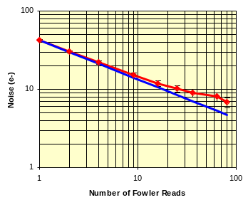
The amount of reduction that can be accomplished using Fowler sampling is limited by the planned 12 seconds it will take to read out the NIR detectors. Thus, read noise will always contribute significantly to the total detector noise (σ_{total}). In fact, for some cases it will be the dominant source of noise. For example, cosmic rays may necessitate exposure times as short as 250 seconds (Rauscher, Isaacs, & Long 2000). In this case, if dark current and read noise contribute equally to the nominal system noise in a 1000 seconds exposure, these short exposures would be dominated by read noise. Read noise has an additional impact on the science attainable by NGST through its influence on guiding. The yardstick design for NGST uses a single chip of the near infrared camera to acquire and track a guide star. Since the frequency of this operation will nominally be 30 Hz, the major source of noise in the determination of the guide star centroid is the read noise (Regan 2000). The short integration times needed for guiding severely limit the number of non-destructive reads that can be used to increase the signal-to-noise ratio. Thus, the inherent read noise of a detector is related to how faint a guide star can be.
Figure 5. Non-destructive reading reduces effective read noise. Data (red) for ALADDIN array, as measured by Co-I Fowler, compared to 1/n^{1/2} (blue).
Although there are many ways of measuring read noise, we feel that the photon transfer method is particularly informative. In making such a measurement, one models the total noise in an exposure as a function of intensity using a noise model that incorporates read noise and shot noise in the collected charge,
$σ_{\text{total}}={\left(σ_{\text{read}}^{2}+gS\right)}^{1/2}$, (1)
where S is the signal (integrated flux) expressed in ADU. Moreover, as more noise components are identified, the model used in equation 1 can easily be expanded to incorporate the additional information.
At very low signal levels, we will extract data for photon transfer measurements from the dark current experiments. At higher signal levels, we will obtain a series of exposures having a range of signals by varying the exposure time. By plotting signal versus exposure time, we will be able to measure linearity. Using this same method, we have measured read noise, gain, and linearity for NICMOS, NIRSPEC/Keck, detectors for the VLT, and facility NIR instruments at a number of 4-m class observatories.
Because it is also important to characterize the temporal and spatial relationship of the read noise, we anticipate a series of tests. These include several sets of double-correlated reads with varying times between them, several sets of Fowler-sampled reads with varying spacing, multiple reads of the same pixels and columns with no or minimal clocking to establish the power spectral distribution of the read noise and the variation in this distribution from pixel to pixel, and special on-chip differential sampling per pixel. All of these tests are geared to understand the strength and origin of the readout noise in order to ultimately design an optimum readout strategy for NGST.

2.4.4 Latent Charge
Latent charge, or “persistence,” is the portion of the signal that is produced by sources in previous images. Anything that liberates charge into the conduction band can result in latent charge, i.e. a bright star or a cosmic ray. Note that latent images are distinguished from spurious sources produced by settling effects in the post-detector analog electronics, i.e. electronic “ghosts” or crosstalk between electronic readout channels.
Experiments suggest that some fraction of the charge produced by light and/or cosmic rays incident on a detector migrates into charge traps, instead of flowing into the depletion region. In general, this charge is not liberated when the pixel is reset. Instead, it slowly escapes the trap according to an exponential profile, in time, and migrates to the PN junction during subsequent exposures. The charge appears as a latent image that grows fainter in successive exposures. There is evidence that some of the latent charge can be flushed by multiple resets, implying that some fraction of the traps are in the silicon multiplexer (Finger et al. 1999); however, this is not true for the NICMOS detectors on-orbit (Bergeron & Najita 1998). In addition, cycling the power can flush out the charge; however, the system then needs considerable settling time to become stable afterwards (Hodapp et al. 1996).
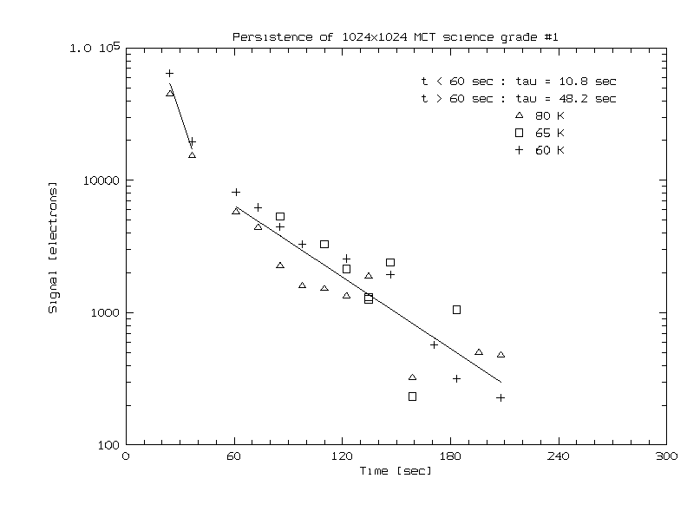
Latent charge reduces the S/N obtainable with an infrared array, and complicates analysis of deep images. It is particularly important in space-based applications, where the sky background is very low, the dynamic range of observed sources is very high, and the radiation environment is intense and variable. Indeed, the sensitivity to this effect was predicted from pre-launch testing of the NICMOS/HST detectors (Young & Rieke 1999) and fully realized on-orbit as elevated dark current after passage through the South Atlantic Anomaly. Even extreme measures, like powering down the NICMOS detectors during SAA passage, yield no change in the resultant latent charge effect. For NICMOS, latent charge affects data quality and significantly increases the data reduction effort compared to that expected before launch.
Figure 6. Persistent charge adds significant noise, even after waiting many minutes after the initial exposure.

It is especially important in the context of NGST to characterize, and attempt to reduce, the effects of persistence. For instance, we have measured the distribution of induced charge from cosmic rays arriving at an altitude of 2600 meters, and estimate an average contribution of ~10³ e⁻ for a typical cosmic ray hit (Finger et al. 2000). Assuming a typical persistence of 1%, that translates to 10 e⁻ in trapped charge which would likely leak to the depletion region during the following exposure, assuming that the integration time was longer than 1 minute. This effect is comparable to the system noise requirement for the pixel in question. One could argue that such an effect can be modeled and removed through sophisticated data processing algorithms, but it would be much better to minimize this effect by choosing a detector technology that exhibits low persistence. In any case, persistence needs to be measured and understood before detector down-select for the NGST to be successful.
Our experiment will be conducted with an external monochromator light source. We will calibrate the light source by measuring the induced charge rate on the detector as a function of wavelength, using calibrated filters. A set of baseline data will be obtained under no illumination using a sequence of non-destructive reads to measure dark current, residual bias, and cosmic ray induced charge. The array will then be flooded with varying light levels from the internal light source up to 100X the detector full well. The pupil wheel will then be commanded to insert the cold blank, and dark frames will be obtained using the same exposure parameters as those used to obtain the baseline data. The two sets of data will then be subtracted from each other so that only latent charge remains. The differences give latent charge release as a function of time and incident light level. This test will be repeated for a range of detector temperatures. In addition, we will try different operating modes in order to test mitigation techniques and to distinguish the fraction of the induced charge that can be eliminated by annealing and multiple resets. We will repeat all experiments using an external laboratory radiation source (Co-60 or Americium) in order to determine latent charge effects due to cosmic ray hits.
Our team (Co-I Finger) has measured latent charge for 1K² InSb and HgCdTe devices using the IRATEC, low-background test instrument. We found a latent charge rate of 0.25%, with respect to the flux produced by illumination in the previous image, for a HgCdTe device, and an exponential decay timescale of a few minutes to a rate of 0.001% (Figure 6). We (PI Figer) have also performed persistence tests on the NIRSPEC/Keck ALADDIN InSb array that revealed up to 3% total latent charge after saturating the array. The latent charge was a function of the exposure time and could not be “drained” by simply reading the multiplexer. Instead, the charge appeared to decay linearly, at least on short timescales. In addition the stored charge was a function of exposure time for the saturated image.

2.4.5 Absolute Quantum Efficiency
Absolute QE describes the photoelectron production rate as a function of incoming photon flux. In general, the response of any solid-state detector is proportional to the incoming photon flux; however, different pixels, in general, have different gains (e⁻/photon). At short wavelengths, input photons can produce more than one photoelectron because the energy of the photon is far in excess of the detector material band gap.
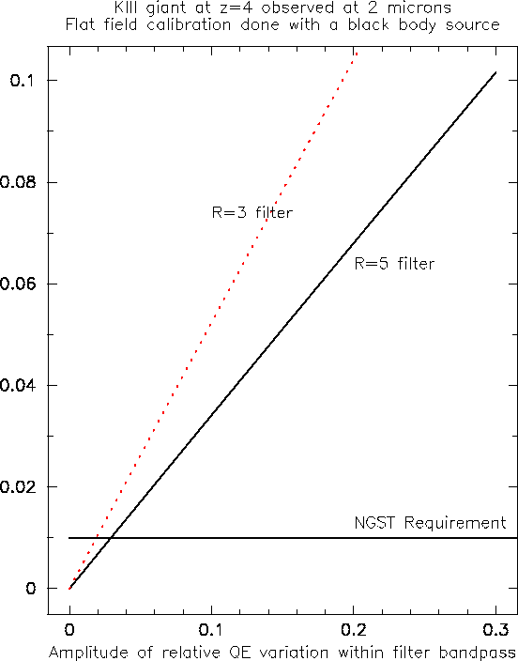
Pixel-to-pixel variations in QE (relative QE) result from differences in the crystal structure of the light sensitive material, as created when the crystal is grown. Other causes are geometrical and can be traced to the manufacturing process: 1) variations in the effective detector area and collecting volume (depletion region), 2) variations of integration capacity, 3) changes in the thickness of the substrate and/or in the antireflection coating. In principle, relative QE can be calibrated and corrected, as long as the detector performance remains stable over time. Several phenomena like cosmic rays, thermal cycling, temperature drifts (also related to variations of the radiative thermal background), may change the relative QE and require frequent calibration. Thus, excellent QE stability under these varying conditions is required.
Figure 7. DRM-quality photometry (1%) cannot be achieved for modest QE variations across the bandpass.
Absolute QE generally varies by ±20% over an array and can be calibrated in science data. However, as with many detector properties, it can vary as a function of temperature, so thermal stability is important. This variation jeopardizes achieving the nominal DRM requirement of 1% photometric accuracy, so QE variations of less than this amount are required between calibrations, i.e. week timescales, at least.
An additional potential distinguishing parameter between the two array technologies is the variation in the QE within a bandpass. When observations made with a broad-band filter of a scientific source are calibrated using a standard object with a different spectral energy distribution, variations in the QE over the filter window will lead to a calibration error, which manifests itself as a color term. Strong color terms can necessitate additional calibration to tie the observations to a standard photometric system. An example of this is shown in Figure 7 where a K-giant at z=4 is observed at 2 μm. The photometric error as a function of the amplitude of the variations in the QE over the filter bandpass is shown. For comparison to real devices, note that data in Finger et al. (1998) imply QE amplitude variations ~20% for HgCdTe across the H-band, implying photometric error >5% from Figure 7. As expected, this problem is more severe as the filter bandpass increases.
A highly uniform field is needed to measure absolute QE. We plan to illuminate the detector through a cryogenic Offner relay, which has the advantage of being achromatic and producing a relatively low-distortion field. A blackbody will be used as a light source, and calibrated filters will be placed close to the pupil image to measure absolute QE. The final goal is to reliably produce a 30x30 mm field uniform within 1% at any wavelength between 0.5 and 5 μm. From this, we will be able to measure both the absolute QE and the change in QE with wavelength.
Our team has considerable experience in measuring detector response as a function of intra-pixel source location. The PI developed a system for measuring the intra-pixel sensitivity for PICNIC3 and ALADDIN arrays (Figer 1998) and for far-infrared photometers and polarimeters. Co-I Finger has measured absolute QE for both the HAWAII and ALADDIN arrays and finds concurrence with the manufacturers results (Finger et al. 2000). In particular, he finds over 80% QE from 1 to 5 μm for the InSb detector and substantially less, and varying as a function of wavelength, for the HgCdTe detector.

2.4.6 MTF and Intra-pixel Sensitivity
The Modulation Transfer Function (MTF) describes how well the detector preserves the original sharpness of the signal. More rigorously, the MTF is defined as the Fourier transform of the spatial response of the detector. The primary reasons for deviations from an ideal MTF are crosstalk between the pixels and intra-pixel sensitivity variations. At near-infrared wavelengths, photon absorption occurs at depths in the detector material that are significant relative to the width of a pixel. Because of this, a photoelecton experiences a three-dimensional random walk until it recombines to the valence band or reaches the edge of a depletion region. Thus, a photoelecton generated under one well may eventually land in an adjoining well (crosstalk), blurring the image and reducing the MTF. In addition, the photoelectons generated near pixel boundaries have to travel larger distances to reach the depletion region and thus have a higher probability of being lost through recombination. This variation in detection probability leads to a variation in intra-pixel sensitivity.
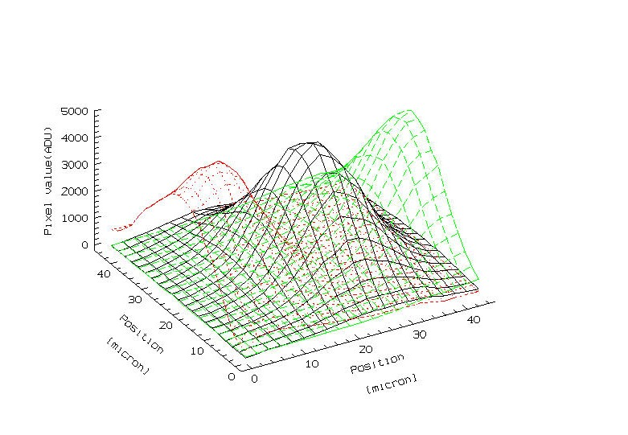
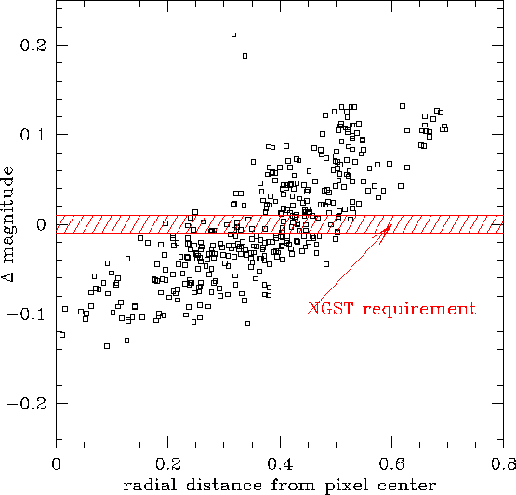
The effects of crosstalk and intra-pixel sensitivity variations become important when the detector is operated in an under-sampled regime. In this case, a high inter-pixel crosstalk will degrade the image that could be reconstructed via dithering, while a large variation in intra-pixel sensitivity will lead to photometric errors. The right hand panel of Figure 8 shows photometric errors encountered on NICMOS when camera 3 was used with the F160W filter. When the near-infrared camera of the NGST is operating at its blue limit, it will under-sample the PSF by a factor greater than three and thus concentrate a large fraction of the light of a point source onto a single pixel. In this regime, low values for the crosstalk and intra-pixel sensitivity variation will be desirable. Unfortunately, a very high MTF requires very small diffusion lengths and well separated depletion regions. These requirements work against the desire to have small pixels, high QE, and the absence of dead space between pixels, characteristics that are desirable for performance and manufacturing considerations. Evidently, these contrary desires require that accurate comparative testing be done, and a significant trade-off be made in the detector design and selection phase.
Figure 8. DRM-quality photometry (1%) cannot be achieved according to our measurements of intra-pixel sensitivity. (Left) Intra-pixel sensitivity of HgCdTe to a point source measured by Co-I Finger. (Right) NICMOS magnitude errors as a function of intra-pixel source location (Stiavelli, private communication).
The simplest measurement of the detector MTF can be done by focussing a calibrated target onto the detector. The major concern in this kind of measurements is the quality of the optics used for re-imaging, which should produce an Airy disk much smaller than the pixel size. This constrains the f/# of the cryogenic relay system. For example, an Airy disk with FWHM=1.22λ⋅(f/#)<5μm can only be produced for f/#<2 at λ=2 μm. At these extreme f/numbers, optical aberrations and alignment errors can be larger that the Airy disk size. Instead of forcing the relay optics to operate in these conditions, we prefer to adopt a novel approach for the ultimate in MTF measurement. In order to create a small image, a special achromatic ultra-fast imaging system has been developed by Co-I Finger (Finger et al. 2000). The system uses an inverted Cassegrain telescope (f/2) directly realized onto a glass substrate, suitable for cryogenic use. In this case, a single diffraction-limited spot is produced, chromatic aberration is minimal, and the MTF is measured by scanning the pinhole (5 μm); note that the imaged size of the pinhole will be dominated by diffraction only, given the very large optical demagnification of our system. We will use an automated system with a motorized 3-axis stage in order to focus and scan the pinhole along detector rows and columns, and scan the monochromator in wavelength. The output from these measurements will allow us to measure the two components of the MTF, crosstalk and intra-pixel sensitivity variations, as well as the composite MTF value as a function of wavelength.

2.4.7 Environmental Effects Will Dominate Science Performance

2.4.7.1 Radiation and Long-term Damage
High energy charged particles pose a threat to spaceborne electronics and detectors. The flux of these particles can be reduced, but not eliminated by shielding; beyond a certain thickness of shielding, the number of primary cosmic rays is reduced, whereas the number of energetic secondaries increases. An obvious manifestation of cosmic ray hits in a detector is a spurious signal that results when electrons are excited into the conduction band. Pipher et al. (1999) simulated cosmic ray exposure of SIRTF InSb detectors (27 μm pixels) by exposing them to energetic protons in the Harvard cyclotron. Based on our analysis of their data (Rauscher, Isaacs, & Long 2000), we find that a typical hit raises ~5 pixels 5 sigma above the noise floor. Average hits on the NICMOS HgCdTe (40 μm pixels) raise ~2 pixels significantly above the noise floor, however median hit intensity in the accelerator data is much higher than on-orbit. Rauscher, Isaacs, & Long (2000) are conducting a study to i) determine the importance of cosmic ray hits on NGST science, and ii) evaluate strategies for minimizing the effects of cosmic ray hits.
Energetic charged particles damage solid-state detectors via bulk displacement or by the deposition of ionizing energy in oxides (total ionizing dose, or TID, effects). Displacement damage gives rise to permanent electrically active bulk traps. A potential example of such effects, the NICMOS HgCdTe detectors developed an anomalous dark current bump at temperatures between 75K and 87K after ~2 years on-orbit (Böker et al. 1999). There is an apparent correlation between the morphology of the anomalous dark current and the morphology of the measured DQE at 2.1 μm. Bergeron et al. (1999) suggest that the anomaly may have been caused by the NICMOS detectors cumulative exposure to ~400 rads(Si) TID during the first two years in orbit. While this hypothesis has yet to be proven, testing of a pristine unirradiated NICMOS detector at the University of Arizona (Böker et al. 2000) failed to reproduce the anomalous dark current bump. Radiation damage is insidious for calibrations when it causes long-term degradation in detector performance.
It is critically important to distinguish between displacement damage and TID effects. Displacement damage might be annealed by raising the temperature of the detector above a certain threshold temperature (activation energy), although it is generally thought that flat band shift cannot be annealed. This has important consequences for the design of the NIR instruments since offset of the flat band shift may require on-board capability to adjust the clock and bias voltages. Indeed, flight electronics for the STIS CCD detector and the ACS HRC and WFC CCD detectors provide commandable biases and clock voltages. The effect of annealing is uncertain and may even result in an increase in the density of interface states (the phenomenon of reverse anneal).
Evaluating the two types of NIR detectors for radiation damage may reveal that one type is superior to the other. Amelioration strategies to reduce the impact of radiation damage on performance will be explored. The possibility of annealing the radiation damage by raising the temperature of the detectors would be a major thrust of our test program; motivation for this emphasis comes from the fact that relatively little is known about the annealing properties of IR hybrid detectors in the space radiation environment. Prior to exhaustion of cryogens, the temperature of the NICMOS HgCdTe detectors was not raised for the purpose of annealing. Furthermore, attempts to assess the effect of annealing on dark current activation during the SIRTF radiation test program were hampered by experimental difficulties (McKelvey et al. 1998; 1999).
We will follow a procedure that is similar to the one used by the IRS/SIRTF, STIS and ACS instrument teams. We will begin by using models for the radiation environment at L2 (Barth & Isaacs 1999). These models will be transported through the shielding surrounding the detectors to the level of accuracy possible given the maturity of the NGST design at the time the test is performed. Generation of secondary particles in the shielding will be simulated using a well accepted computer tool such as BRYNTRN (Wilson et al. 1989). It is important to understand the shielding configuration for the NGST detectors in detail as soon as possible in order to properly simulate the exiting secondary particle spectra. After thorough pre-rad performance characterization of the InSb and HgCdTe detectors, we will irradiate the detectors to two NIEL and TID exposure levels equivalent to one-half of the mission lifetime and the full mission lifetime. In order to separate TID effects from displacement damage effects, we will expose one set of HgCdTe and InSb detectors to a lab gamma source such a Co-60. TID effects can be decoupled from displacement damage effects using a gamma source because high energy photons produce relatively little displacement damage (have lower NIEL) compared to protons. Displacement damage in the L2 space radiation environment will be simulated by proton irradiation of a second set of detectors at the UC Davis Crocker Nuclear Laboratory cyclotron. After returning to the IDTL, the detectors will be characterized to determine: 1) the extent of the radiation damage, 2) the effects of the radiation damage, 3) the possibility of annealing to reverse the effects of the damage, and 4) the anneal temperature. Discrimination between TID and displacement damage effects, if there are indeed significant differences, will by achieved by comparison of the post-rad performance of the detectors exposed to gamma radiation and the detectors exposed to protons.
Our team has experience in evaluating the effects of radiation on the NICMOS arrays, IRS/SIRTF, and the CCD detectors in ACS. We know a good deal about the on-orbit phenomenology of cosmic ray persistence in the NICMOS arrays (Daou & Skinner 1997; Najita et al. 1998). All aspects of the ACS CCD radiation test program, from environment definition to post-radiation performance characterization were either executed or managed by STScI and JHU. External environment modeling was performed using the NASA AP8/AE8 trapped radiation models. Shielding transport calculations and NIEL/TID equivalence analysis was executed by STScI utilizing the BRYNTRN and SHIELDOSE-2 (Seltzer 1994) computer codes. STScI and JHU personnel were on-site at UC Davis to supervise of the irradiation of the detectors. Characterization of the detectors was performed in the JHU CCD characterization laboratory and the Ball ACS CCD characterization facility. The pre-rad and post-rad detector characterization test plans were defined for both facilities by STScI and JHU. Finally, reduction of the data was performed by personnel at STScI and JHU.

2.4.7.2 Temperature Effects
The requirement on detector operating temperature is somewhat flexible and comes from the desire to operate the detectors with as little cooling power as possible. The detector technologies are advancing at a rapid pace, and it is too early to know optimal operational temperatures. For instance, the HAWAII 5 μm cutoff 1K² devices perform well in the 50 K range, whereas the comparable InSb devices require much cooler temperatures, 30-40 K. The present NGST architecture demands that the observatory thermal design be able to provide a 30 K stage for the NIR detector (Geithner 2000).
Separate from the issue of determining the optimal temperature, one must know the thermal stability that is needed to achieve the performance requirements in Table 1, given a realistic NGST environment, i.e. changes in telescope pointing and spacecraft thermal exposure. Such effects can be important, given that the most challenging DRM programs require photometric stability on the order of 0.1% (McCreight et al. 1999). Unfortunately, very small temperature variations can induce large DC offsets in the measured signal and variable “shading” amplitudes in the HgCdTe detectors (Böker et al. 2000). This induces an imprint of the QE pattern onto the reduced image, inducing several hundred electron variations across the NICMOS detector for 100 mK drift within a single HST orbit. Variable shading is a much greater problem. We expect to see residual bias in the target minus bias frame on the order of 0.3 e⁻/mK due to thermal drifts. Lallo et al. (1998) find that the NGST sunshield-to-instrument module thermal circuit produces about 20 mW of parasitic heating in the instrument module, and that this load is a function of telescope pointing. Of course, this is separate from the effects of detector self-heating. A change of a few mW of heating power can induce temperature changes on the order of 30 mK, or 30 e⁻ in variable DC offset and 10 e⁻ in variable “shading,” or much greater than the whole NGST system noise requirement. An effect of similar magnitude can be seen in the InSb detectors, where Finger et al. (2000) measured a drift of 1.7 e⁻/mK for dead pixels.
Our experiment will be similar to the NICMOS dark bump tests that were done on-orbit and post warm-up at the University of Arizona (Böker et al. 2000). We will measure dark current, read noise, absolute QE, intra-pixel sensitivity, linearity, and latent charge at 100 mK intervals, over several intervals bracketing optimal operating temperatures. In addition, we will obtain these same measurements over larger temperature intervals. The measurements will be done at one wavelength (2 μm). We can extrapolate the behavior to other wavelengths by assuming that the wavelength dependence will be independent of temperature. This latter dependence will be determined in other tests where the temperature is kept fixed and the light source is scanned in wavelength. Temperature control will be done with a Lakeshore system, similar to the one used in the ESO setup by Co-I Finger. We will verify the on-chip temperature using a calibrated relationship between reset level and temperature, i.e. was done for the NICMOS dark bump tests (Böker et al. 2000). Our setup will provide 5 mK control.

2.4.8 Optimal Use Study - How Would Either Detector Be Operated for NGST?
Throughout this document, we have referred to various schemes for detector readouts that are aimed at optimizing signal to noise under different conditions: double-correlated sampling, fast-chopping, nodding, Fowler-sampling, up-the-ramp etc. Ultimately, for the NGST, the operating modes will be designed to optimize scientific performance under system and financial constraints. In particular, the number, speed, and duration of readouts will affect the observing efficiency as well as the overall thermal balance of the ISIM (direct on-chip dissipation, analog electronics power dissipation, and the parasitic heating by the wire bundles). Thus, the choice and design of operating modes will be an exacting engineering exercise that must leave some flexibility for on-L2 experience. One of the key goals of the characterization effort is to provide the low-level performance characteristics needed to model and design optimum operating modes, test a specific subset of these modes to validate the models, and compare the two NIR technologies with their optimum readout modes. We do not expect the detailed optimum operations for InSb and HgCdTe to be identical. Characteristics that will affect the design of the readout scheme will include: relative values of read noise and dark current, induced signal from clocking and readout, white-noise levels, true pixel-level 1/f noise (usually unmeasureable), sensitivity to thermal drifts (read-induced and external) and externally-supplied bias levels, availability of reference signals (per pixel, per column, per frame), and the uniformity of these sensitivities across the device.
Not withstanding engineering and financial constraints, the optimum operating modes for the NGST will depend on the typical background and maximum integration time (cosmic ray effects). In general, they may consist of a combination of up-the-ramp (for cosmic ray rejection), multiple (Fowler) samples (for thermal drifts), with long “integrations” per pixel (for white noise reduction). The spacing per ramp-sample, number of Fowler samples, and integration period will be designed to maximize the overall SNR or minimize the RMS variance including cosmic ray effects and the loss of integration time due to readouts. Part of this study will be the creation of a simple model for each device that includes the principle read-noise effects and their amelioration. Given a background level and cosmic ray flux, the model will produce a range of operating modes with comparable signal-to-noise performance.

2.5 The IDTL Effort Enables Future NASA Origins Missions
The proposed program is designed to inform NASA, NGST international partners, and instrument PIs in the selection of the optimum technology and operating modes (InSb or HgCdTe) for the NGST NIR camera and spectrograph(s). This effort, as well as the testing done by our collaborators and other university groups, will have great significance for other infrared observatories. On the ground, high- resolution spectrographs (R~20,000) on the VLT and Gemini 8-m class telescopes with adaptive optics will have 1−2 μm backgrounds between the OH lines approaching those encountered on NGST at lower resolutions (R~1000). Low-noise NIR detectors will enable breakthrough high-resolution spectroscopic studies of distant galaxies and obscured star formation regions.
The OSS strategic plan for the period 2000-2015 shows that the Terrestrial Planet Finder (TPF) will immediately follow NGST launch. Although several TPF pre-Phase A architecture studies are now underway, we anticipate that the basic concept described by Beichman, Woolf, and Hindensmith (1999) will be followed: a long-baseline, mid-infrared (MIR) nulling and imaging interferometer. In the MIR, the zodiacal background will be significant at the resolutions of R=20-200 needed for the interferometer. However, the requirement on the stability of the interferometric baselines will be inversely proportional to the readout rate. To reduce technological risk and enable long baseline MIR imaging with TPF, the designs will choose detectors and readout schemes with the fastest possible response while still being zodiacal light-limited. We can calculate from Figure 1 that the zodiacal light signal will be less than 1e⁻/s with a readout rate of 1 Hz and R ~ 200 and dividing the beams among 4 telescopes. Clearly, low readout noise will be essential to reduce the baseline stability requirements for TPF to second-to-minute timescales. Since InSb and Si:As BIB detectors utilize common multiplexer technologies, our study will be important for the TPF detector technology development program and the design of the Phase A TPF architecture.

2.6 The IDTL Delivers Public Products
The primary products from the proposed effort are: 1) test reports, 2) test suites, 3) data packs, 4) an “optimal use” study, and 5) data processing software. The test reports, summarized at national and international meetings, give measured results and describe the tests in sufficient detail so that another group could reproduce them. The test suite is a compilation of the test procedures. The data packs will contain all the data used to derive our results. The “optimal use” study will prescribe the best ways to run either detector technology in light of NGST system and budget constraints. The primary outlet for our products will be the IDTL web site, on which we will publish results, reports, and data processing and analysis software. In addition, the data packs will be available for distribution as a single archive on DVD; small data packs, i.e. from the MTF experiments, will be available on the web site. The data packs will become an invaluable archive for the instrument builders, other testing labs, and the NGST Project operations planning group. In addition, these products will leverage the testing activities to the NGST Project's benefit by allowing many other researchers to learn about potential NGST detectors.
The proposed activities will be reported to the NGST Project through regular reports, to an internal review board through project review documents, and to the astronomy community through the laboratory web site, PASP papers, SPIE papers, and workshops sponsored at STScI. We have scheduled reviews shown in the accompanying table. The first NGST Project Review will coincide with the test suite product (code and a technical description of the tests). The second NGST Project Review will coincide with release of the remaining products.

2.7 Work Plan and Management Approach
Review Milestones
Nov 1 00 | Internal test plan review
Apr 1 01 | Phase I External Review
Aug 1 01 | NGST Project Review
May 1 02 | Phase II External Review
Jul 1 02 | NGST Project Review

The project follows a two-phase plan. Phase I includes simple tests using vendor-provided engineering grade devices to validate the performance of the laboratory. Due to the fact that JHU and STScI have elected to make a strategic investment by establishing an infrared laboratory, most of the hardware (dewars, optical components, electronics, vacuum pumps, cryo-coolers, etc.) will be in place, within 1 month of the project start date. In parallel with the laboratory validation, we will draft detailed protocols for the detector characterization, based on our previous experience with operating NICMOS on HST, and testing detectors in laboratories at UCLA (Figer), University of Chicago (Rauscher, Figer), Durham (Rauscher), NOAO (Fowler) and ESO (Finger). The results will be presented to an external review committee in April 2001, and suggested changes will be incorporated into the hardware and the protocols. In addition, we will then implement the code to allow motion control, and changing read mode and temperature in an automated and controlled way.
We will rerun the tests from Phase I in Phase II, this time using project-provided science grade detectors (Matt Greenhouse, priv. comm.), and iterate until there is concurrence with the earlier results. We will then move on to more exploratory testing to determine the detector characteristics as a function of temperature, wavelength, and operations mode. The radiation testing for latent images will be done in the middle of Phase II, and that for permanent damage will be done at the end of Phase II. We will send a HgCdTe device to our collaborators at ESO (pending export license; past experience exporting 1K² and 2K² arrays to ESO suggests that this will not be a problem), and an InSb device to our collaborators at Gemini/NOAO to verify our results. We anticipate that the NGST Project will verify our results with those from other labs in the network of NGST testing labs, via “round-robin” testing. In the last part of Phase II, we will complete the optimal use study to determine how each detector type would be operated under the constraints of other NGST system and cost requirements.
PI Figer (60%=level of commitment) will have direct responsibility for all aspects of the project, including the quality and accuracy of the results. He will participate in designing and performing the tests and publishing the results. He will be supported by Co-Is Regan (30%), Rauscher (10%), McCandliss (15%), Fowler (10%), and Finger (10%), in the development, execution and analysis of the various tests needed to characterize NGST prototype detectors. In addition, he will be assisted by a post-doc (50%), a data analyst (50% for 1st year, 100% second year), a technician (40%), the JHU Instrument Development Group, and an administrative assistant (25%). Two graduate students (50% each) will be trained in NIR detector testing techniques and will assist in writing software and obtaining data. Co-I Stockman (10%) will lead the optimal use study. Co-I Ford (10%) will lead the radiation testing effort, assisted by a Test Instrument Scientist (10% first year, 30% second year).
The project will be carried out under the auspices of the Center for Astrophysical Sciences, in laboratory space provided by the Center. Senior management oversight will be provided by STScI Lead Instrument Scientist for NGST Co-I Long (10%). The STScI and the JHU understand the criticality of meeting program milestones so they will hold internal progress reviews on a monthly basis. Co-Is Long and Ford will also be responsible for convening an advisory committee to review the activities of the project in detail and to advise on future directions. The membership of the committee will consist of a mixture of those who are involved in the project and those in the community. Project members will consist of the non-local Co-Is – Fowler (NOAO) and Finger (ESO), and representatives from Raytheon and Rockwell. The remaining membership will involve individuals and institutions involved in other aspects of detector development for NGST (and NASA’s other premier infrared mission, SIRTF). A summary of personnel contributions can be found on the page entitled, “Summary of Personnel, Commitments, and Costs.”

3.0 References
Ando, K., Estrada, A. D., Love, P. J., Smith, M. S., & Sparkman, K. P. 2000, “Infrared detectors for ground-based and space-based astronomy,” SPIE, 4008-159
Barth, J. L., & Isaacs, J. C. 1999, “The Radiation Environment for the Next Generation Space Telescope,” NGST Project, internal document
Bergeron, L. E., & Najita, J. R. 1998, “Cosmic Ray and Photon Image Persistence in NICMOS, and Ways to Reduce its Effects”, BAAS, 193, #36.06
Bergeron, L., Böker, T., Bacinski, J., & Mazzuca, L. 1999, “Observed Characteristics of the HST/NICMOS Dark Current During the end-of-life Warm-up,” STScI, Baltimore, MD, internal document
Böker, T., Bacinski, J., Bergeron, L. E., Holfeltz, S. T., Gilmore, D., Monroe, B., & Sosey, M. 1999, “Analysis, results, and assessment, of the NICMOS warm-up monitoring program,” NICMOS ISR-99-001, STScI, Baltimore, MD
Böker, T., Ferro, T., Holfeltz, S. T., Hubbard, P., Jarrell, D., Monroe, B., O'Neil, E., Schneider, G., & Sosey, M. 2000, “NICMOS Dark Current Anomaly: Test Results,” ISR-00-002, STScI, Baltimore, MD
Daou, Doris, & Skinner, Chris, “Persistence in NICMOS: Results from On-Orbit Data,” STScI Instrument Science Report NICMOS-97-024, 12 September 1997
Figer, D. F. 1998, “NIRSPEC Optics Design Note 26.00: NIRSPEC Optomechanical System Acceptance Test Plan”, NIRSPEC project internal document
Finger, G., Biereichel, P., Mehrgan, H., Meyer, M., Moorwood, A. F. M., Nicolini, G., & Stegmeier, J. 1999, “Experience with near IR detector arrays used for low background ground based applications,” NGST Detector Workshop April 20-21, 1999, STScI, Baltimore, MD
Finger, G. , Biereichel, P., Mehrgan, H., Meyer, M., Moorwood, A. F. M., Nicolini, G., & Stegmeier, J. 2000, “Performance of large format HgCdTe and InSb arrays for low background applications,” SPIE, 4008-143
Fowler, A. M., & Gatley, I. 1990, ApJ, 353, 33
Fowler, A. M., Gatley, I., McIntyre, P., Vrba, F. J., & Hoffman, A. W. 1996, “ALADDIN: the 1024x1024 InSb array–design, description, and results”, SPIE, 2816-150
Garnett, J. D., & Forrest, W. J. 1993, “Multiply sampled read limited and background limited noise performance,” SPIE, 1946, 395
Geithner, P. 2000, “Detector Temperature Requirement for NGST Near Infrared (NIR)”, NGST Project Memo
Hall, D. N., & Hodapp, K. 2000, “Characterization of λ_{c}=5 μm Hg:Cd:Te arrays for low-background astronomy,” SPIE, 4008-142
Hodapp, K.-W. et al. 1996, “The HAWAII Infrared Detector Arrays: testing and astronomical characterization of prototype and science-grade devices”, New Astronomy, vol. 1, no. 2, 177
Janesick, J. R., Elliott, T., Collins, S., Blouke, M. M., & Freeman, J. 1987, Optical Engineering, 26, 692
Lallo, M., Bely, P., & Petro, L. 1998, “Thermal Considerations for a Passively Cooled NGST”, in The Next Generation Space Telescope: Science Drivers and Technological Challenges, Liege, Belgium
McKelvey, M., McMurray, Jr., Robert E., Johnson, Roy R., McCreight, Craig, & Castaneda, Carlos, “SCA30218 Proton Tests at the UC Davis Cyclotron,” October 1999
McKelvey, M., McMurray, Jr., Robert E., Johnson, Roy R., McCreight, Craig, & Castaneda, Carlos, “Recent Proton Tests at the UC Davis Cyclotron,” May 1998
McCreight et al. 1999, “Recommendations of the NGST Detector Requirements Panel”
McLean, I. S. 1997, “Electronic Imaging in Astronomy: Detector and Instrumentation,” John Wiley & Sons: Chichester, p. 222
Najita, J., Dickinson, M., & Holfeltz, S., “Cosmic Ray Persistence in NICMOS Data,” STScI Instrument Science Report NICMOS-98-001.
Rauscher, B. J., Isaacs, J., & Long, K. 2000, “Cosmic Ray Management on NGST: The Effect of Cosmic Rays on Near Infrared Imaging Exposure Times”, STScI, Baltimore, MD
Regan, M. W. 2000, “Guiding with NGST NIR detectors,” STScI, Baltimore, MD
Pipher, J. et al. 1999, “Radiation Testing of InSb Array on CRC 744 Multiplexer,” Presentation to the IRAC Team 9/15; Revised 11/99
Seltzer, S. M. 1994 “Updated Calculations for Routine Space-Shielding Radiation Dose Estimates: SHIELDOSE-2,” NIST Publication NISTIR 5477
Skinner, C. J., Bergeron, L. E., & Daou, D. 1997, “Characteristics of the NICMOS Detectors”, in HST Calibration Workshop, STScI, Baltimore, MD, 171
Terrestrial Planet Finder, Origins of Stars, Planets, and Life, eds. C. A. Beichman, N.J. Woolf, C.A. Lindersmith,, JPL Pub. 99-3, 1999, see http://tpf.jpl.nasa.gov/
Wilson, J. W., Townsend, L. W., Healy, J.E., Chun, S.Y., Hong, B.S., Buck, W.W., Lamkin, S.L., Banapol, B.D., Khan, F., & Cucinotta, F.A. 1989, “BRYNTRN: A Baryon Transport Model,” NASA Technical Paper 2887

Acknowledgements

We thank Massimo Robberto, Larry Petro, Eddie Bergeron, Mike R. Jones, Knute Ray, Casey Lisse, and Massimo Stiavelli, for their contributions to this proposal. In addition, we thank Jeff Valenti, Tom Lutterbie, John Mackenty, Mark Clampin, Torsten Böker, Ethan Schreier, Mike Hauser, Steve Beckwith, David Humm, and others for a critical review of the proposal.

4.0 Facilities and Equipment
The primary laboratory work will be performed in an Independent Detector Testing Laboratory (IDTL) currently being established the Center for Astrophysical Sciences, in the Johns Hopkins University Department of Physics and Astronomy. JHU has a long-standing and broad-ranging scientific capability in space astrophysics. This capability is complemented, and was originally nurtured, by a strong experimental capability in the area of designing and building advanced state-of-the-art telescope/spectrometer systems, which have had an impact in space research far beyond the confines of the Johns Hopkins program. During the past three decades, we have developed the laboratory capabilities to handle the assembly and integration of sounding rockets and other space-based instrumentation, having developed the (absolute) calibration techniques necessary for performance assessment and acceptance testing of the component hardware. Previous experience includes: the absolute calibration of the Apollo-17 UVS (Fastie et al. 1973), the development of space qualified platinum hollow cathode lamps for IUE (Mount et al. 1977), a study of candidate gratings for IUE (Mount & Fastie 1978), the absolute calibration of HUT on the Astro-1 and -2 missions (Davidsen 1993, Kruk 1999), the absolute calibration of lumigen coated and backside thinned CCD's (Morrissey et al. 1994, 1995), the project development and mission operation of the FUSE observatory (Moos et al. 2000), and the development of the HST Advanced Camera for Surveys (Ford et al. 1996).
In 1990, the Department of Physics and Astronomy moved into a new building, the Bloomberg Center for Physics and Astronomy, located at the north end of the campus across from the Space Telescope Science Institute. Bloomberg contains almost twice as much laboratory space as previously and includes special facilities and equipment that will be made available to this project as in-kind cost sharing. These include two class 10,000 clean rooms, vacuum pumping systems, 1300 ft² of laboratory space (including power, water and exhaust plumbing), optical benches, flow tables, light sources, monochromator, power supplies, general lab electronics, and full computer network and systems support. In addition, real dollar cost sharing will include, partial salary support for JHU research, engineering staff, and administrative support. The department maintains a Machine Shop and Instrument Design Group, which have been critical to the timely fabrication of rocket hardware and have provided the engineering expertise to the HUT and FUSE projects. Use of the shop and engineers will be offered at subsidized rates.
While many of the resources required to establish an IR lab are already in existence at JHU, some hardware will need to be obtained prior to the start of this program. Since both JHU and STScI have identified IR expertise as critical to our long-term productivity in space and ground-based research, we are funding these from other funds independently of this proposal. Specifically we are procuring two identical dewars, based on the IRATEC (Figure 3), with the associated optics, mechanisms, mechanical housings, optical baffles, and electrical feedthroughs. Dual-stage closed-cycle refrigerators (CTI Model 1050) with thermal circuits connected to the detectors, optics, and baffles will be used to allow precise thermal control and array operation between 20-70 K. In addition, one warm and one cold mechanism will be used for the proposed effort. The warm mechanism will be procured and the cold mechanism will be designed and built by the IDG, in collaboration with Co-I Fowler. We will use the fan-out boards that have already been designed by ESO, although we will make a minor modification in order to accommodate changes in the HAWAII-1R design versus previous HAWAII designs. We are procuring the array controller from Astronomical Research Cameras, Inc. (see attached letter), through IR Labs. The system will be delivered by September, 2000. These electronics are being tested to operate both InSb or HgCdTe detectors in formats including 2K² pixels, and with performance suitable for the application (i.e. low noise).
Davidsen, A. F. 1993, “Far-Ultraviolet Astronomy on the Astro-1 Space Shuttle Mission,” Science, 259, 327
Fastie, W. G., Feldman, P. D., Henry, R. C., Moos, H. W., Barth, C. A., Thomas, G. E., & Donahue, T. M. 1973, “A Search for Far-Ultraviolet Emissions from the Lunar Atmosphere,” Science 182, 710
Finger, G., Biereichel, P., Mehrgan, H., Meyer, M., Moorwood, A. F. M., Nicolini, G., & Stegmeier 1998, “Infrared Detector Development Programs for the VLT Instruments at the European Southern Observatory,” SPIE, 3354, 87
Kruk, J. W., Brown, T. M., Davidsen, A. F., Espey, B. R., Finley, D. S., & Kriss, G. A. 1999, “Final Astro-2 Calibration of the Hopkins Ultraviolet Telescope,” Ap. J. Supp. 122, 299
Ford, H. C. et al. 1996, “Advanced camera for the Hubble Space Telescope,” SPIE, 2807, 184
Morrissey, P. F., McCandliss, S. R., Feldman, P. D., & Friedman, S. D. 1994, “Vacuum ultraviolet quantum efficiency of a phosphor-coated charge-coupled device,” App. Opt. 33, 2534
Morrissey, P. F., McCandliss, S. R., & Feldman, P. D. 1995, “Vacuum-ultraviolet quantum efficiency of a thinned, backside-illuminated charge-coupled device,” App. Opt. 34, 4640
Mount G. H., & Fastie, W. G. 1978, “Comprehensive Analysis of Gratings for Ultraviolet Space Instrumentation,” App. Opt. 17, 3108
Mount, G. H., Yamasaki, G., Fowler, W., & Fastie, W. G. 1977, “Compact Far Ultraviolet Emission Source with Rich Spectral Emission 1150-3100 Angstroms,” App. Opt. 16, 591
Moos, H. W. et al. 2000, “Overview of The Far Ultraviolet Spectroscopic Explorer Mission,” Ap. J., submitted

5.0 CV

5.1 Donald F. Figer, STScI/JHU
PI Figer received his PhD in 1995 from UCLA and is currently an Assistant Astronomer at STScI and Adjunct Assistant Professor at JHU. His primary responsibilities are leading the joint STScI/JHU Infrared Detector Testing Laboratory (IDTL) and serving as instrument scientist from STScI for the NEXUS project. He has 9 years of experience with near-infrared detectors (NICMOS-2, NICMOS-3, 256² InSb, PICNIC3, and ALADDIN) and infrared instrumentation. He has designed, built, and tested automated detector characterization systems, motion-control systems, cryogenic thermometry systems, warm and cryogenic optics, high-speed/low-noise detector readout electronics, data analysis software, and instrument user-interface software. He will have responsibility for delivering all products in this proposal.

Served as Principal Investigator, FLITECAM ($921,000, developed system-level requirements)
Principle Optical Designer, NIRSPEC (designed optics and managed $750,000 and 7 vendor contracts)
Local Project Scientist, NIRSPEC
Electronics Designer, GEMINI (designed original high-speed, low-noise, analog electronics to read both InSb and HgCdTe detectors)
Chief Engineer, MIST, Inc. (designed photonics and electronics system for medical transilluminescence imaging)
Technician, GRIM (implemented motion-control and thermometry systems)
Graduate Student, STOKES (designed FIR detector characterization system and motion-control system)

Selected Publications:
Figer, D. F., Becklin, E. E. , McLean, I. S. , Gilbert, A. M., Graham, J. R., Larkin, J. E., Levenson, N. A., Teplitz, H. I., Wilcox, M. K., & Morris, M. 2000, “2-micron Spectroscopy within 0.3” of Sgr A*,” ApJ, 533, L49
Figer, D. F., Kim, S. S., Morris, M., Serabyn, E., Rich, R. M., & McLean, I. S. 1999, “HST/NICMOS Observations of Massive Stellar Clusters Near the Galactic Center,” ApJ, 525, 750
Figer, D. F., Morris, M., Geballe, T. R., Rich, R. M., McLean, I. S., Serabyn, E., Puetter, R., & Yahil, A. 1999, “High Resolution Infrared Imaging and Spectroscopy of the Pistol Nebula: Evidence for Ejection,” ApJ, 525, 759
Figer, D. F., McLean, I. S., & Becklin, E. E. 1998, “FLITECAM: a 1-5 micron camera for testing the performance of SOFIA,” SPIE Vol. 3354, 1179
Figer, D. F., & McLean, I. S. 1998, “Wavefront error budget and optomechanical tolerancing for NIRSPEC,” SPIE 3354, 1005
Figer, D. F., Najarro, F., Morris, M., McLean, I. S., Geballe, T. R., Ghez, A. M., & Langer, N. 1998, “The Pistol Star,” ApJ, 506, 384
Robichaud, J. L., Zellers, B., Philippon, R., McLean, I. S., & Figer, D. F. 1998, “Cryogenic performance of the NIRSPEC three-mirror anastigmat,” SPIE 3354, 1068
McLean, I. S., Becklin, E. E., Bendiksen, O., Brims, G., Canfield, J., Figer, D. F., Graham, J. R., Hare, J., Lacayanga, F., Larkin, J., Larson, S. B., Levenson, N., Magnone, N., Teplitz, H., & Wong, W. 1998, “The Design and Development of NIRSPEC: A Near-Infrared Echelle Spectrograph for the Keck II Telescope,” SPIE 3354, 566
Figer, D. F. 1998, “NIRSPEC Optics Design Note 26.00: NIRSPEC Optomechanical System Acceptance Test Plan,” NIRSPEC project internal document
McLean, I. S., Becklin, E. E., Figer, D. F., Larson, S., Liu, T. & Graham, J. 1995, “NIRSPEC: a near-infrared cross-dispersed echelle spectrograph for the Keck II telescope,” SPIE, 2475, 350
McLean, I. S., Macintosh, B. A., Liu, T., Casement, L. S., Figer, D. F., Lacayanga, F., Larson, S., Teplitz, H., Silverstone, M. & Becklin, E. E. 1994, “Performance and results with a double-beam infrared camera,” SPIE, 2198, 457
Figer, D. F. 1993, “A Preamp for the Gemini Camera,” GEMINI project internal document
McLean, I. S., Becklin, E. E., Brims, G., Canfield, J., Casement, L. S., Figer, D. F., Henriquez, F., Huang, A., Liu, T., Macintosh, B. A. & Teplitz, H. 1993, “UCLA double-beam infrared camera system,” SPIE, 1946, 513
Hildebrand, R. H., Davidson, J. A., Dotson, J., Figer, D. F., Novak, G., Platt, S. R. & Tao, L., 1993, “Polarization of the Thermal Emission from the Dust Ring at the Center of the Galaxy,” ApJ, 417, 565
Donald F. Figer
STScI
3700 San Martin Drive
Baltimore, MD 21218
Telephone: 410-338-4377 Fax: 410-338-5090 figer@stsci.edu

EDUCATION Ph.D., University of California, Los Angeles, Astronomy June, 1995

M.S., University of Chicago, Astron. and Astroph. September, 1989 to September, 1991

B.A., Northwestern University, Evanston, IL. Triple Major: Physics (Honors), Mathematics, Astronomy (Honors) September, 1985 to June, 1989

EXPERIENCE Adjunct Assistant Professor, JHU April, 2000 to current

Assistant Astronomer, STScI July, 1999 to current

STScI Verification Lead for NEXUS. Served NGST project on the Wavefront Sensing and Control panel, and developed the Independent Detector Testing Laboratory.

Assistant Research Astronomer, UCLA, Division of Astronomy & Astrophysics, Department of Physics & Astronomy. October, 1996 to June, 1999

Continued role as Local Project Scientist and optical designer for NIRSPEC project. Primary work involved wavefront error and optomechanical tolerance analysis, alignment of individual subassemblies, and development of optical system qualification procedure.

Led team that identified the “Pistol Star” as being one of the most massive stars known (STScI-PR97-33). Led team that identified the Arches Cluster as containing more O-stars than any other cluster in the Galaxy (STScI-PRC99-30).

Principal Investigator of FLITECAM, the First-light Infrared Test and Experiment Camera for SOFIA. June, 1998 to January, 1999

Principal Investigator on HST GO7364: Compact Young Clusters and the r⁻² Cusp near the Galactic Center. September, 1997 to September, 1999

Postdoctoral Research Fellow, UCLA, Division of Astronomy & Astrophysics, Department of Physics & Astronomy. June, 1995 to October, 1996

Designed optics for the NIRSPEC high-resolution spectrometer to be used on the Keck II telescope. Performed optical design, opto-mechanical tolerance analysis, and managed subcontracts with Optics 1, Inc., Breault Research Organization, Speedring Systems, Inc., and SSG, Inc. Procured vendors for assembling the opto-mechanical modules. Continued researching the hot, young stellar population at the Galactic Center.

Principal Opto-mechanical Designer, MIST (Medical Imaging and Scanning Technologies). November, 1994 to October, 1995

Designed prototype non-invasive imaging systems for brain hematoma and breast cancer detection. Wrote SBIR proposals for emergency room and battlefield diagnostic hardware. Assisted in the development of one of the first NIR transilluminescence brain hematoma detectors.

Ph.D. candidate, UCLA, Division of Astronomy & Astrophysics, Department of Physics & Astronomy. June, 1992 to June, 1995

Researched and discovered members of the hot, young stellar population near the Galactic Center.

Research Assistant, UCLA, Department of Astronomy. June, 1992 to May, 1994

Designed high-speed low-noise analog electronics for controlling and reading InSb and HgCdTe IR focal plane arrays in the UCLA Gemini camera. Designed optics for NIRSPEC, the high resolution IR spectrometer for the Keck II Telescope.

Research Technician, University of Chicago, Department of Astronomy and Astrophysics. November, 1991 to June, 1992

Designed and constructed 68HC11-based motion-control and sensing system for the Astrophysical Research Consortium GRIM IR camera. The design work included: reading a multiplexed array of potentiometer shaft encoders, cryo-mechanical thermal issues, FORTH-based embedded controller programming, and cryogenic thermometry.

Research Assistant, University of Chicago, Department of Astronomy and Astrophysics.
June, 1989 to November, 1991

Researched the direction of interstellar magnetic fields in star-forming regions and at the Galactic Center. Designed and constructed two-axis motion control electronics with automated computer control, position encoder electronics, and manual front-panel button controls. Designed and constructed robotic lab testing system for far-infrared cameras and polarimeters. These systems produce an image of a black-body source at the focal-plane of the far-infrared cameras. Separate motion-control electronics were built to spin a half-wave plate inside the polarimeter (T=2 K) where a wire-wound resistor was used for feedback information.

Teaching Assistant, University of Chicago, Department of Astronomy and Astrophysics.
September, 1989 to January, 1990

Assisted in the implementation of CCD camera for a teaching telescope laboratory. Taught introductory level students how to use the associated software.

Undergraduate Researcher, Northwestern University, Department of Physics and Astronomy. September, 1987 to June, 1989

Designed, built, and used a high-speed photoelectric photometry data acquisition system on 1 meter telescope. The system was built for research and teaching purposes. Investigated occurrence of rare short time transient variable stars. This system contained pulse-counting electronics which could measure incident flux on the Starlight-1 (PMT) photometer.

Experiment Assistant, Fermilab, Batavia, Illinois. June, 1987 to September, 1987

Performed diagnostic testing of experiment data acquisition electronics. Built experiment hardware and wrote temperature probe display software.

Undergraduate Researcher, Northwestern University, Department of Physics and Astronomy. September, 1986 to June, 1987

Programmed pattern recognition software for Fermilab experiment, D0 (proton-antiproton annihilation).

5.2 Hervey S. Stockman, STScI
Co-I Stockman is presently an Astronomer at STScI and heads the NGST Division. He received his PhD in 1973 from Columbia and AB in 1968 from Princeton University.

Previous positions:
Astronomer, Deputy Director, Space Telescope Science Institute, 1987-1995
Astronomer, Chief, Research Support Branch, Space Telescope Science Institute, 1983-1987
Associate Astronomer, Steward Observatory, University of Arizona, 1978-1983
Research Associate, Steward Observatory, University of Arizona, 1975-1978
Project Officer, Technology Division, Air Force Weapons Laboratory, 1973-1975

Major Awards:
NASA Public Service Medal Headquarters, 1994, membership in HST First Servicing Mission Review
NASA Public Service Medal Goddard Space Flight Center, 1998, editing The Next Generation Space Telescope: Visiting a Time When Galaxies were Young

NGST-related Activities:
Member, NGST Study Team (1995-present), Received NASA Group Achievement Award 1997.
Member, Astronomical Search for Origins and Planetary Systems Advisory Subcommittee (1996-present).
Member, ESA HST 2002 Study Team (1995)
Member, HST and Beyond Committee (1993-1995).
Member, Astrophysics Subcommittee (AS, 1992-1994).
Member, Hubble Program Review Team (1992-1994). Received NASA Public Service Medal 1994
Chairman, Space Telescope Observatory Performance Assessment Team (STOPAT, 1985-1987).
Project Scientist, Science Certification Review (SCR, 1987).
Member, Astronomy and Relativity Mission Operations Working Group (ARMOWG, 1985-l987).
Member, Orbital Verification Planning Team (OVPT, 1983-1986).
Member, Science Verification Working Group (SVWG, 1983-l985).
Member, Maintenance and Refurbishment Workshop (1987).
Member, Level l Requirements Working Group (1987).
Member, MSFC Optics Review Panel (1983-1986).

Selected Publications:
A Large-Area Lithium-Flouride Bragg Spectrometer for Stellar X-Ray Astronomy, (H.S. Stockman, Jr., J. R. P. Angel, B. E. Woodgate and R. A. Nidey). Nuc. Inst. and Methods, 126, 217, 1975
Null Circular Polarization Measurements for the Controversial White Dwarf LDS 678B (EG131), (J. Liebert, H. S. Stockman and J. R. P. Angel). M.N.R.A.S., 185, 1P, 1978
High Speed Polarimetry of AM Herculis, (H. S. Stockman, T. A. Sargent). Ap. J., 227, 197, 1979
Optical and Infrared Polarization of Active Extragalactic Objects, (J. R. P. Angel and H. S. Stockman). Annual R. Astron. Astrophys., 18, 321, 1980
Optical Polarization of the Seyfert Galaxies Mrk 3, Mrk 231, NGC 3227 and NGC 3516, (I. Thompson, J. D. Landstreet, H. S. Stockman, J. R. P. Angel and E. A. Beaver). M.N.R.A.S., 192, 53, 1980
Circular Polarization Measurements of Selected White Dwarfs, (J. Liebert and H.S. Stockman). P.A.S.P., 92, 657, 1980
Differential Imaging Using Charge-Coupled Device Imagers with On-Chip Charge Storage, (H. S. Stockman). SPIE Proc. Vol. 331, 76, 1982
HST Time Resolved Spectroscopy of ST LMi and UZ For: Resolving the Accretion Stream. (H.S. Stockman and G.D. Schmidt), Ap. J. 468,883, 1996.

5.3 Bernard J. Rauscher, STScI
Co-I Rauscher is presently an Assistant Scientist at STScI working in the NGST Division. His primarily responsibilities are NIR detectors and detector issues for NGST. He received his Ph.D. in 1995 from the University of Chicago. He has 14 years of laboratory experience including building, training staff, and supervising the lab in Durham as well as hands-on testing of NICMOS-3, NICMOS-2, and Rockwell 64×64 PANIC detectors at U. Chicago. His primary research interests are infrared astronomy instrumentation and galaxy formation and evolution.

Previous positions:
Lecturer, Head IR Astronomy Instrumentation, University of Durham (UK), 1995-1999
Post-doctoral Research Associate, University of Chicago, 1993-1995

NGST-related Activities:
STScI Lead, Study of the effect of cosmic rays on NGST observations
Member, ISIM IPT at GSFC
Member, NGST Detector Readout Committee at GSFC –this group is charged with developing a Reference Readout Architecture for NGST

Selected Publications:
David Barnaby, Doyal A. Harper, Robert F. Loewenstein, Fred Mrozek, Mark Thoma, James P. Lloyd, Bernard J. Rauscher, Mark Hereld, and Scott A. Severson 2000, Near-infrared Extinction and Photometric Stability During the South Pole Winter”, PASP, submitted
Eric F. Bell, David Barnaby, Richard G. Bower, Roelof S. de Jong, Doyal A. Harper, Mark Hereld, Robert F. Loewenstein, and Bernard J. Rauscher 2000, “The Star Forming Histories of Low Surface Brightness Galaxies”, MNRAS, 312, 470
Eric F. Bell, Richard G. Bower, Roelof S. de Jong, Mark Hereld, and Bernard J. Rauscher 1999, “The Stellar Populations of Low Surface Brightness Galaxies”, MNRAS, 302, L55
Bernard J. Rauscher, James P. Lloyd, David Barnaby, Doyal A. Harper, Mark Hereld, Robert F. Loewenstein, Scott A. Severson, and Fred Mrozek 1998, “Near Infrared Halo Emission in the Edge-on Spiral Galaxy ESO~240-G11”, ApJ, 506, 116
Deqing Ren, Jeremy Allington-Smith, and Bernard J. Rauscher 1997, “A Compact all-Reflective Near Infrared Spectrograph and Imager”, in SPIE Vol. 3122 - Infrared Spaceborne Remote Sensing V, San Diego, California, 30 July-1 August 1997, eds. Marija Strojnik and Bjorn F. Andresen, p. 280
Bernard J. Rauscher, David Barnaby, Doyal A. Harper, Mark Hereld, James P. Lloyd, Robert F. Loewenstein, Scott A. Severson, and Fred Mrozek 1997, “South Pole Near Infrared Astronomy: Site Characteristics and Deep Spiral Galaxy Imaging”, proceedings of XVIIth RENCONTRES DE MORIOND – “Extragalactic Astronomy in the Infrared”, 1997 March 15--22, Les Arcs, Savoie, France, eds. G. A. Mamon, T. X. Thuan, and J. T. Thanh Van, Editions Frontieres:Paris, p. 551
H. T. Nguyen, Bernard J. Rauscher, Scott A. Severson, Mark Hereld, D. A. Harper, R. F. Loewenstein, F. Mrozek, and R. J. Pernic 1996, “The South Pole Near Infrared Sky Brightness”, PASP, 108, 718
Bernard J. Rauscher 1995, “Near Infrared Surface Photometry and Morphology in Virgo Cluster Spiral Galaxy Nuclear Regions”, AJ, 109, 1608
John Bally, David Devine, Mark Hereld, and Bernard J. Rauscher 1993, “Molecular Hydrogen in the IRAS 03282+3035 Stellar Jet”, ApJ Lett., 418, L75
Harley A. Thronson, Jr., Mark Hereld, Steve Majewski, Matthew Green, Paul Johnson, Earl Spillar, C. E. Woodward, D. A. Harper, and Bernard J. Rauscher 1989, “Near-Infrared Images of NGC 1068: Bar-Driven Star Formation and the Circumnuclear Composition”, ApJ, 343, 158
Bernard J. Rauscher, Mark Hereld, Hien Nguyen, and Scott Severson 1995, “The South Pole Infrared Explorer (SPIREX): Near Infrared Astronomy at the South Pole”, ASP Conf. Ser., 79, 195
Mark Hereld, Bernard J. Rauscher, D. A. Harper, and Robert J. Pernic 1990, “GRIM - A near-infrared grism spectrometer and imager”, in SPIE Vol. 1235 - Instrumentation in Astronomy VII, Tucson, Arizona, 11-17 February 1990, ed. David L. Crawford, p. 43
Mark Hereld, D. A. Harper, Robert J. Pernic, and Bernard J. Rauscher 1990, “pNIC - A near-infrared camera for testing focal plane arrays”, in SPIE Vol. 1235 - Instrumentation in Astronomy VII, Tucson, Arizona, 11-17 February 1990, ed. David L. Crawford, p. 84

5.4 Michael W. Regan, STScI
CO-I Regan received his PhD in 1996 from the University of Mayland and is currently an Assistant Astronomer at STScI. His primary responsibility is being the instrument scientist for the multi-object spectrograph for NGST. His research interests are bar gas kinematics and dynamics, molecular gas in spiral galaxies, the fueling of AGN, and galaxy evolution.

Previous Positions:
Hubble Fellow, Carnegie Institution of Washington, Department of Terrestrial Magnetism, 1997–1999
Research Associate, University of Maryland, Department of Astronomy, 1997
Research Assistant, University of Maryland, Department of Astronomy, 1993–1996
Teaching Assistant, University of Maryland, Department of Astronomy, 1990–1992
Staff Programmer, IBM, 1982–1990

NGST-related Activities:
STSCI lead on study of the use of the near infrared camera for guiding NGST Member, ISIM IPT at GSFC

Selected Publications:
Regan, M. W. & Vogel, S. N. “The Near Infrared Structure of M33” 1994, ApJ, 434, 536.
Regan, M. W. & Vogel, S. N. “NGC 6946: Molecular Spiral Arms Masquerading as a Bar?” 1995, ApJ, 452, L21.
Regan, M. W., Vogel, S. N., & Teuben, P. J. “The Mass Inflow Rate in the Barred Spiral Galaxy NGC 1530” 1997, ApJL, 482, L143.
Mulchaey, J. S., Regan, M. W., & Kundu, A. “The Role of Bars in Fueling of Active Galaxies: I. A Near-Infrared Imaging Survey of Seyfert and Normal Galaxies” 1997, ApJS, 110, 229.
Regan, M. W. & Elmegreen, D. M. “K-band Observations of Barred Spiral Galaxies” 1997, AJ, 114, 965.
Regan, M. W. & Mulchaey, J. S. “Using HST Imaging of Nuclear Dust Morphology to Rule Out Bars Fueling Seyfert Nuclei”, 1999, AJ, 117, 2676.

5.5 Knox S. Long, STScI/JHU
Co-I Long is an Astronomer at STScI and Adjunct Professor at JHU. His primary duty is Lead Instrument Scientist for the NGST. As such, he is one of the team of scientists and engineers at GSFC and STScI attempting to design the integrated science instrument module (ISIM). He brings to this proposal approximately 30 years of experience with space instrumentation, from X-ray sounding rockets, to the Hopkins Ultraviolet Telescope which flew on the Space Shuttle in 1990 and 1994, to Hubble Space Telescope, where as Head of the Science Support Division, he had overall responsibility for the calibration of HST instrumentation. He received his PhD in 1976 from the California Institute of Technology and AB in 1971 from Harvard College. His primary research interests are supernova remnants, x-ray properties of normal galaxies, cataclysmic variables, and space instrumentation.

Previous positions:
Head, Science Support Division, STSCI 1995-1999
Lead, Data Systems Operations Branch, STSCI 1992-1995
Project Scientist, Data Archive and Distribution System, STScI 1990-1992
Research Scientist, Department of Physics and Astronomy, JHU – 1982-1990
Asst. Professor of Physics, Columbia Univ., 1977-1982
Research Associate, Columbia Astrophysics Lab., Columbia Univ., 1975-1977

Projects:
Co-Investigator and Project Scientist, Hopkins Ultraviolet Telescope
Instrument team, Einstein Observatory
Instrument team, OSO-8 Bragg Crystal Spectroscopy and Polarimetry Experiments
Guest Investigator – AXAF, FUSE, HST, ROSAT, EUVE, IUE, KPNO, CTIO, VLA, Las Campanas Observatory

Selected Publications:
Long, K. S., Bowers, C. W., Tennyson, P. D., & Davidsen, A. F. 1985, “An Intensified Photo Diode Array Detector for Space Applications”, Advances in Electronics & Electron Physics, 64A, 239
Davidsen, A. F., Long, K. S., Durrance, S.T., Blair, W. P., Bowers, C., W., Feldman, P. D., Ferguson, H. C., Fountan, G. H., Kimble, R. A., Kriss, G. A., & Moos, H. W. 1992, “The Hopkins Ultraviolet Telescope: Performance & Calibration During the Astro-1 Mission”, ApJ, 392, 264
Long, K. S., Charles, P. A., Blair, W. P., Gordon, S. M. 1996, “A Deep X-ray Image of M33”, ApJ, 466, 750
Long, K. S., Mauche, C. W., Raymond, J. C., Szkody, P., & Mattei, J. A. 1996, “EUVE Observations of U Gem in Outburst”, 1996, ApJ, 469, 841
Winkler, P. F., & Long, K. S. 1997, “X-ray and Optical Imagery of the SN 1006 Supernova Remnant”, ApJ, 491, 829
Long, K., & Gilliland, R. L., 1999, “GHRS Observations of the White Dwarf in U Geminorum”, ApJ, 511, 916
Greenhouse, M. A., Geithner, P. H., Jurotich, M. M. 2000, “NGST Integrated Science Module” in “UV, Optical, and IR Space Telescopes”, ed. by J. M. Breckenridge & P. Jakobsen, Proc. of the SPIE, Vol 4013, in press

5.6 Holland Ford, JHU/STScI
Co-I Ford is concurrently a Professor at the Johns Hopkins University Department of Physics and Astronomy and an Astronomer at the Space Telescope Science Institute. Ford was a Co-Investigator on the Hubble Space Telescope Faint Object Spectrograph, and is presently the PI of the Advanced Camera for Surveys (http://adcam.pha.jhu.edu/instrument/papers/), which will be installed in Hubble in June 2001. In 1990, he and Dr. Robert Brown co-chaired the Hubble Space Telescope Strategy Panel, a group of scientists and engineers who sought solutions for the spherical aberration in the Hubble Telescope. The Strategy Panel recommended COSTAR, the corrective optics for the Hubble Space Telescope. Dr. Ford became project scientist for COSTAR and was responsible for the scientific performance of the instrument. In 1992, Ford received the NASA Exceptional Achievement Medal awarded for unusually significant scientific contributions toward achievement of aeronautical or space exploration goals. In 1994, Ford received a NASA Public Service medal for leadership in the development of the COSTAR.
Co-I Ford's research interests include planetary nebulae and novae, active galactic nuclei and massive black holes, stellar dynamics, the extragalactic distance scale, and spacecraft instrumentation.

Selected Publications:
Ford, H.C., Harms, R.J., Tsvetanov, Z.I., Hartig, G.F., Dressel, L.L., Kriss, G.A., Davidsen, A.F., Bohlin, R.A., and Margon, B. 1994, “Narrow Band HST Images of M87: Evidence for a Disk of Ionized Gas Around a Massive Black Hole,” ApJ, 435, L27
Harms, R.J., Ford, H.C., Tsvetanov, Z.I., Hartig, G.F., Dressel, L.L., Kriss, G.A., Bohlin, R.A., Davidsen, A.F., Margon, B., and Kochhar, A.K. 1994, “HST FOS Spectroscopy of M87: Evidence for a Disk of Ionized Gas Around a Massive Black Hole,” ApJ, 435, L35
Ford, H.C., Hui, X., Ciardullo, R., Jacoby, G.H., and Freeman, K.C. 1995, “The Stellar Halo of M104. I. A Survey for Planetary Nebulae and the PNLF Distance,” ApJ, 458, 455
Ford, H.C., Feldman, P., Golimowski, D., Tsvetanov, Z., Bartko, F., Crocker, J., Bely, P., Brown, R., Burrows, C., Clampin, M., Hartig, G., Postman, M., Rafal, M., Sparks, W., White, R., Broadhurst, T., Illingworth, G., Kelly, T., Woodruff, B., Cheng, E., Kimble, R., Krebs, C., Neff, S., Lesser, M. and Miley, G., 1996, “The Advanced Camera for the Hubble Space Telescope,” SPIE, 2807, 184
Ferrarese, L., Ford, H.C., and Jaffe, W. 1996, “Evidence for a Massive Black Hole in the Active Galaxy NGC 4261 from Hubble Space Telescope Images and Spectra,” ApJ, 470, 444
Ford, H.C., Tsvetanov, Z.I., Ferrarese, L., and Jaffe, W. 1998, HST Detections of Massive Black Holes in the Centers of Galaxies,” in the Proc. IAU Symp. No. 184, The Central Regions of the Galaxy and Galaxies, ed. Yoshiaki Sofue (Kluwer Academic Publishers, Dordrecht).
Ford, H.C. and the ACS Science Team 1998, The HST Advanced Camera for Surveys, in Space Telescopes and Instruments V, eds. P.Y. Bely and J.B. Breckinridge, Proc. SPIE, Vol. 3356, 234.
Ford, H.C., Angel, J.R.P., Burrows, C.J., Morse, J.A., Trauger, J.T., and Dufford, D.A. 2000, "HST to HST10X: A Second Revolution in Space Science", SPIE, in press

5.7 Karl Glazebrook, JHU
Co-I Glazebrook received his PhD in 1991 from University of Edinburgh, and is presently Assistant Professor at JHU. His primary role over the last few years was as Instrument Scientist with the Two-Degree Field facility (2dF), a 400-fibre multi-object spectroscopic system mounted at the 4m Anglo-Australian Telescope's prime focus. He was responsible for the scientific commissioning of the facility, including issues involving astrometric and photometric performance, instrument evaluation, field configuration, documentation and data reduction. During his time at the AAO 2dF progressed from a bare fibre system (no spectrographs) to a full 400 fibre operational system. More recently he was responsible for the inception and development of the LDSS++ project. This involved a major upgrade of the multi-slit Low Dispersion Survey Spectrograph, increasing the optical performance by a factor of 2 using new Volume-Phase Holographic grating and Deep-Depletion CCD technology and increasing the object multiplexing by a factor of 10 (up to 300 objects in a 9 arcmin field) with the new techniques of microslits, charge-shuffling and telescope nodding. This project took one year from conception to commissioning.

Selected Publications:
Glazebrook K., Blake C. A., Economou F., Lilly S. J., & Colless M. M. 1999, “Measurement of Star-Formation Rate from H-alpha in field galaxies at z=1,” MNRAS, 306, 843
Glazebrook K., Offer A. R., & Deeley K. 1998, “Automatic Redshift Determination by use of Principal Component Analysis --- I: Fundamentals,” ApJ, 492, 98
Glazebrook K, Abraham R. G., Santiago B. X., Ellis R. S, & Griffiths R. E. 1998, “The physical parameters of the evolving population of faint galaxies,”, MNRAS, 297, 885
Glazebrook K., Ellis R. S., Santiago B. X., & Griffiths R. E. 1995, “The morphological identification of the rapidly evolving population of faint galaxies,” MNRAS, 275, L19
Glazebrook K., Peacock J. A., Miller L., & Collins C. A. 1995, “An imaging K-band survey -- II: The redshift survey and galaxy evolution in the infrared,” MNRAS, 275, 169
Glazebrook K., Ellis R. S., Colless M. M., Broadhurst T. J., Allington-Smith J. R., & Tanvir N. R. 1995 “A faint galaxy redshift survey to B=24,” MNRAS, 273, 157
Glazebrook K., Lehar, J., Ellis R. S., Aragon-Salamanca A., & Griffiths R. E. 1994, “An unusual high redshift object discovered with HST: peculiar starburst galaxy or new gravitational lens?,” MNRAS, 270, L63
Glazebrook K., Peacock J. A., Collins C. A., & Miller, L. 1994, “An Imaging $K$ Band Survey --- I. The Catalogue and Galaxy Counts,” MNRAS, 266, 65

5.8 Stephan R. McCandliss, JHU
Co-I McCandliss received a B.S. in Physics and one in Astronomy from the University of Washington, Seattle in 1980. He completed his Ph.D. in Astrophysics at the University of Colorado, Boulder in 1988. He has over 20 years of experience in astrophysical research, both ground and space based. His research interests range from hot stars to comets, with a specialization in high efficiency space based instrumentation. He is currently a Co-Investigator with the JHU/NASA sounding rocket program and has flown 10 sub-orbital missions since 1988. His duties with the JHU rocket group include complete responsibility for the design, procurement, fabrication, calibration, integration and launch of spectroscopic telescope experiments. He is intimate with microchannel plate and ccd detector designs and all aspects of their operation and absolute calibration. He has built several evacuated spectrographs, housing holographic gratings fabricated to his specification. With the GSFC mirror coating group, he developed and flew the first large glass mirror (400 mm diameter) coated with ion-beam sputtered SiC. He is also the PI on a NASA UV/Visible Supporting Technology grant, entitled, “Windowless Lamps.”

Selected Publications:
McCandliss, S. R., Feldman, P. D., McPhate, J. B., Burgh, E. B., Pankratz, C., Pelton, R., Nikzad, S., Siegmund, O. & Vallerga, J. 1999, “Current and planned FUV technology development at the Johns Hopkins University,” ASP Conf. Ser., 164, 437
McPhate, J. B., Feldman, P. D., McCandliss, S. R., & Burgh, E. B. 1999, “Rocket borne long-slit ultraviolet spectroscopy of comet Hale-Bopp,” Ap. J., 521, 920
McCandliss, S. R., McPhate, J. B., & Feldman, P. D. 1998, “Narcissistic ghosts in Rowland gratings mounted with beta = 0 degrees; a cautionary note,” Appl. Opt. 37, 5070
Morrissey, P. F., McCandliss, S. R., & Feldman, P. D. 1995, “Vacuum ultraviolet quantum efficiency of a thinned, backside illuminated charge-coupled device,” Appl. Opt. 34, 4640
Morrissey, P. F., McCandliss, S. R., Feldman, P. D., & Friedman, S. D. 1994, “Vacuum ultraviolet quantum efficiency of a phosphor-coated charge-coupled device,” Appl. Opt. 33, 2534
Sahnow, D. J., Feldman, P. D., McCandliss, S. R., & Mackey, E. F. 1994, “Two-dimensional intensified photodiode array detector for spaceflight use,” Rev. Sci. Instr., 65, 813
McCandliss, S. R., Martinez, M. E., Feldman, P. D., Pelton, P., Keski-Kuha, R. A. M., & Gum, J. S. 1993, “The design and fabrication of a 40 cm diameter, SiC coated, normal incidence telescope and spectrometer,” SPIE, 2011, 310
McCandliss, S. R., Buss Jr., R. H., Blair, W. P., Bowers, C. B., Davidsen, A. F., Feldman, P. F., & Kruk, J. W. 1993, “The spectrum of EZ Canis Majoris (HD 50896) to the Lyman limit with the Hopkins Ultraviolet Telescope,” Ap. J., 416, 372

5.9 Albert M. Fowler, NOAO

Education: B.S. (Electrical Engineering), University of Missouri at Rolla (1960)
M.S. (Electrical Engineering), California State University, Fullerton (1970)

Employment:
Manager, R & D Group, AURA/NOAO, 1980−1984
Manager, Infrared Program, AURA/NOAO, 1984−1992
Manager, Infrared Detector R & D Program, AURA/NOAO, 1992−1999
Semi-Retired, Infrared Technical Specialist, AURA/NOAO, 2000−

Research Field: Infrared Detectors and Arrays with emphasis on InSb for astronomical uses

Experience Relevant to this Proposal:
Co-I Fowler has worked on infrared detectors for over 20 years at AURA, and, before that, another 15 years at Rockwell/Boeing. He has extensive experience in infrared arrays for the 1-5 micron bands, and was one of the principal developers of the Aladdin 1K² InSb focal plane along with the engineers at SBRC/Raytheon. His particular research interests are optimization and performance improvements of InSb focal planes for ground based astronomy. In that pursuit, he was the developer of the multiple sampling technique, which bears his name, that has resulted in read noise improvements of up to a factor of 10 over conventional correlated double sampling techniques previously used to read infrared focal planes. He was recently the Principal Investigator and designer of the “Abu” infrared camera, which operated at the South Pole on the SPIREX telescope from 1997-1999 and will go to Chile for use on the Gemini South 8M telescope in 2000.

Selected Publications:
Fowler, A. M., "Demonstration of an Algorithm for Read-Noise Reduction in Infrared Arrays," (with 1. Gatley), The Astrophysical Journal, Vol. 353:L33-34, (April 1990)
Fowler, A. M., "Noise reduction strategy for hybrid IR focal plane arrays," (with I. Gatley), SPIE Vol. 1541-15 (July 1991
Fowler, A. M., "Evaluation of SBRC 256x256 InSb Infrared Array for Astronomy," (with J. Heynssens), SPIE Vol. 1946, April 1993. NOAO Preprint No. 528
Fowler, A. M., Valley Oak/Cincinnati Electronics 256x256 InSb Array Evaluation," (with J. Heynssens), SPIE Vol. 1946, April 1993. NOAO Preprint No. 530
Fowler, A. M., “Next Generation in InSb Arrays: ALADDIN, the 1024x1024 InSb Focal Plane Array Readout Evaluation Results (with D. Bass, J. Heynssens, I. Gatley, F. Vrba, D. Ables, A. Hoffman, M. Smith, and J. Woolaway) SPIE Proceedings, Vol. 2268 (July 1994)
Fowler, A. M., “Controlling an ALADDIN 1Kx1K Array with Wildfire” (with G. Heim and N. Buchholz), SPIE Proceedings on Infrared Detectors and Instrumentation for Astronomy, Vol. 2475, April 1995. NOAO Preprint No. 654
Fowler, A. M., “ALADDIN, the 1024x1024 InSb Array: Design, Description, and Results”, (with I. Gatley, P. McIntyre, F. Vrba, and A. Hoffman), SPIE Proceedings on Optical Science, Engineering and Instrumentation, Vol. 2816, August 1996

Recent Research Collaborators:
Alan Hoffman, Raytheon Infrared Center of Excellence
Ian Gatley, Rochester Institute of Technology
Frederick Vrba, U.S. Navel Observation, Flagstaff, Arizona
Michael Merrill, National Optical Astronomy Observatories
Nigel Sharp, National Optical Astronomy Observatories
Jim Jackson, Boston University
John Storey, University of New South Wales, Australia
Al Harper, Yerkes Observatory, CARA

5.10 Gert Finger, ESO
Co-I Finger studied physics at the Swiss Institute of Technology from 1970−1975 and received his diploma in low temperature physics. From 1975−1976, he worked at the University of Zuerich on high temperature superconductors employing pulsed nuclear magnetic resonance. In 1976, he joined the group of Prof. F.K. Kneubuehl at the Swiss Institute of Technology working on infrared spectroscopy, where he received his PhD in 1983. Since 1983, he has been a member of the infrared instrumentation group at the European Southern Observatory ESO. He is in charge of the Infrared Dectector Development Programmes for the VLT instruments at ESO.

Selected Publications:
Meyer, M., Finger, G., Mehrgan, H., Nicolini, G., Stegmeier, J. 1998, “ESO infrared detector high-speed array control and processing electronic IRACE,” SPIE, 3354, 87
Finger, G., Biereichel, P., Mehrgan, H., Meyer, M., Moorwood, A. F., Nicolini, G., Stegmeier, J. 1998, “Infrared detector development programs for the VLT instruments at the European Southern Observatory,” The Messenger,94, 7
Moorwood, A., Cuby, J.-G., Biereichel, P., Brynnel, J., Delabre, B., Devillard, N., van Dijsseldonk, A., Finger, G., Gemperlein, H., Gilmozzi, R., Herlin, T., Huster, G., Knudstrup, J., Lidman, C., Lizon, J.-L., Mehrgan, H., Meyer, M., Nicolini, G., Petr, M., Spyromilio, J., Stegmeier, J. 1997, “ISAAC sees first light at the VLT,” SPIE, 2871, 1160
Finger, G., Biereichel, P., Lizon, J. L., Mehrgan, H., Meyer., M., Moorwood, A. F., Nicolini, G., Silber, A., Stegmeier, J. 1995, “Megapixel infrared arrays at the European Southern Observatory,” SPIE, 2475, 97
Meyer, M., Finger, G., Mehrgan, H. 1995, “Connection between detector front end and number cruncher with a 1-gigabit-per-second multiplexing fiber optic link,” SPIE, 2475, 15
Finger, G., Biereichel, P., Meyer, M., Moorwood, A. F. M. 1994, “Infrared Arrays at the European Southern Observatory,” SPIE, 2198, 763
Finger, G., Biereichel, P., van Dijsseldonk, A., Meyer, M., Moorwood, A. F. 1994, “Real-time image sharpening without adaptive optics by on-chip tracking,” The Messenger, 77, 8
Finger, G., Biereichel, P., Meyer, M., Moorwood, A. F. M. 1993, “A novel sampling technique for image sharpening in infrared array cameras,” SPIE, 1946, 134
Finger, G., Biereichel, P., Meyer, M., Moorwood, A. F. 1992, “Image sharpening by on-chip tracking in IRAC2,” The Messenger, 69, 61
Moorwood, A., Finger, G., Biereichel, P., Delabre, B., van Dijsseldonik, A., Huster, G., Lizon, J.-L., Meyer, M., Gemperlein, H., Monetti, A. 1991, “IRAC2 at the 2.2-m telescope,” The Messenger, 64, 66
Moneti, A., Moorwood, A., Finger, G., Meyer, M., Gemperlein, H. 1990, “Broadband imaging performance of IRAC with the new Philips 64x64 array,” SPIE, 1308, 194
Martin, C. J., Niblack, C. A., Timlin, H. A., Finger, G. 1988, “Performance of a InSb hybrid focal plane array,” SPIE, 865, 94
Finger, G., Meyer, M., Moorwood, A. F. M. 1988, “Test results with Mullard CMT-CCD hybrid focal plane arrays,” The Messenger, 54, 56

5.11 Jeffrey Van Cleve, Cornell University
Date of Birth: 20 September 1960
Current Position: SIRTF/IRS Resident (Senior Research Associate)
Scientific Goals
Co-I Van Cleve’s long-term scientific goal is to assess the prevalence of habitable worlds by linking studies of the Solar System to astronomical observations of other planetary systems, extant and forming. His near-term interests are the thermophysical properties of the surface of Mars and the Galilean satellites; formation and dissipation of circumstellar dust disks; the taxonomy of gas giant planets and brown dwarfs; and the detailed cartography of the nearby stars. He currently pursues these interests with observations at Palomar, and as a Co-Investigator for the Infrared Spectrograph of the Space Infrared Telescope Facility (SIRTF), due to launch in Dec. 2001.
Recent Publications
- P. D. Nicholson et al., ``Palomar observations of the R impact of comet Shoemaker-Levy 9,'' GRL 22, 1613-1620 (1995)
- K. A. Marsh, J. E. Van Cleve, M. J. Mahoney, T. L. Hayward, and J.R. Houck, ``Detection of a Clearing in a Young Circumstellar Disk, From High-Resolution Mid-Infrared Observations,'' ApJ 451, 777 (1995)
- J. E. Van Cleve, B. E. White, and R. O. Pohl,"Elastic Properties of Quasicrystals," Physica B 219&220, 345 (1996)
- J. E. Moersch, T. L. Hayward, P.D. Nicholson, S. W. Squyres, J. Van Cleve, and P. R. Christensen,"Identification of a 10 μm Silicate Absorption Feature in the Acidalia Region of Mars", Icarus 126, 183 (1997)
- D. S. Bayard, T. Kia, and J. Van Cleve, “Reconfigurable Pointing Control for High Resolution Space Spectroscopy,” NASA Tech Briefs (1998).
- Jeffrey Van Cleve, R. Brown, W. Blalock, G.E. Gull, J.D. Smith, John Wilson and J.R. Houck, “SCORE, a Mid-infrared Echelle Format Spectrograph with No Moving Parts,” PASP 110, 1479 (1998).
- Jeffrey Van Cleve, “Detecting Europan Thermal Palimpsests,” submitted to Icarus.
Published Proceedings
- J. E. Van Cleve, T. L. Hayward, J. W. Miles, G. E. Gull, J.Schoenwald, and J. R. Houck, ``10 micron Images and Spectra of T Tauri Stars,'' Planetary Systems: Formation, Evolution, and Detection, B.Burke, J. Rahe, and E. Roettger, eds., Astrophysics and Space Science 212, 231 (1994)
- James R. Houck and Jeffrey E. Van Cleve, ``IRS: an infrared spectrograph for SIRTF,'' SPIE 2475, 456 (1995)
- Jeffrey Van Cleve, T. Herter, R. Butturini, G. Gull, J. R. Houck,B. Pirger, and J. Schoenwald,``Evaluation of Si:As and Si:Sb Blocked Impurity Band Detectors for SIRTF and WIRE,'' SPIE 2553, 502 (1995)
- J. E. Van Cleve, G. Rieke, and D. Cruikshank,``Infrared Inferences of Planetary Systems among the Nearby Stars,'' Journal of the British Interplanetary Society 49, 3 (1996)
Recent Presentations
- “Thermal Emission Remote Sensing of Europan Cryovolcanism and Tectonism,” AGU 1997 Fall Meeting.
- “Thermal Palimpsests on Europa: how to detect sites of current activity, “ with R. Pappalardo and J. Spencer, LPSC XXX March 1999.
- “Cold Bodies, Hot Topics: The Ice Worlds of the Outer Solar System,” IBM Almaden Research Center science seminar, May 1999.
Technical Portfolio
- attitude control system requirements definition
- optical system design and radiometric sensitivity calculation
- mid-IR (5-40 μm) focal plane array development and radiation testing
- system engineering and technical contractor oversight
Instrumentation Projects and Grants
- SIRTF-IRS
- SCORE, the SIRTF-Cornell Echelle Spectrograph, used at Palomar. Wrote grant proposal for upgrades and operations, awarded $250,000 by NASA ISR branch (NAG5-4376).
- SCORE2, a proposal to build a version of SCORE for the Keck 10m telescope. Wrote grant proposal, awarded feasibility study for $90,000.

6.0 Current and Pending Support

7.0 Statements of Commitment from Co-I's and/or Collaborators

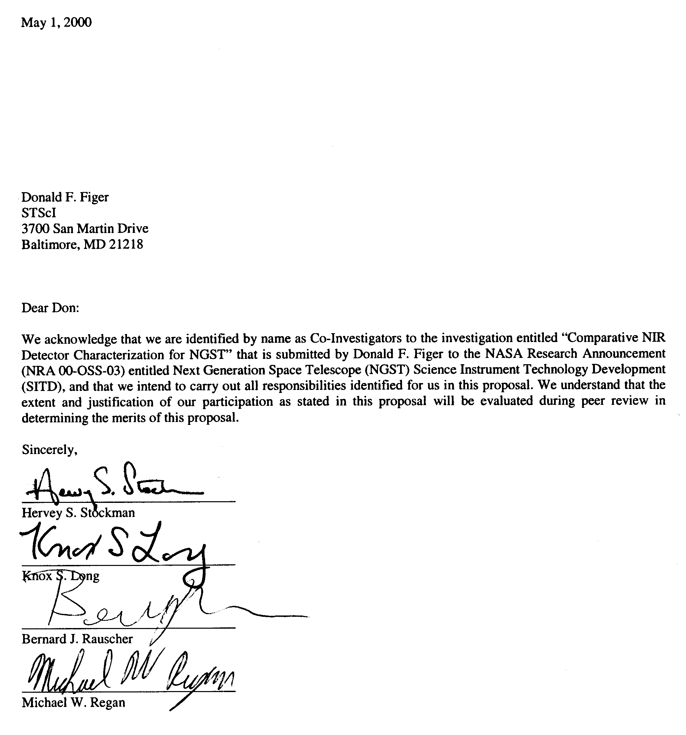

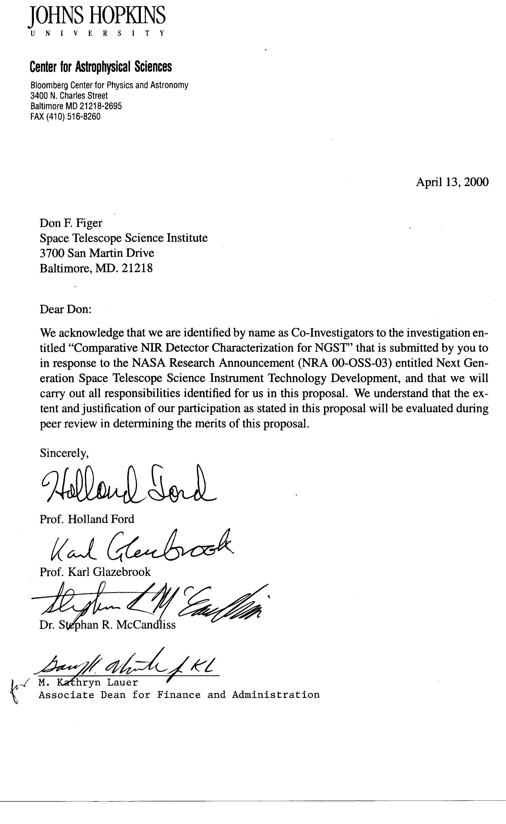
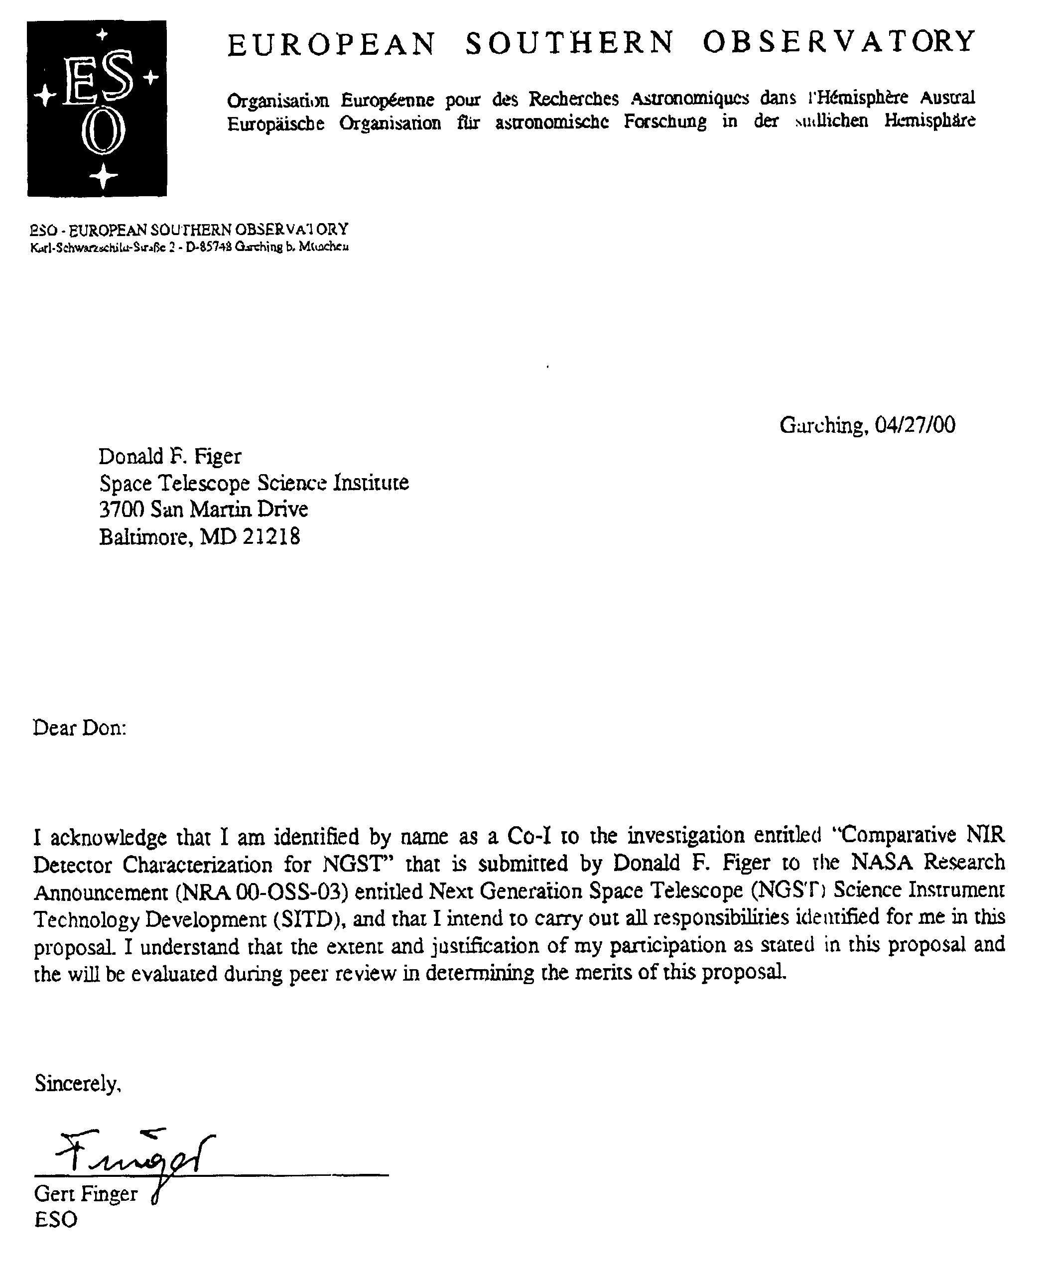

April 25, 2000
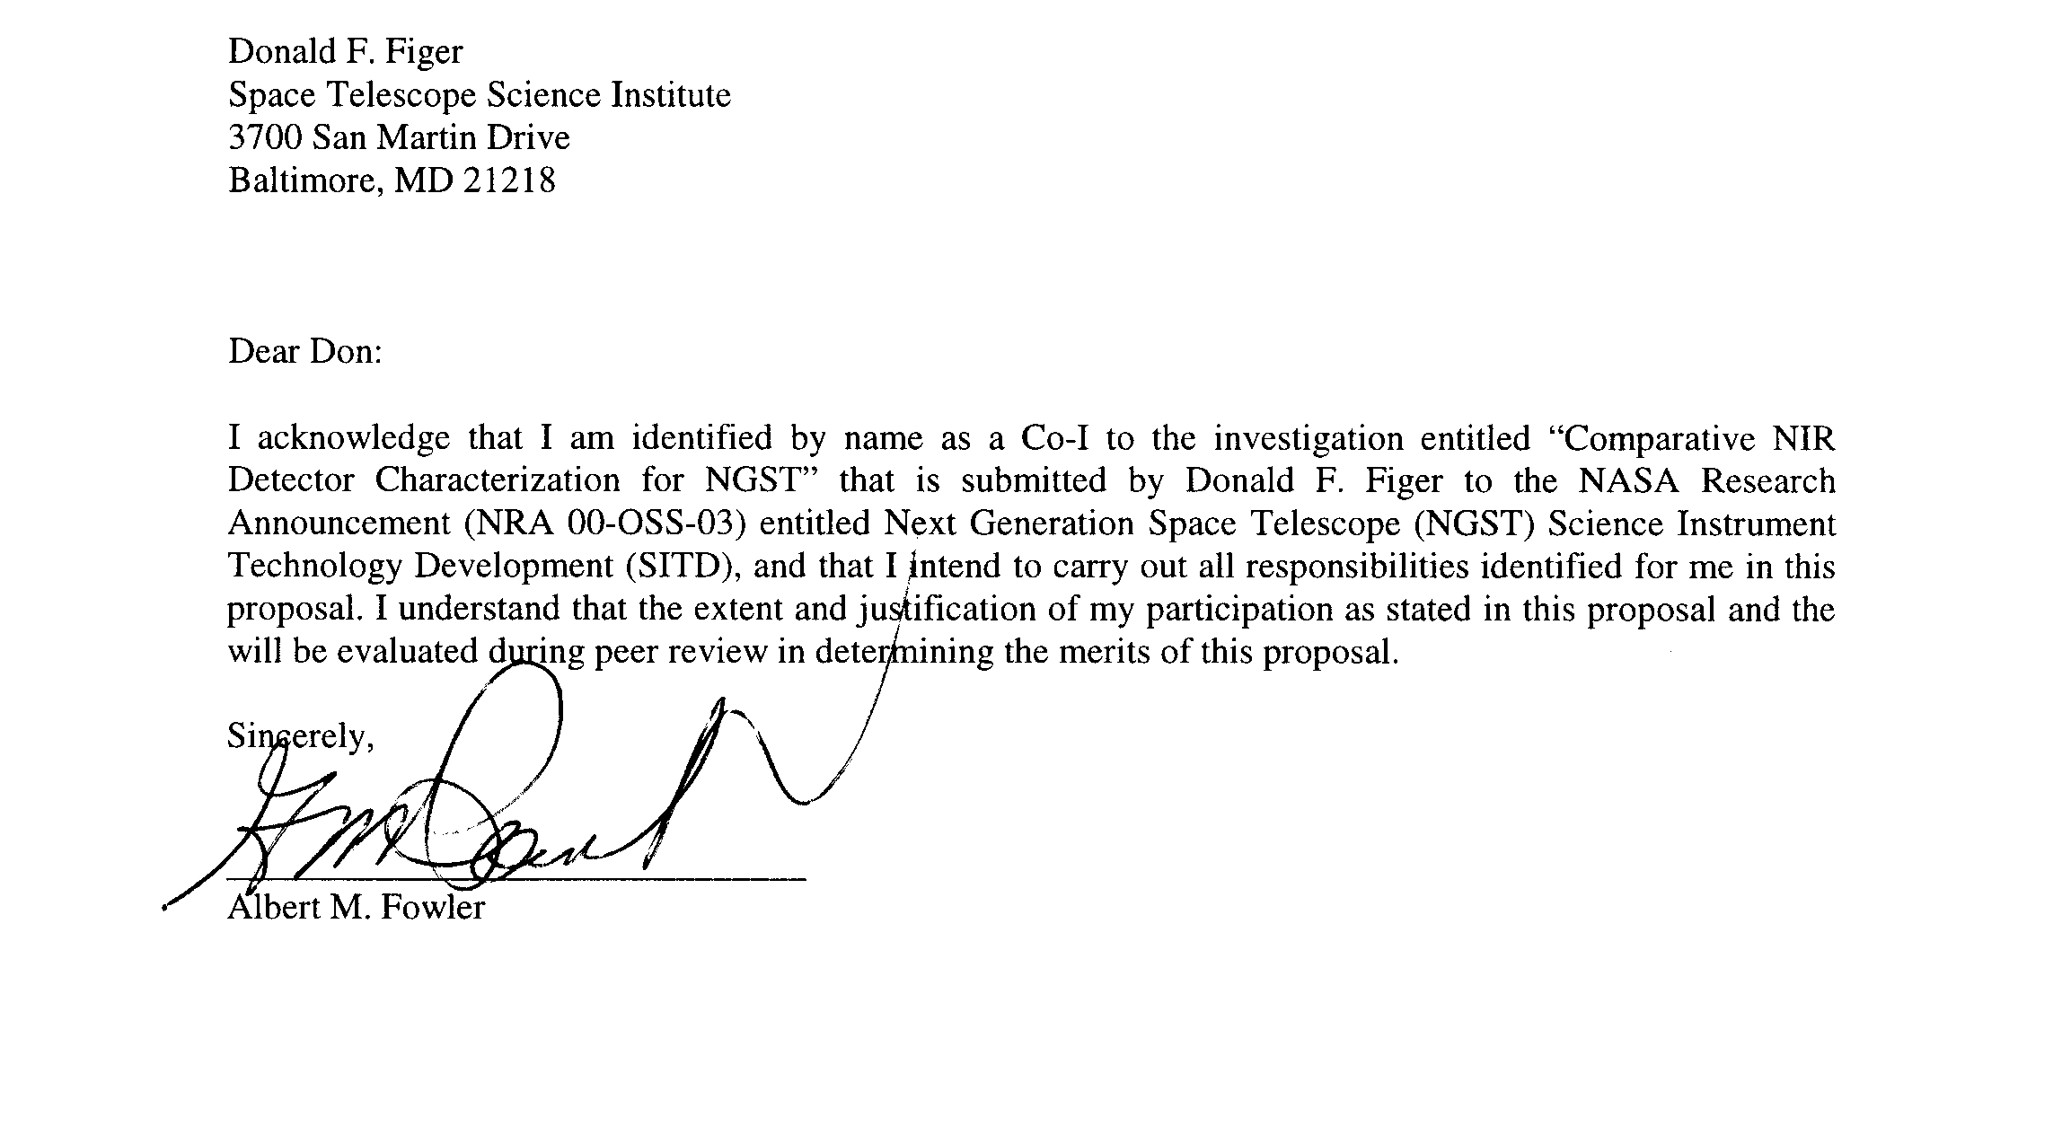

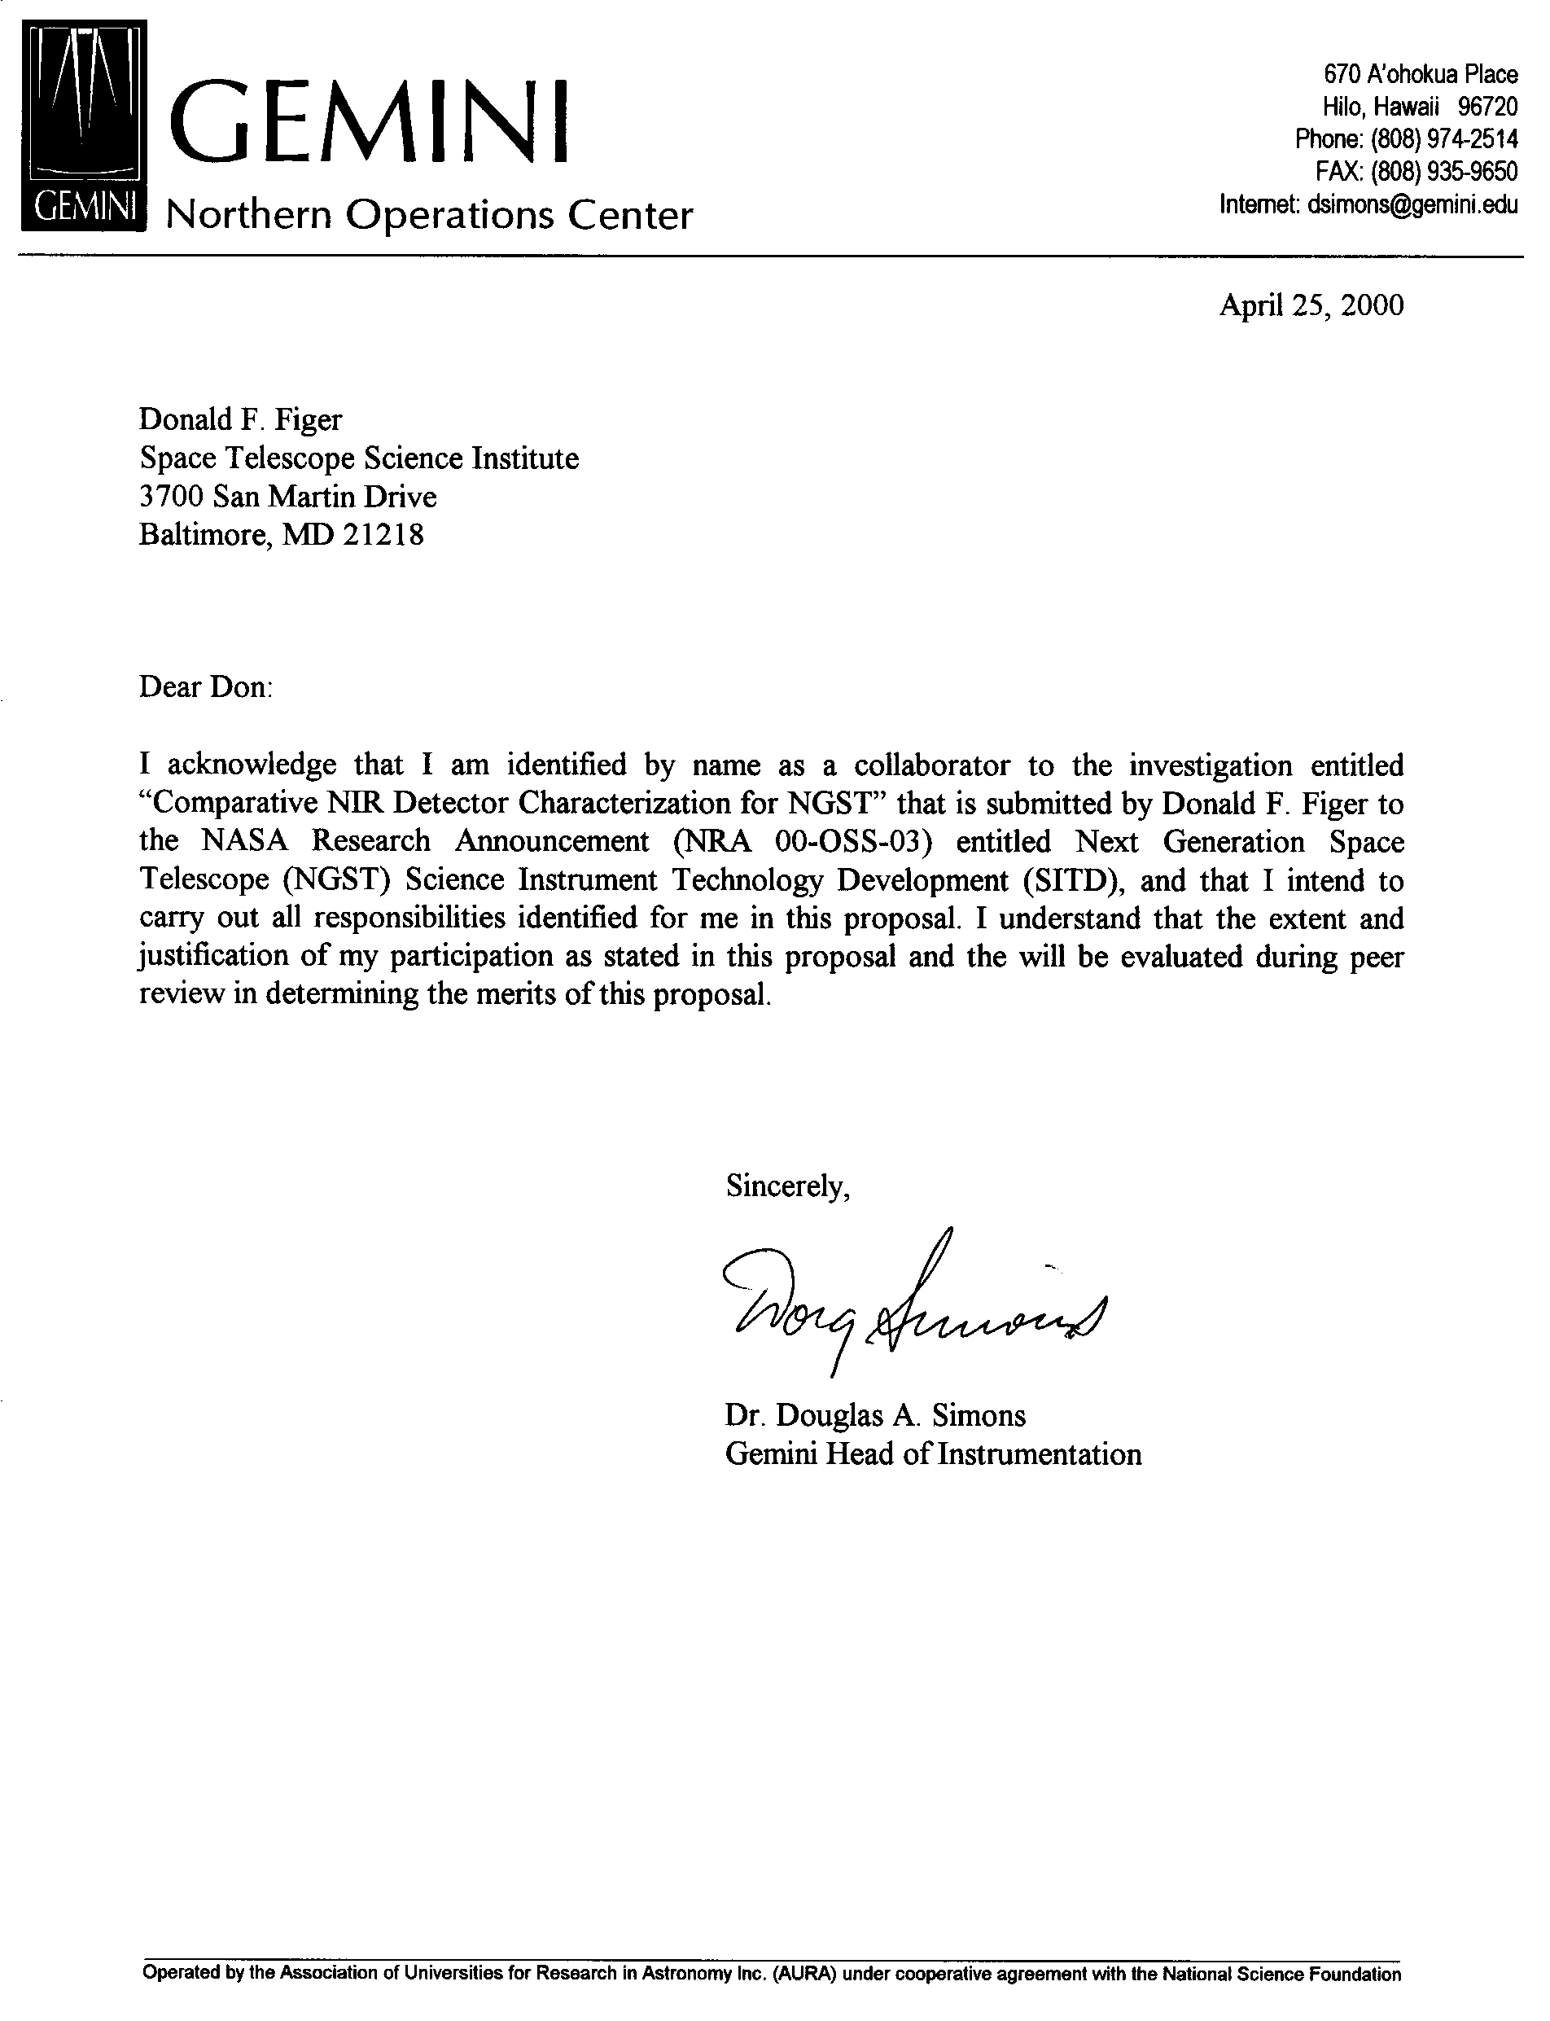

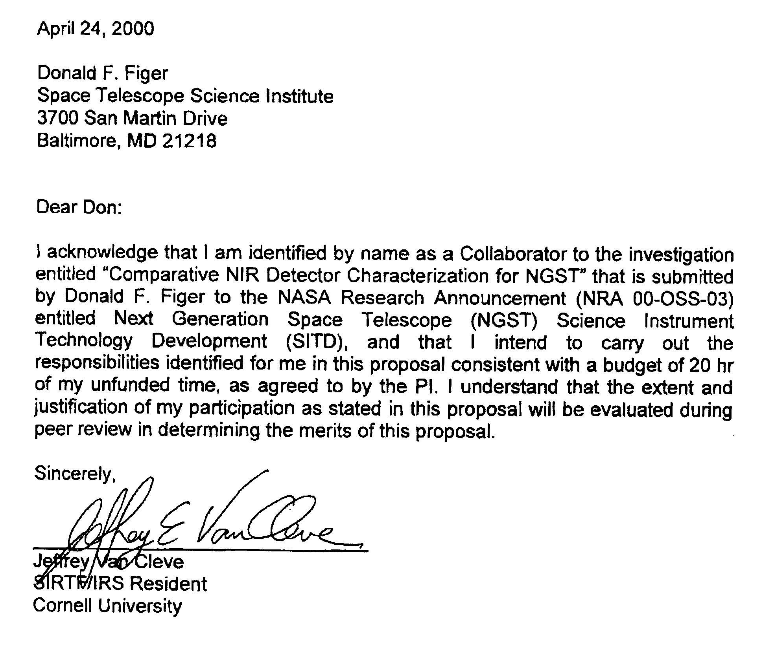

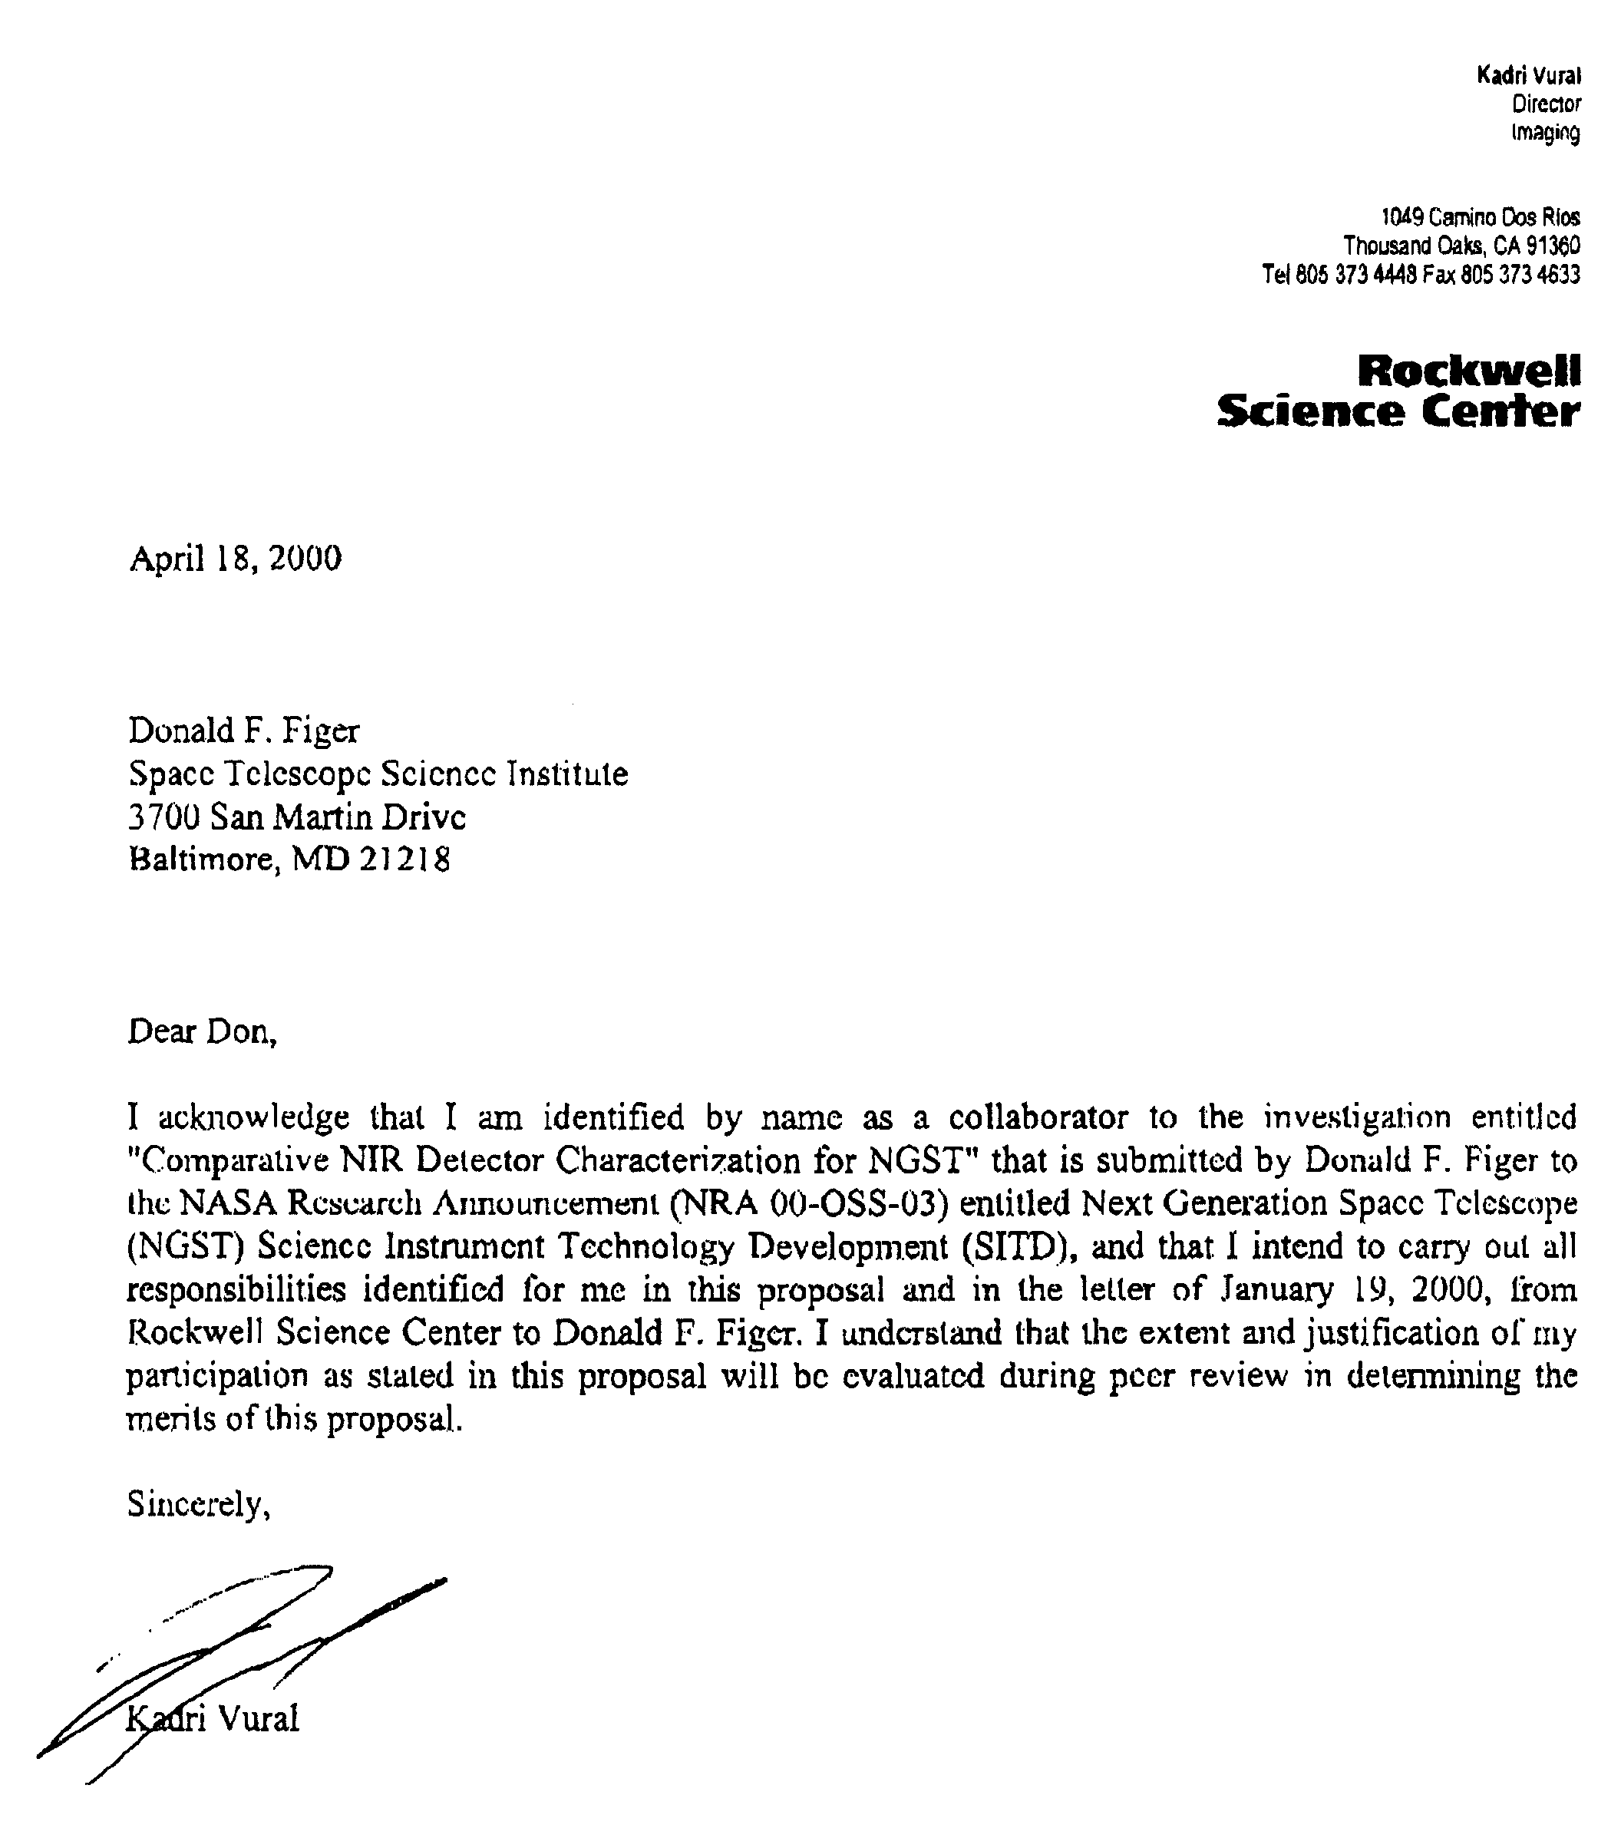

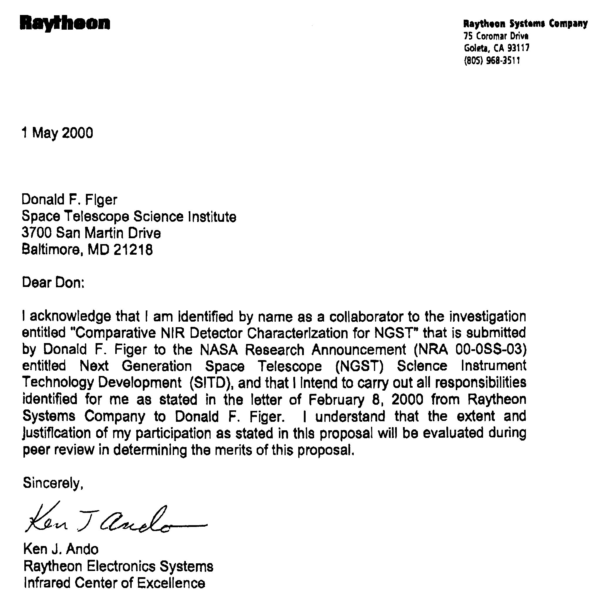

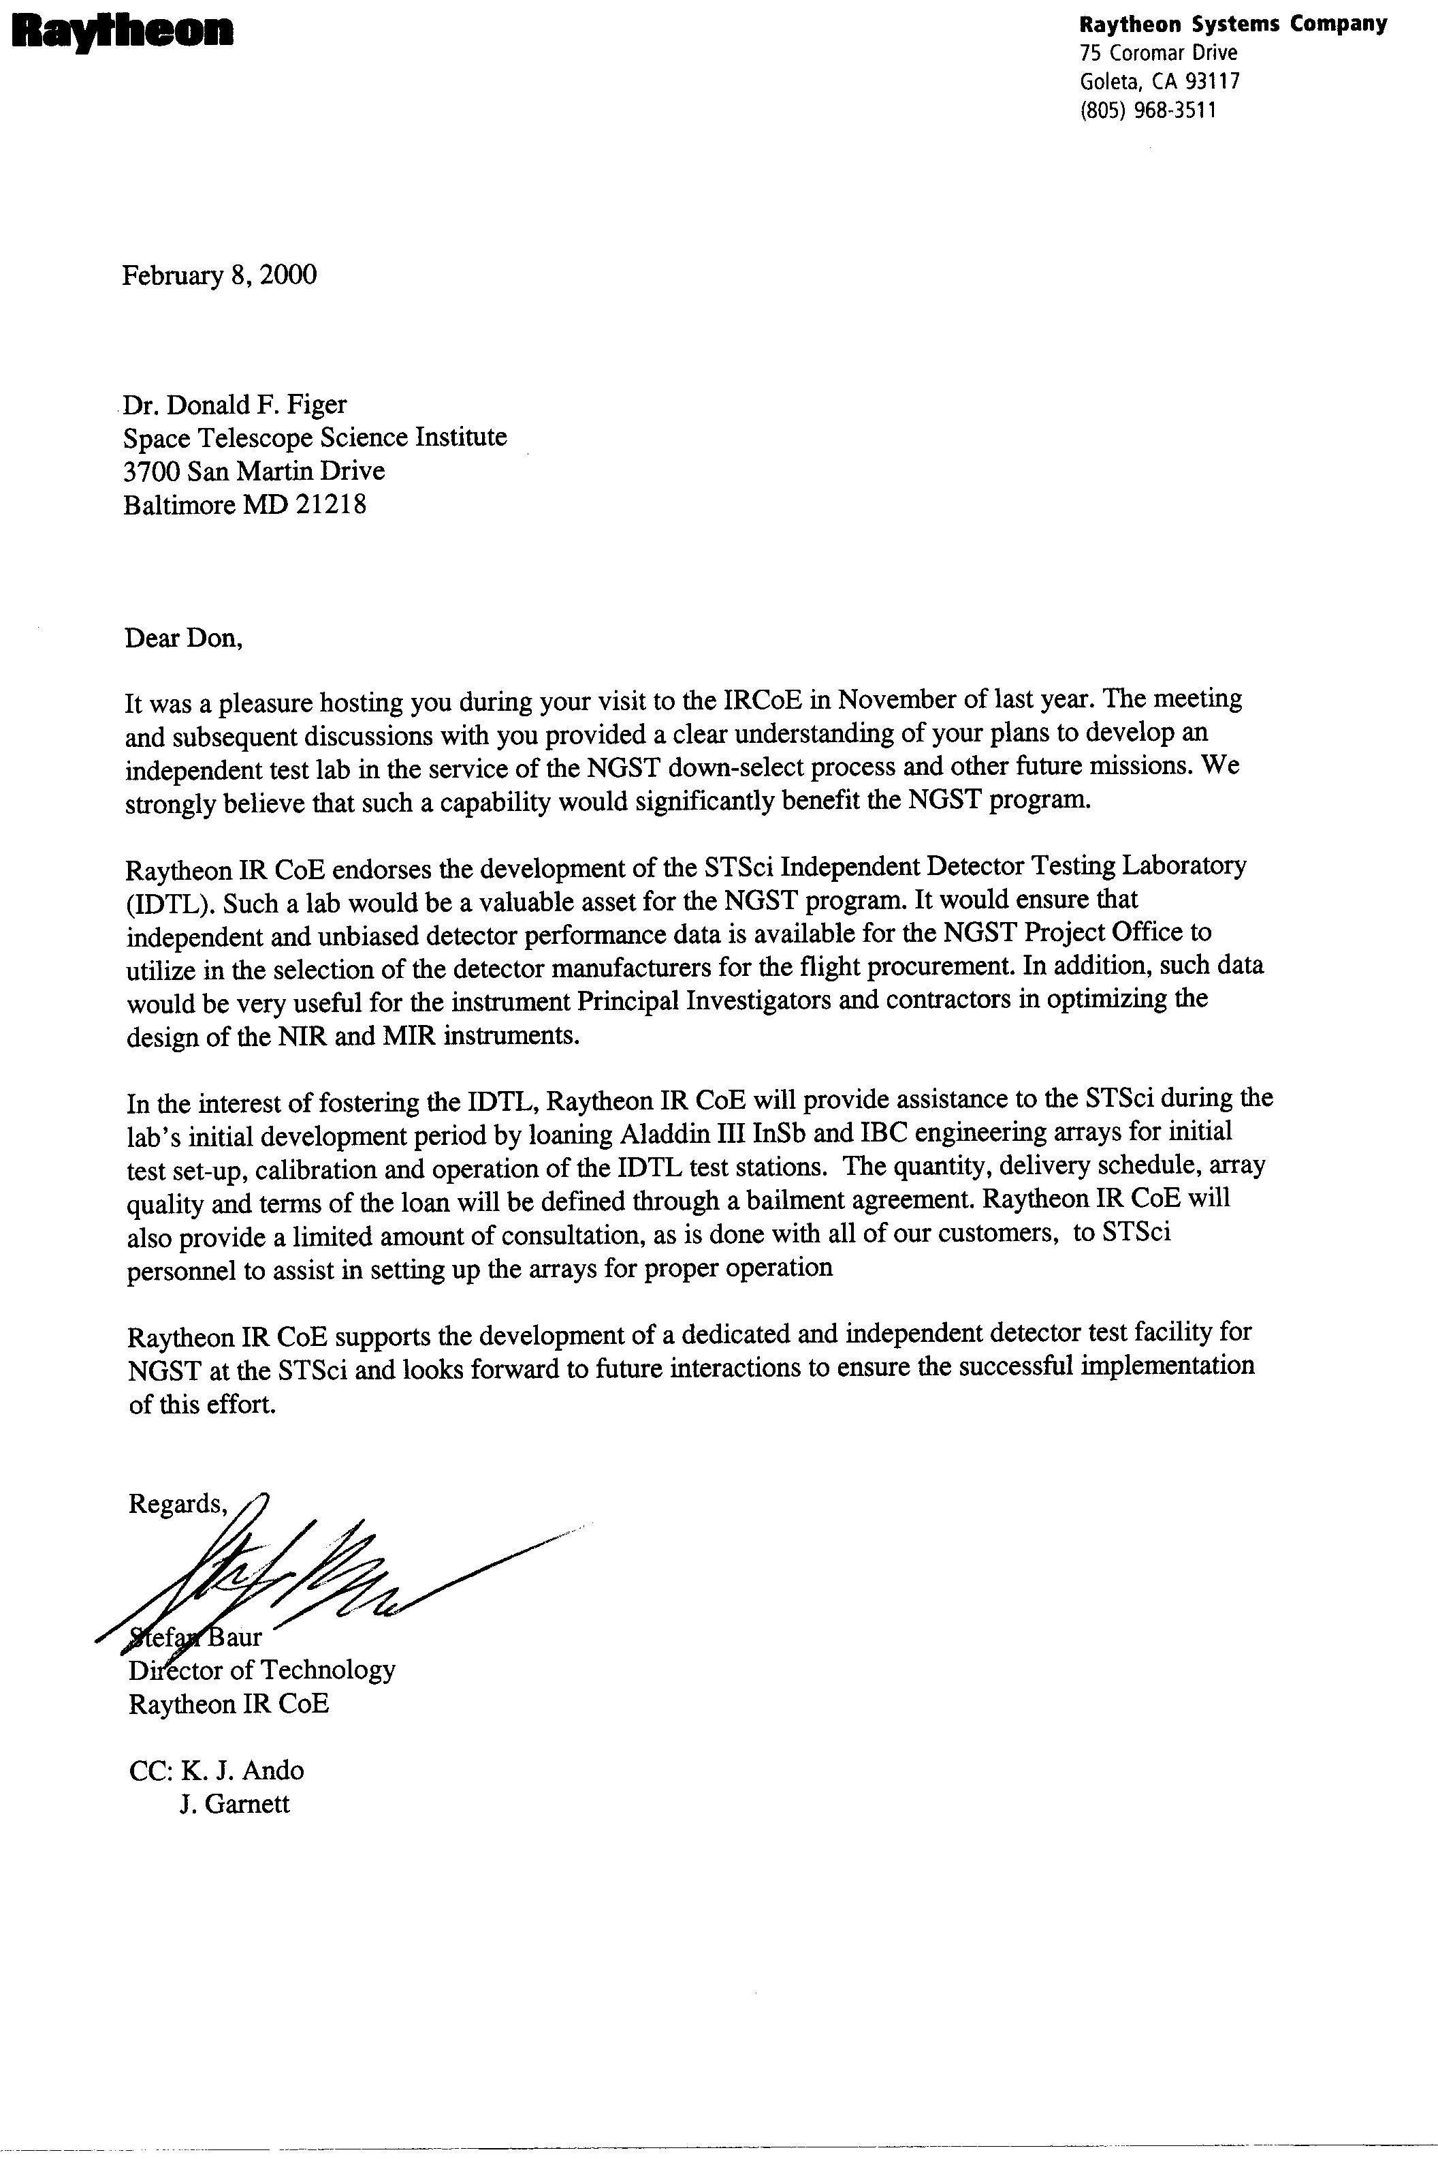
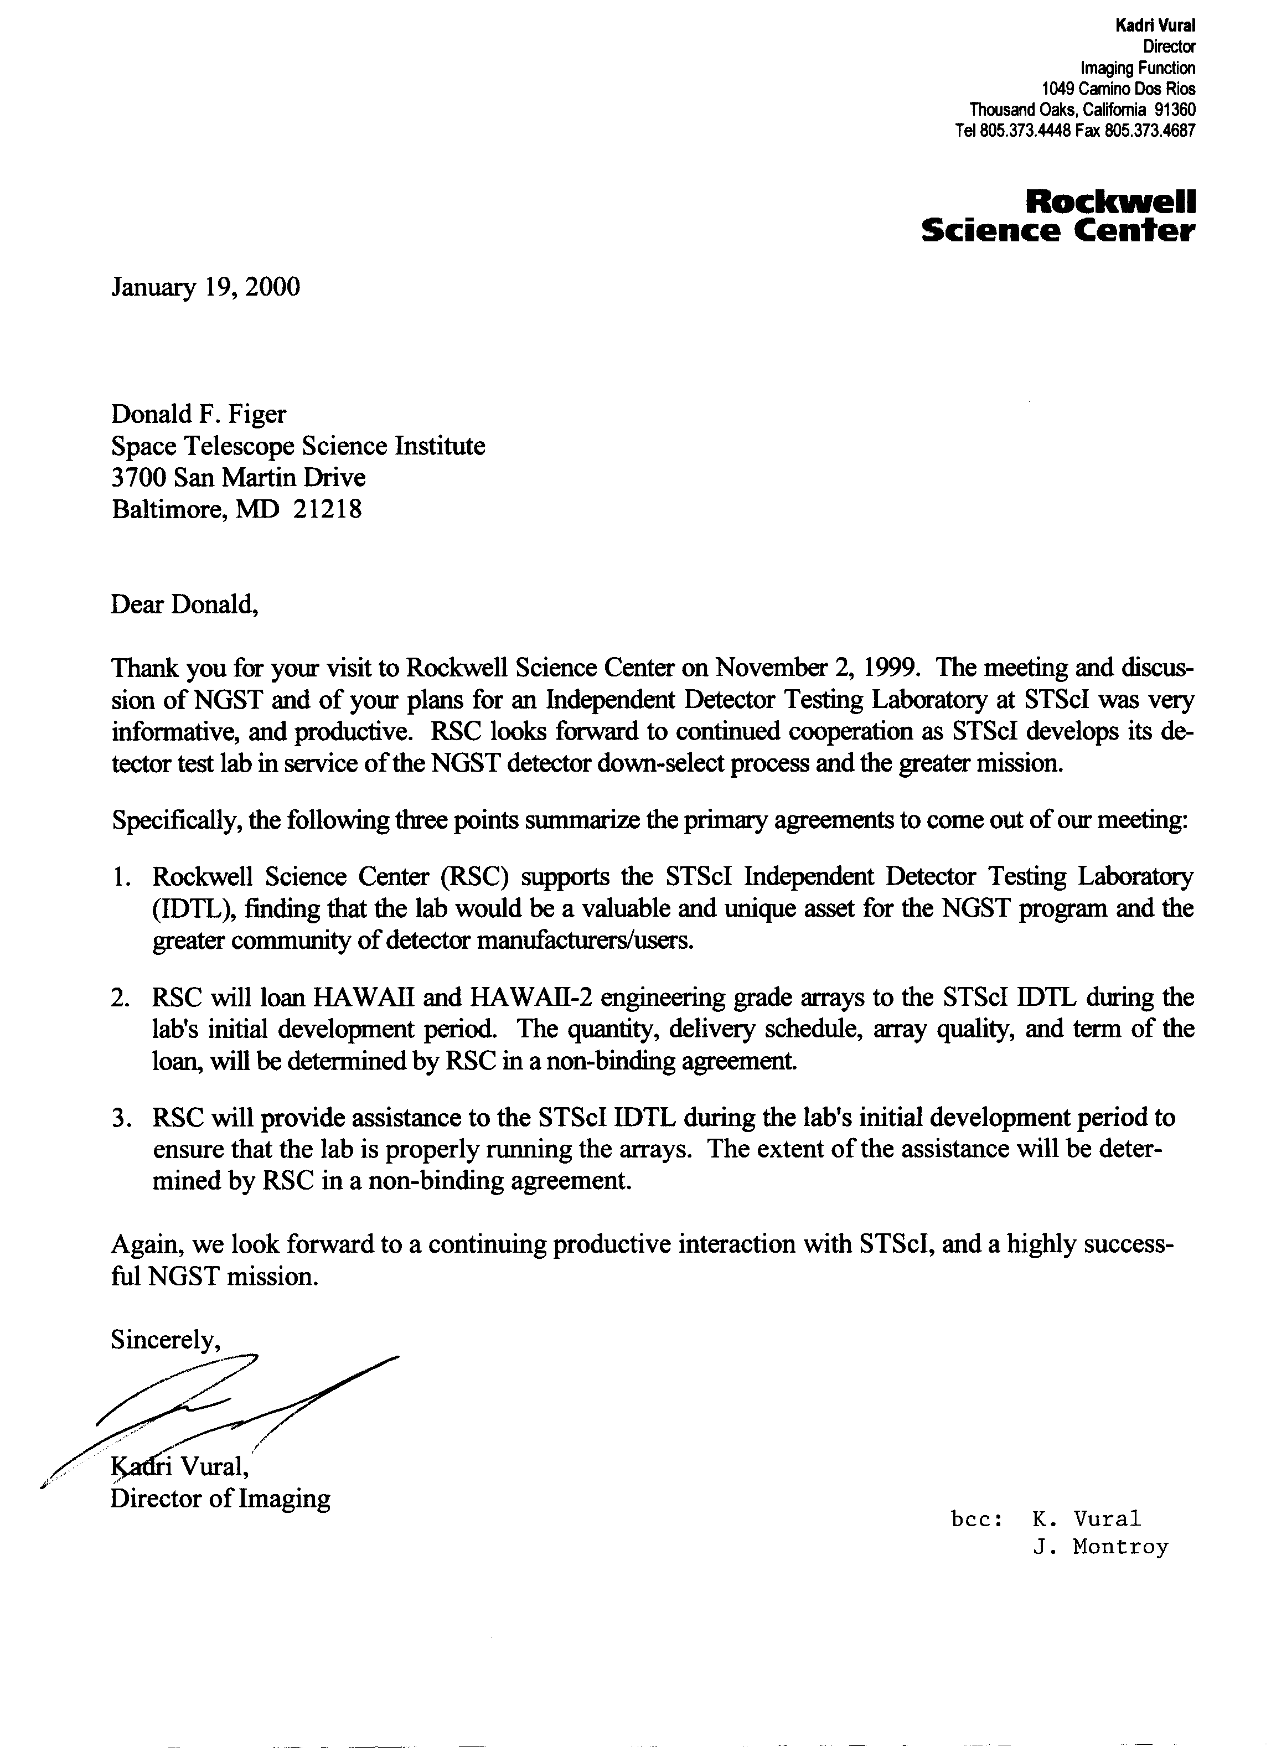
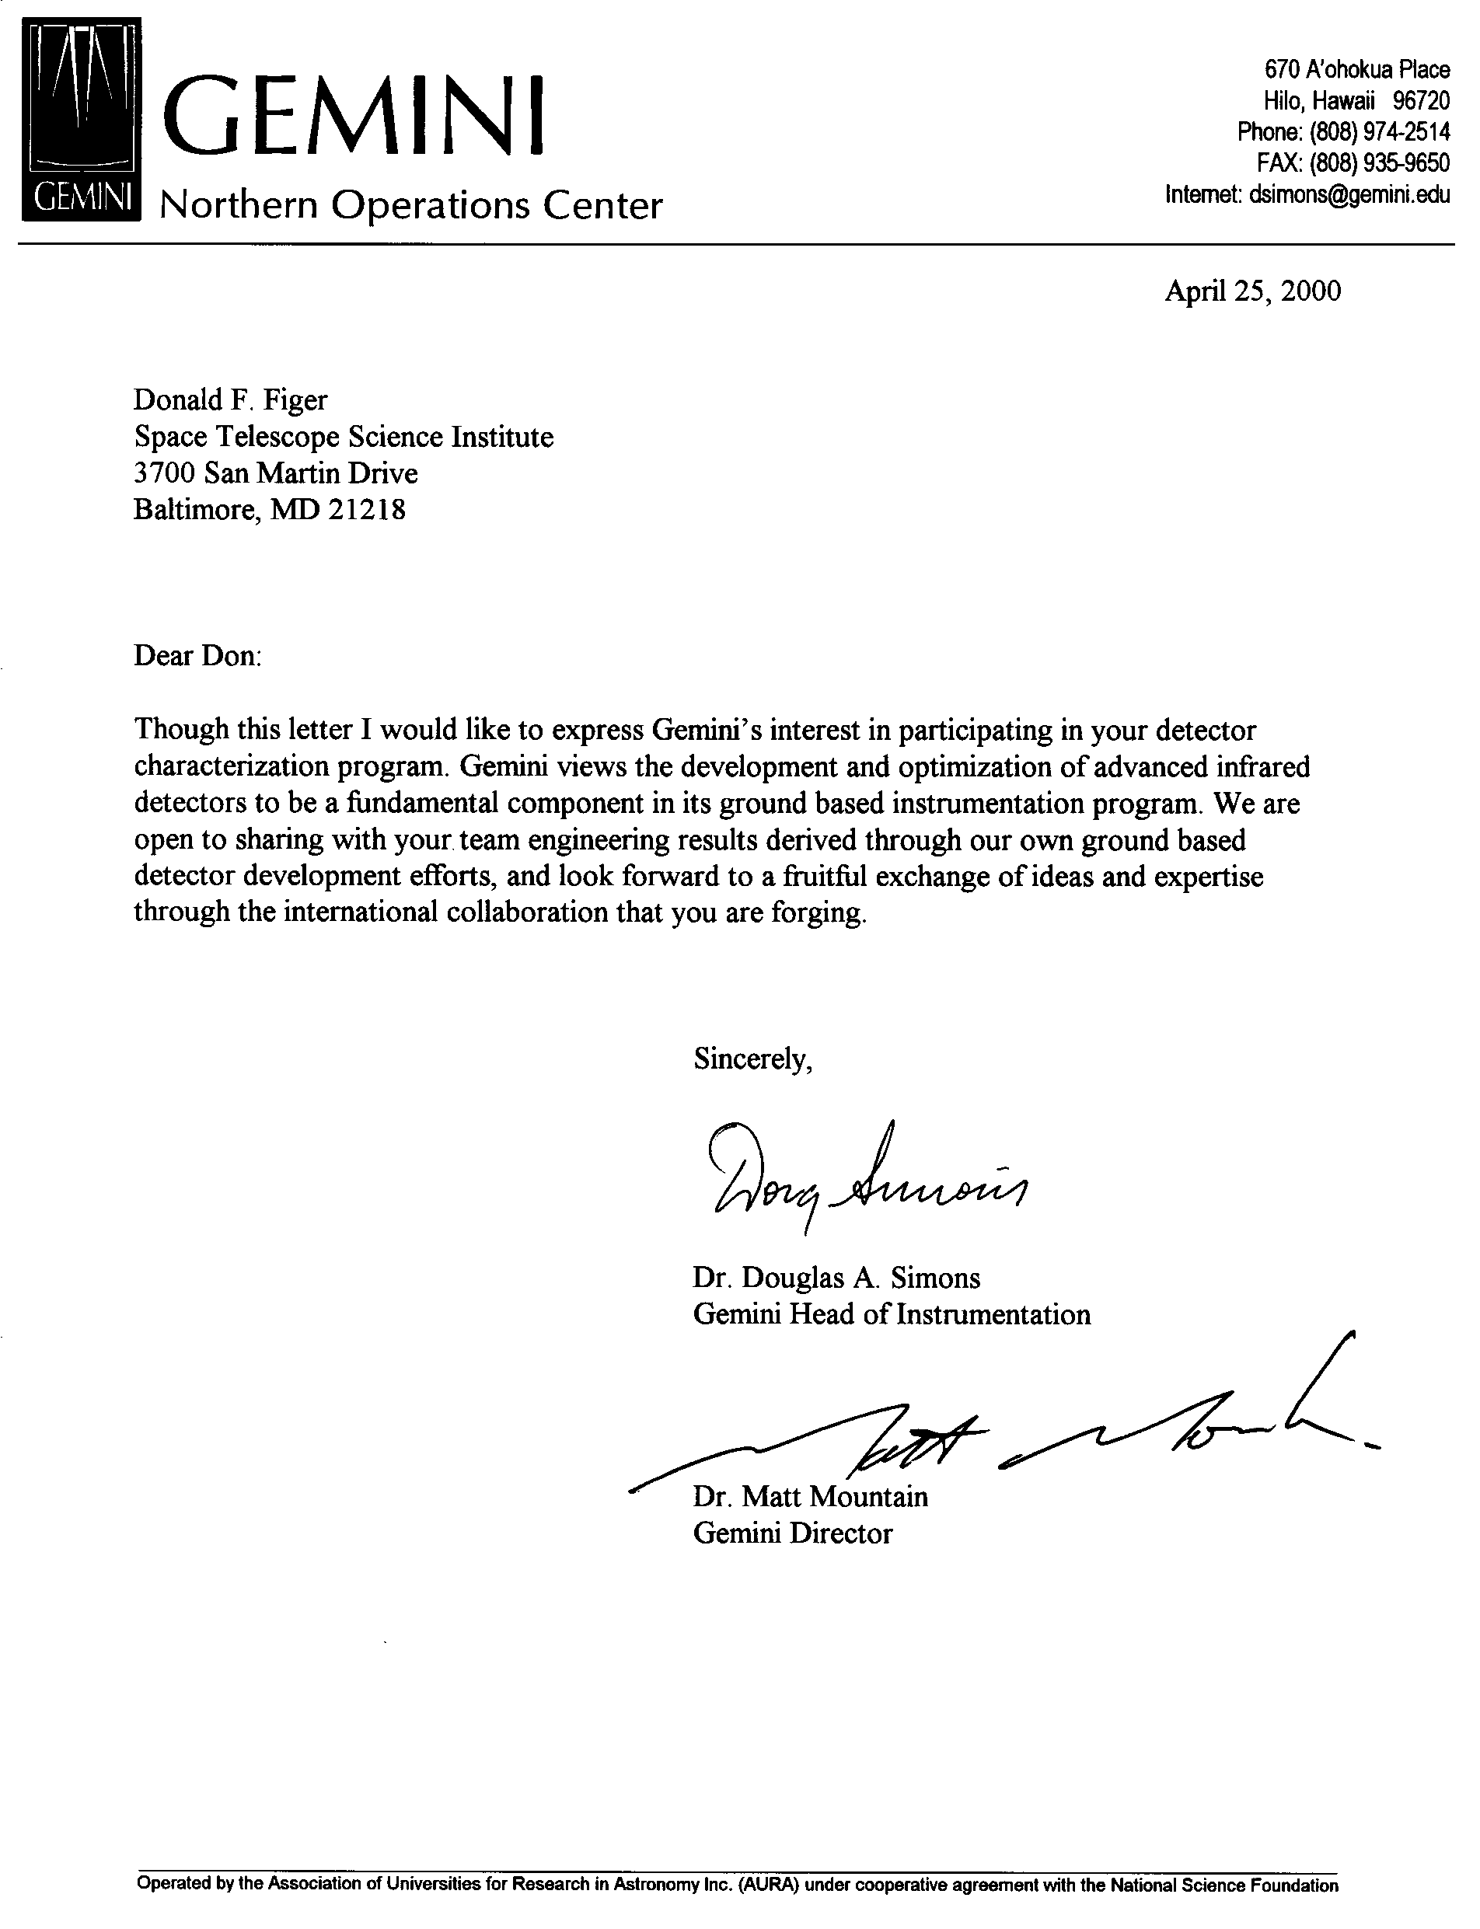
Through

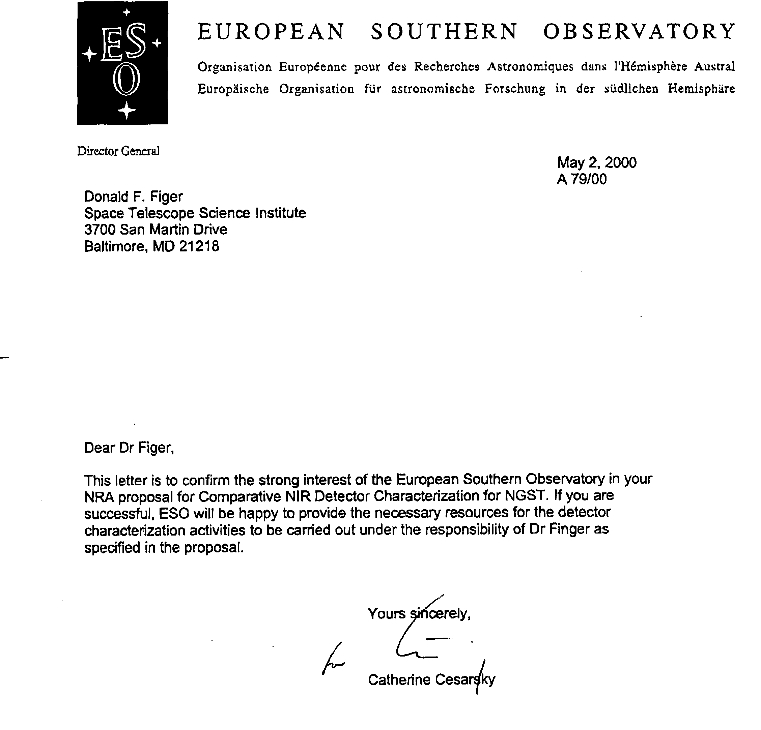
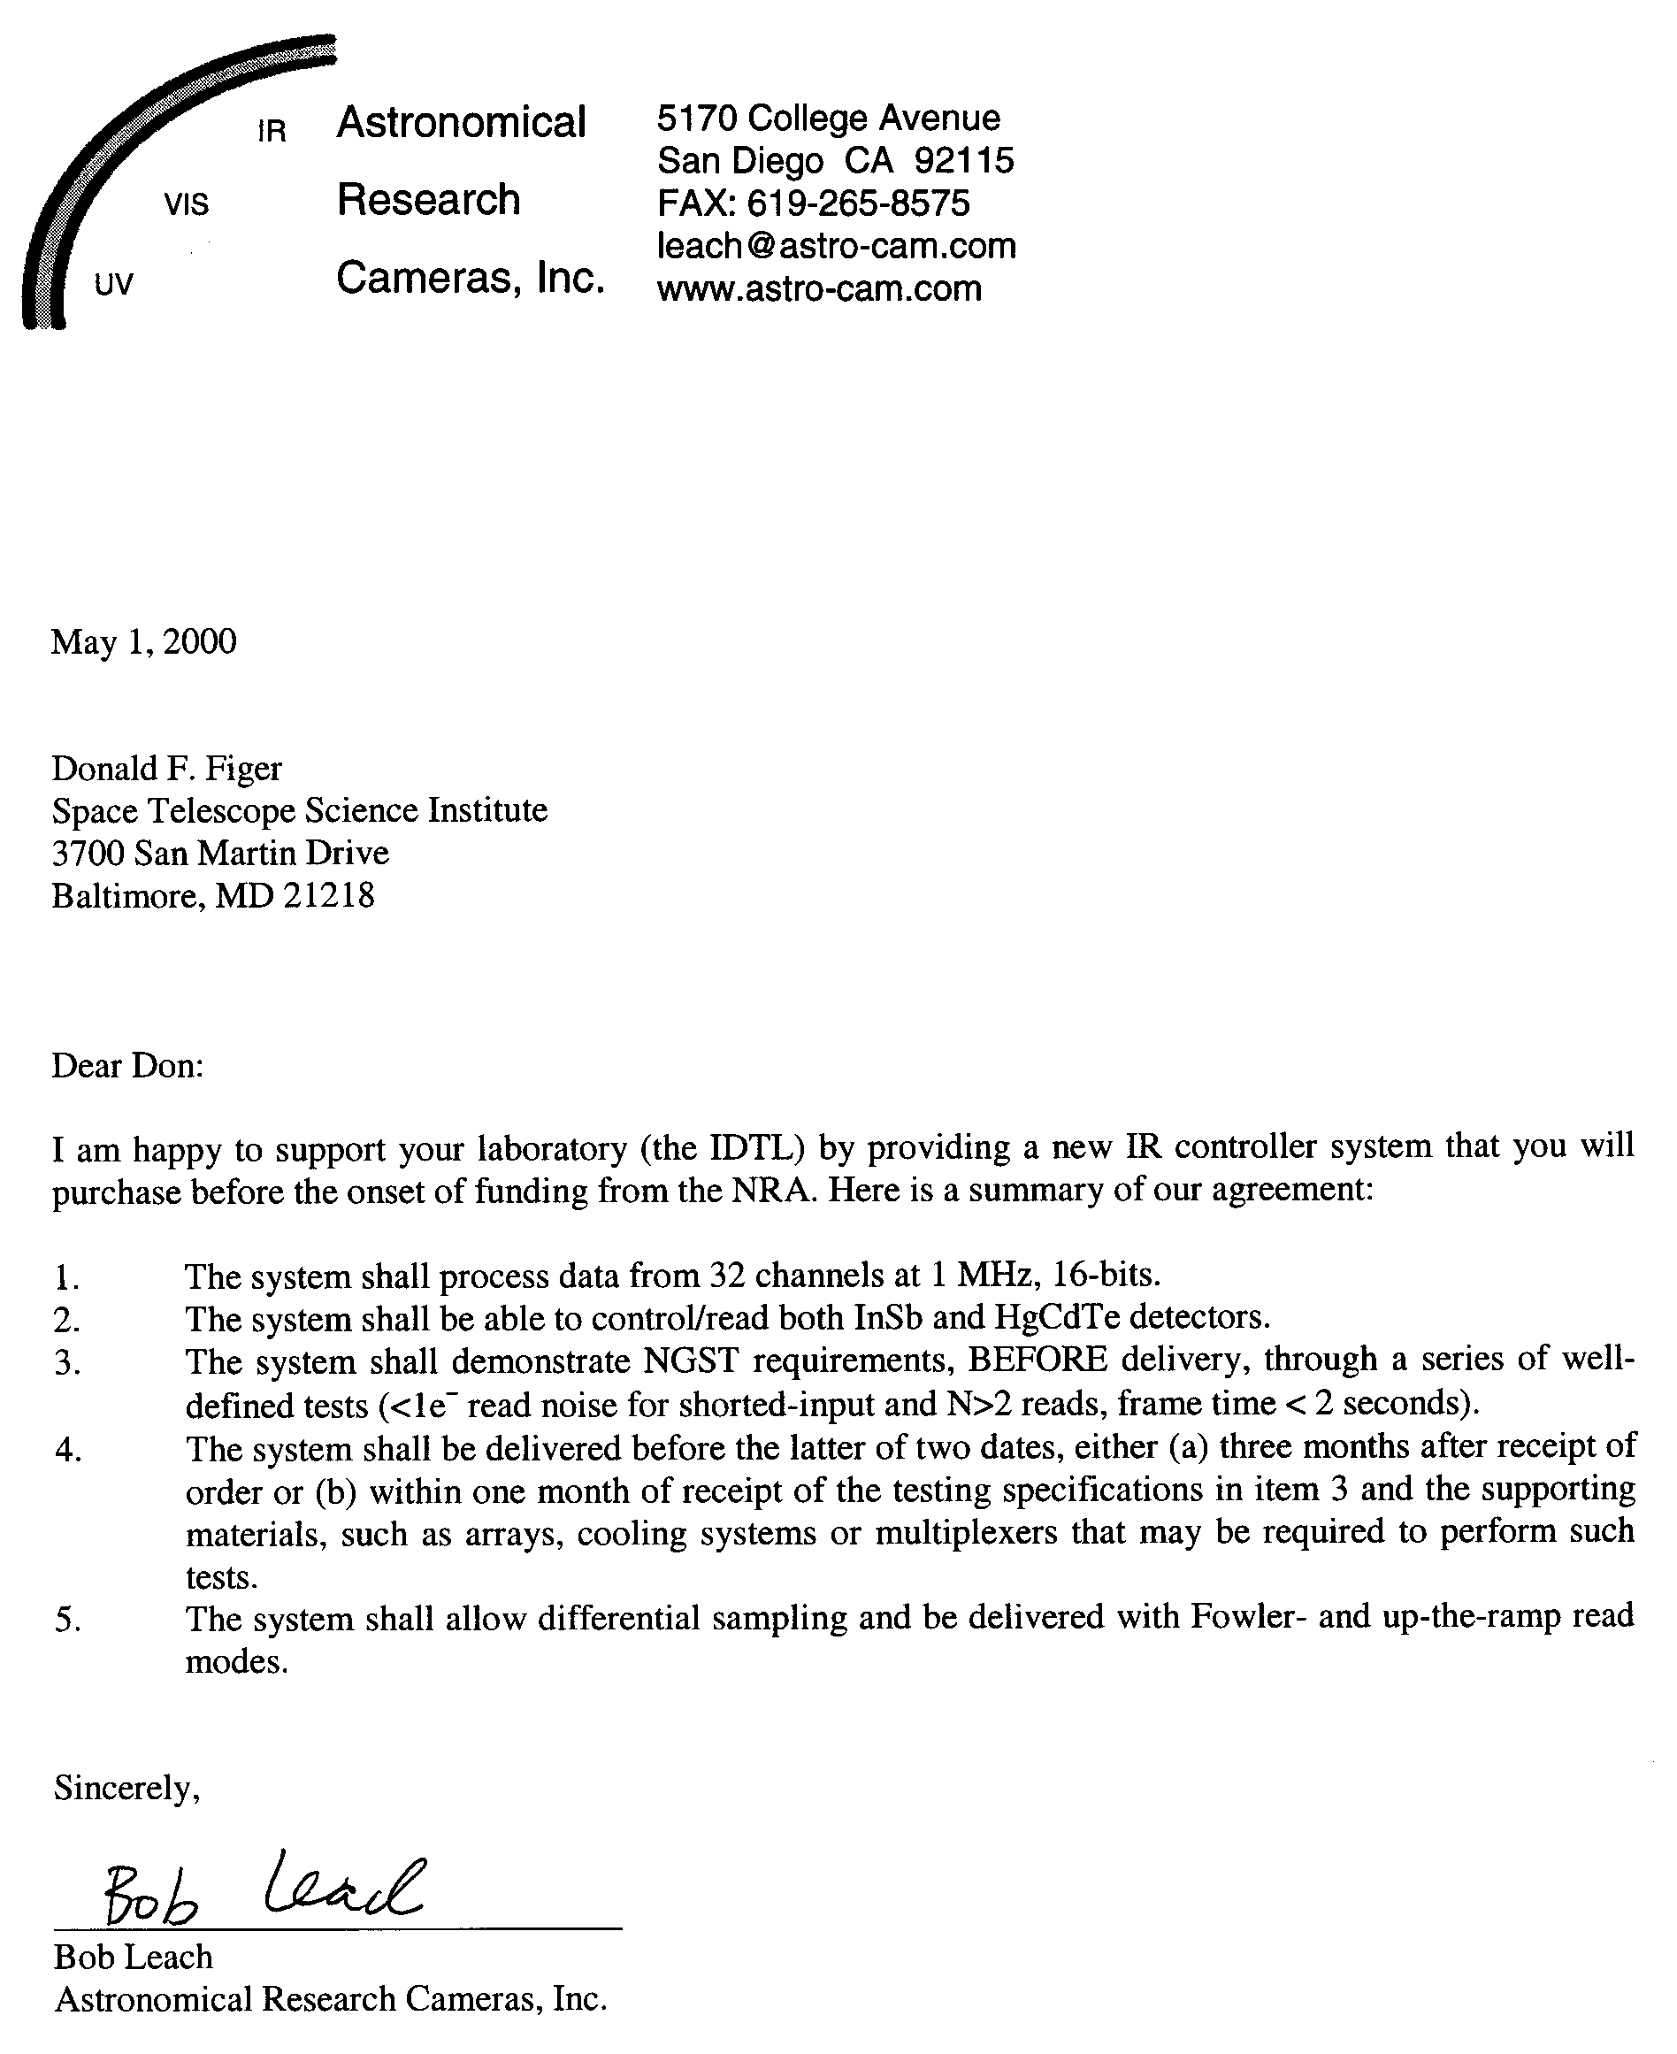

8.0 Research Budget Summary and Details

Strictly speaking, noise in dark current may not follow the Poisson statistics that are applicable to shot noise. Until more is known, however, we follow the current convention of relating noise in dark current, s_{dark}, to the accumulated dark signal, i_{dark}t by σ_{dark} = (i_{dark}t)^{1/2}.
Rockwell’s new MBE arrays are grown onto a CdZnTe substrate. Because this material is a better lattice-match to HgCdTe, there should be fewer charge traps and correspondingly better dark current in MBE devices.

