NDC 3.1.2.4
DCC Noise Baseline Tests

Author: Ernie Morse

Initial release reviewed by: Don Figer

Latest revision: 11/22/02

1. Introduction
This document describes read noise baseline tests performed in the IDTL. These tests were conducted using shorted DCC boards with two configurations of the Leach box (sitting on the bench and attached to the dewar). All tests were performed with the standard read noise test script (readnoise_test.pro), using a parameter file modified so as to disable detector temperature control. See the sections below for details and results of the testing.

2. Read Noise Experiment Description
The goal of this experiment is to obtain a measurement of read noise for various read modes, i.e. Fowler sampling (with 1, 2, 4, 8, 16, and 32 pairs of reads). The detector temperature is not varied in this version of the experiment because a detector is not present in the system. The standard IDTL reduction/analysis code is used, and reference pixel correction is performed for the H1R and H1RG data.

Three images with the minimum possible exposure time are taken for each read mode. The images are saved as a 3D array (“data cube”). This array can be abstracted as a stack of the individual reads (represented by 2D arrays) in the Fowler exposure. For instance, a Fowler-8 exposure (16 reads) with a 1024-by-1024 detector array produces a 1024 x 1024 x 16 data cube.

The image data cubes are processed into a 2D frame; for Fowler-1, this is just a subtraction of the 1st read from the 2nd, while for Fowler-N, the average of the first N reads is subtracted from the average of the 2nd N reads. The resulting image can optionally be subjected to reference pixel correction. Read noise is calculated on the difference of two such processed 2D frames in order to correct for residual bias effects. For each trio of images taken with a specific read mode, two such difference images are created; one is created by subtracting the first image from the second, and another is created by subtracting the second image from the third. These difference images serve as the inputs for the read noise analysis procedure.

The process of calculating the read noise of a difference image is initiated by making a histogram of all pixel values within 5-sigma of their median value. This histogram is then fit to a Gaussian, and the standard deviation is taken from the fit parameters. This value is divided by the square root of 2 to account for the fact that the calculation is being performed on the difference of two images and is reported as the read noise (in ADU) of the difference image.

For each read mode, the read noise results for the two difference images are averaged together and reported as the read noise for that read mode.

3. Video Board Parameters
The experiments are performed using three different video boards. One board has a video gain of 14.3, while the other two both have a video gain of 40. The signal bandwidth of the 14.3x board is 80 kHz, while it is 160 kHz for both of the 40x boards. One of the 40x boards has a 160-kHz bandwidth for the references, while the other has a 16-kHz bandwidth for the references.

The 14.3x board has a input-referred gain of 10.67 microvolts per ADU, while the 40x boards have an input-referred gain of 3.81 microvolts per ADU.

The board used for each experiment is noted in the explanatory text preceding the results. In the case of the 40x boards, it should be assumed that the one with 160 kHz gain on the references is used unless otherwise noted.

4. Conversion Gain
The conversion gain measured by the IDTL’s photon transfer experiment is 2.8 electrons per ADU for the Rockwell H1RG SCA.

5. Baseline Tests with 14.3X Gain Board and H1RG DCC
The following tests were conducted with the gain 14.3 board connected to the H1RG. The DCC was shorted at the Nanonics plug (DB37) to which the detector is connected, with the two video output channels connected with a 1k-ohm resistor to the DSUB channel. A test was conducted with the Leach controller and DCC on the bench, and the test was then repeated with the controller and DCC mounted on the dewar.

Bench | # of Sample Pairs
Bench | 1 | 2 | 4 | 8 | 16 | 32
Read Noise (ADU) | 2.5 | 1.8 | 1.3 | 0.9 | 0.6 | 0.4

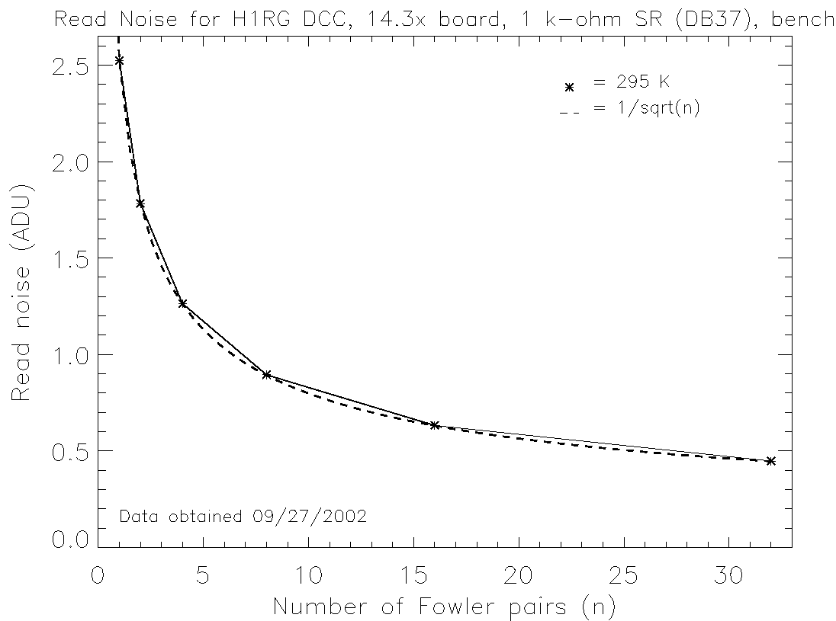

Dewar | # of Sample Pairs
Dewar | 1 | 2 | 4 | 8 | 16 | 32
Read Noise (ADU) | 2.5 | 1.8 | 1.3 | 0.9 | 0.6 | 0.5

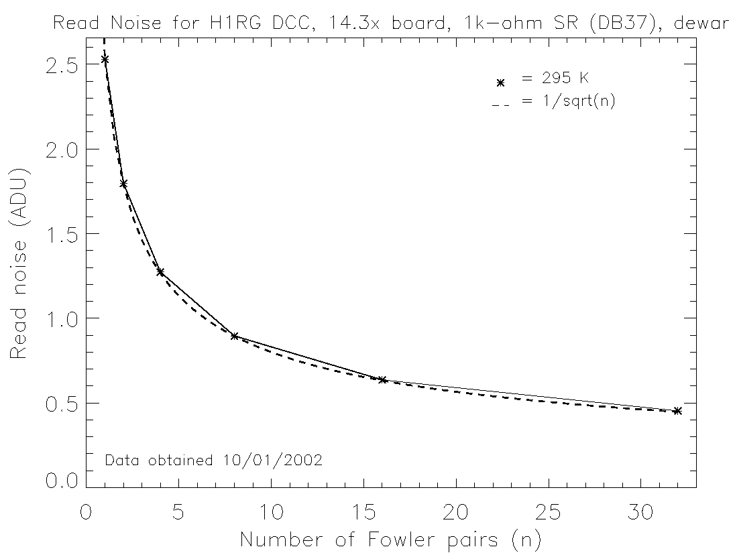
For comparison purposes, the following plot and table present data for the same DCC and video board, tested under the same conditions in July, 2002. The data was reduced using the same process as that used to produce the data shown above.

Bench  (July, 2002) | # of Sample Pairs
Bench  (July, 2002) | 1 | 2 | 4 | 8 | 16 | 32
Read Noise (ADU) | 2.7 | 1.9 | 1.4 | 1.0 | 0.7 | 0.5

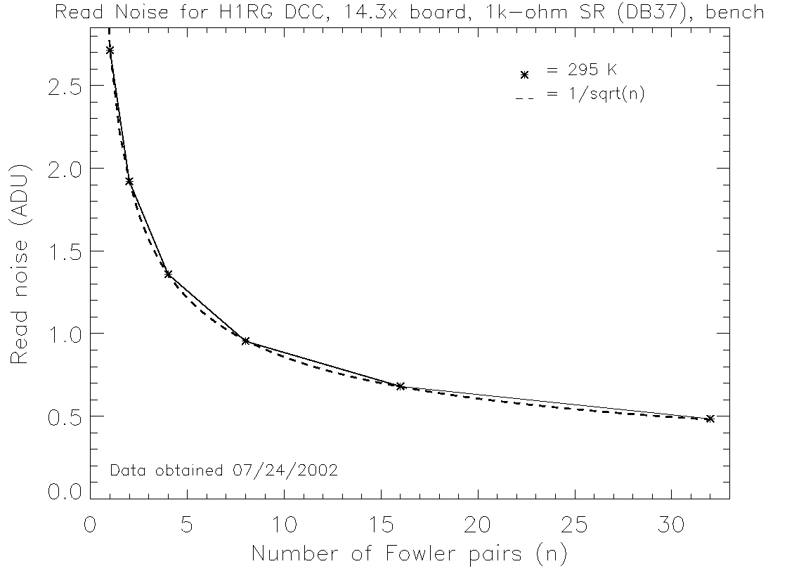

6. Baseline Tests with 40X Gain board and H1RG DCC
The parameters for this test were the same as described in Section 2, except that the video board with a gain of 40 was used in place of the gain 14.3 board. The results are presented below.

Bench | # of Sample Pairs
Bench | 1 | 2 | 4 | 8 | 16 | 32
Read Noise (ADU) | 8.5 | 6.2 | 4.4 | 3.2 | 2.2 | 1.6

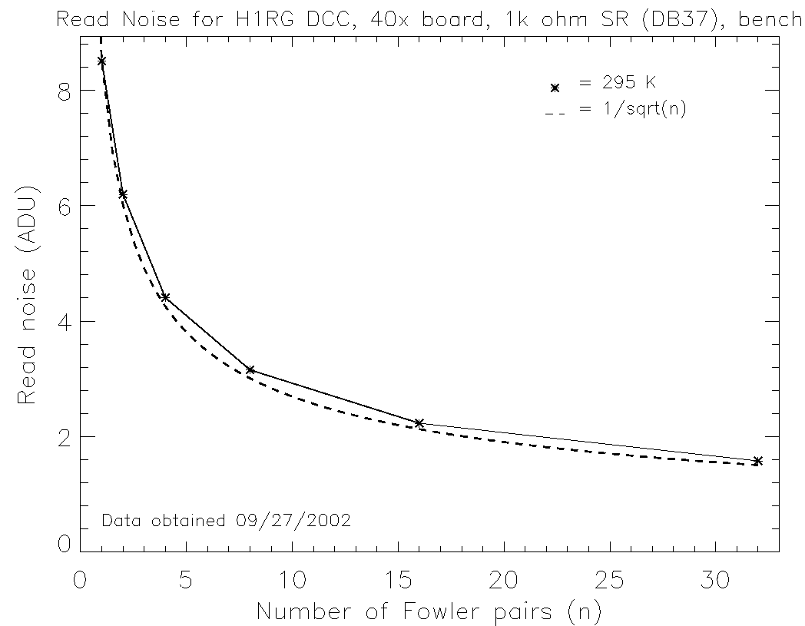

Dewar | # of Sample Pairs
Dewar | 1 | 2 | 4 | 8 | 16 | 32
Read Noise (ADU) | 7.1 | 5.1 | 3.6 | 2.6 | 1.8 | 1.3

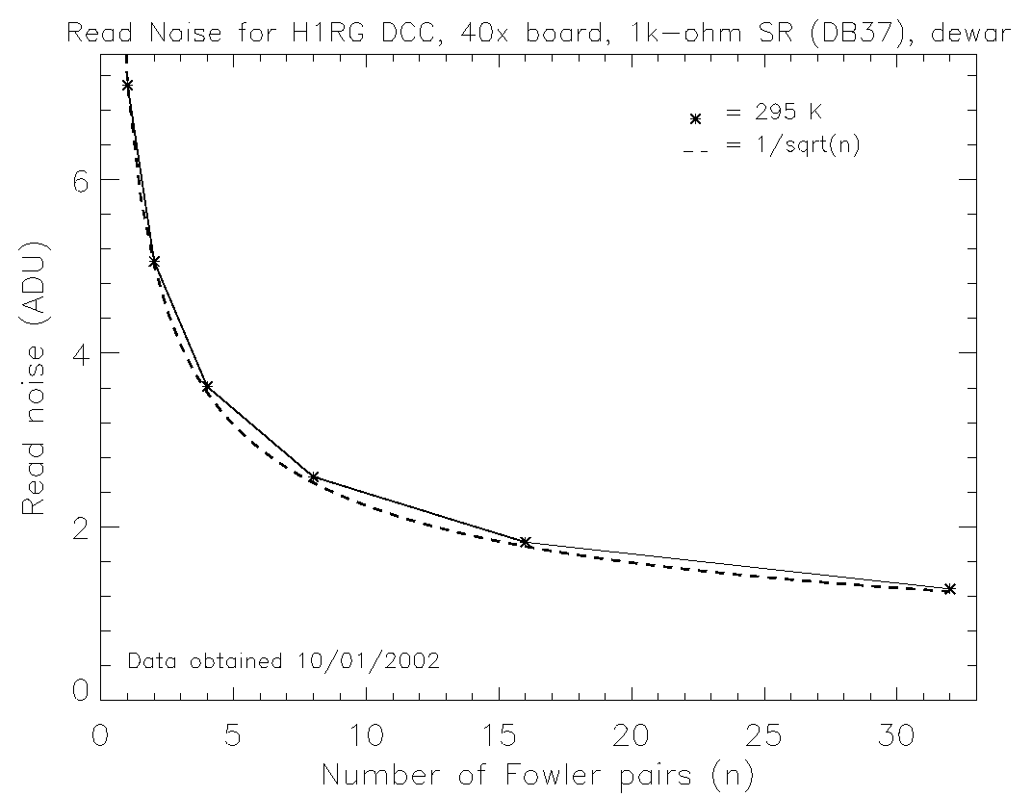

7. Baseline Tests for 14.3X Gain Board and H1R DCC
The parameters for this test were the same as described in Section 2, except that the H1R DCC was used in place of the H1RG DCC, and only bench testing was performed. The DCC was shorted at the Nanonics plug, with the four output channels connected via 1Kohm resistors to the DSUB channel. The results are presented below.
Bench | # of Sample Pairs
Bench | 1 | 2 | 4 | 8 | 16 | 32
Read Noise (ADU) | 2.6 | 1.8 | 1.3 | 0.9 | 0.6 | 0.4

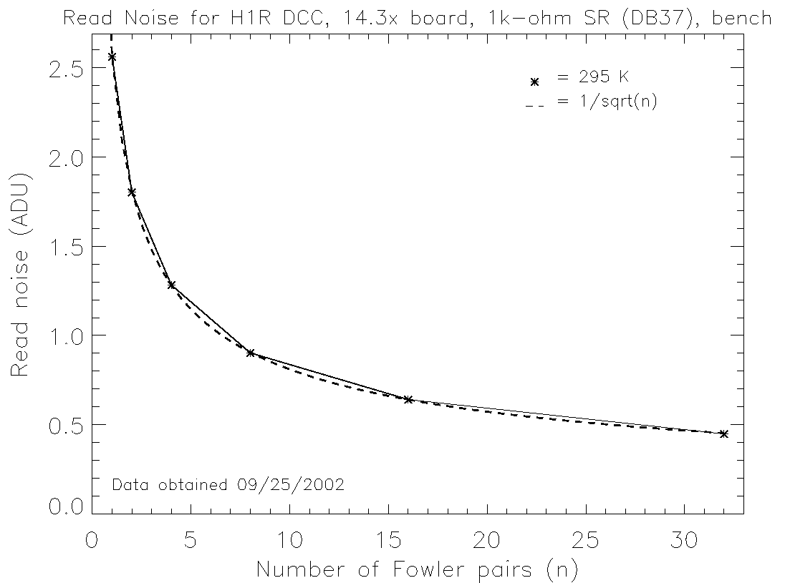
8. Baseline Tests for 40X Gain Board and H1R DCC
The parameters for this test were the same as described in Section 4, except that the gain 40x video board was used instead of the gain 14.3x board. The results are presented below.
Bench | # of Sample Pairs
Bench | 1 | 2 | 4 | 8 | 16 | 32
Read Noise (ADU) | 7.0 | 4.9 | 3.5 | 2.5 | 1.8 | 1.3

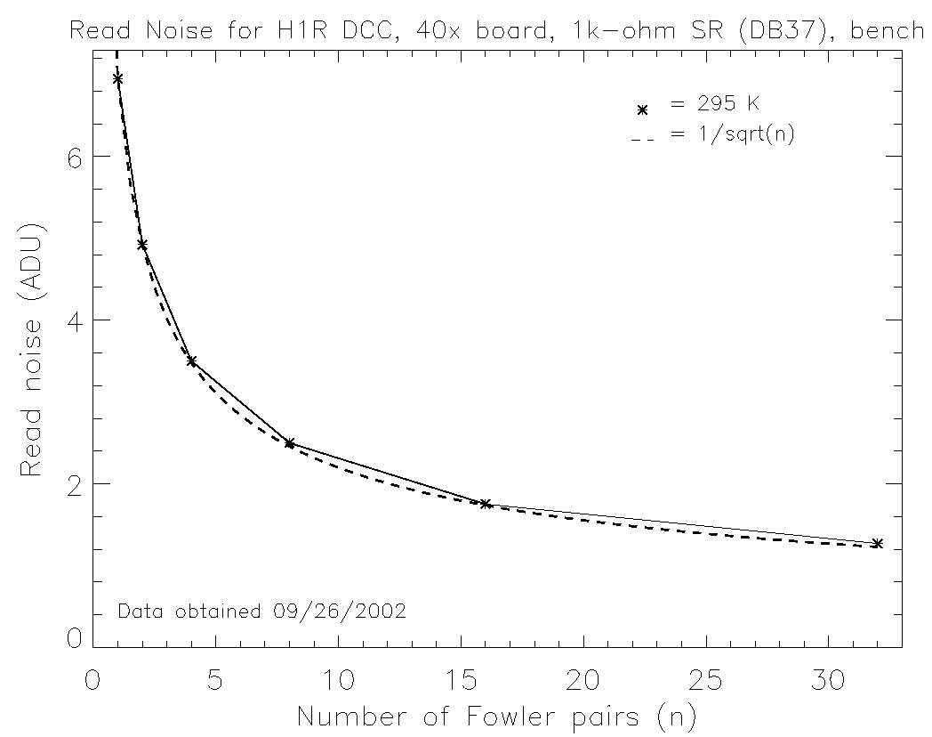
9. Baseline Tests for 40X Gain Board and SB304 DCC
This test was conducted using a 40x gain video board modified to have a 16 kHz bandwidth for the references. A 2k-ohm shorting resistor was installed at the DB37 Nanonics connection leading to the detector. Fowler-32s could not be obtained the size of these images exceeds the maximum image buffer size allowed by the IDTL’s software.
Dewar | # of Sample Pairs
Dewar | 1 | 2 | 4 | 8 | 16 | 32
Read Noise (ADU) | 10.8 | 8.2 | 6.3 | 4.6 | 3.3 | -

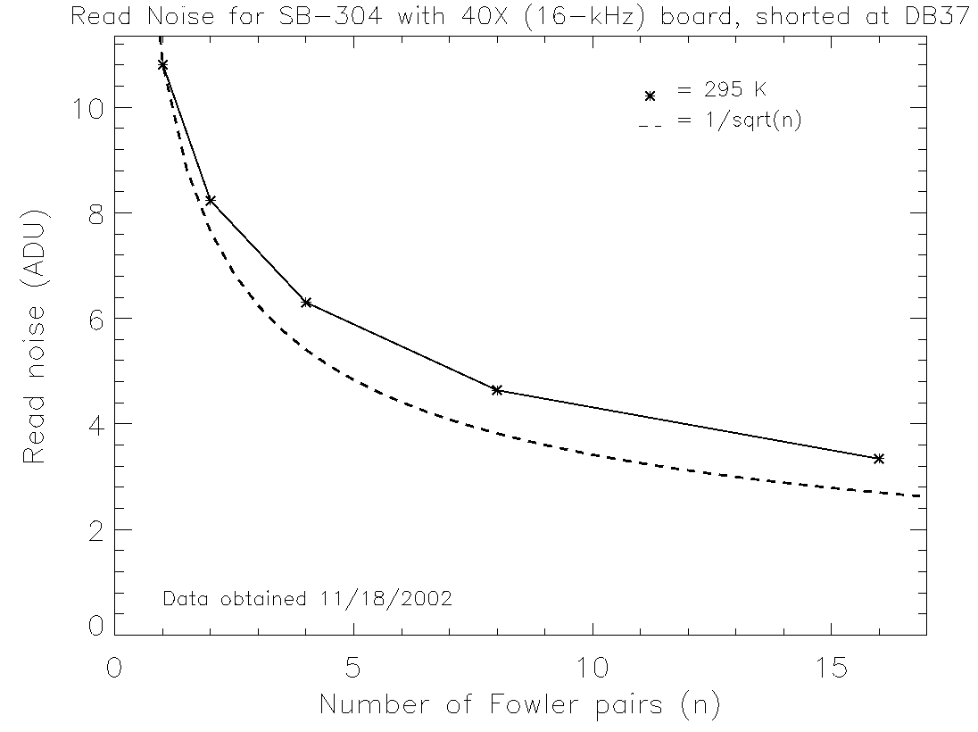
10. Baseline Tests for 40X Gain Board Shorted at Harness
This test was conducted using the same video board that was used in the test described in section 7. A 2k-ohm shorting resistor block was installed on the DB9 connection from the harness to the DCC.
Dewar | # of Sample Pairs
Dewar | 1 | 2 | 4 | 8 | 16 | 32
Read Noise (ADU) | 5.0 | 3.6 | 2.5 | 1.8 | 1.3 | -
